Group Decision Lit

<https://tegorman13.github.io/ccl/llm_energy.html>

## Sasha: Creative Goal-Oriented Reasoning in Smart Homes with Large Language Models.

King, E., Yu, H., Lee, S., & Julien, C. (2024). **Sasha: Creative Goal-Oriented Reasoning in Smart Homes with Large Language Models.** Proceedings of the ACM on Interactive, Mobile, Wearable and Ubiquitous Technologies, 8(1), 1–38. https://doi.org/10.1145/3643505

Abstract

Smart home assistants function best when user commands are direct and well-specified—e.g., “turn on the kitchen light”—or when a hard-coded routine specifies the response. In more natural communication, however, human speech is unconstrained, often describing goals (e.g., “make it cozy in here” or “help me save energy”) rather than indicating specific target devices and actions to take on those devices. Current systems fail to understand these under-specified commands since they cannot reason about devices and settings as they relate to human situations. We introduce large language models (LLMs) to this problem space, exploring their use for controlling devices and creating automation routines in response to under-specified user commands in smart homes. We empirically study the baseline quality and failure modes of LLM-created action plans with a survey of age-diverse users. We find that LLMs can reason creatively to achieve challenging goals, but they experience patterns of failure that diminish their usefulness. We address these gaps with Sasha, a smarter smart home assistant. Sasha responds to loosely-constrained commands like “make it cozy” or “help me sleep better” by executing plans to achieve user goals—e.g., setting a mood with available devices, or devising automation routines. We implement and evaluate Sasha in a hands-on user study, showing the capabilities and limitations of LLM-driven smart homes when faced with unconstrained user-generated scenarios.

|  |
| --- |
|  |

|  |
| --- |
|  |

|  |
| --- |
|  |

|  |
| --- |
|  |

|  |
| --- |
|  |

|  |
| --- |
|  |

Figure 1: Figure from King, Yu, Lee, et al. (2024)

## Thoughtful Things: Building Human-Centric Smart Devices with Small Language Models

King, E., Yu, H., Vartak, S., Jacob, J., Lee, S., & Julien, C. (2024). **Thoughtful Things: Building Human-Centric Smart Devices with Small Language Models** (arXiv:2405.03821). arXiv. http://arxiv.org/abs/2405.03821

Abstract

Everyday devices like light bulbs and kitchen appliances are now embedded with so many features and automated behaviors that they have become complicated to actually use. While such “smart” capabilities can better support users’ goals, the task of learning the “ins and outs” of different devices is daunting. Voice assistants aim to solve this problem by providing a natural language interface to devices, yet such assistants cannot understand loosely-constrained commands, they lack the ability to reason about and explain devices’ behaviors to users, and they rely on connectivity to intrusive cloud infrastructure. Toward addressing these issues, we propose thoughtful things: devices that leverage lightweight, on-device language models to take actions and explain their behaviors in response to unconstrained user commands. We propose an end-to-end framework that leverages formal modeling, automated training data synthesis, and generative language models to create devices that are both capable and thoughtful in the presence of unconstrained user goals and inquiries. Our framework requires no labeled data and can be deployed on-device, with no cloud dependency. We implement two thoughtful things (a lamp and a thermostat) and deploy them on real hardware, evaluating their practical performance.

|  |
| --- |
|  |

|  |
| --- |
|  |

|  |
| --- |
|  |

|  |
| --- |
|  |

|  |
| --- |
|  |

|  |
| --- |
|  |

Figure 2: Figure from King, Yu, Vartak, et al. (2024)

## Designing Home Automation Routines Using an LLM-Based Chatbot.

Giudici, M., Padalino, L., Paolino, G., Paratici, I., Pascu, A. I., & Garzotto, F. (2024). **Designing Home Automation Routines Using an LLM-Based Chatbot.** Designs, 8(3), Article 3. https://doi.org/10.3390/designs8030043

Abstract

Without any more delay, individuals are urged to adopt more sustainable behaviors to fight climate change. New digital systems mixed with engaging and gamification mechanisms could play an important role in achieving such an objective. In particular, Conversational Agents, like Smart Home Assistants, are a promising tool that encourage sustainable behaviors within household settings. In recent years, large language models (LLMs) have shown great potential in enhancing the capabilities of such assistants, making them more effective in interacting with users. We present the design and implementation of GreenIFTTT, an application empowered by GPT4 to create and control home automation routines. The agent helps users understand which energy consumption optimization routines could be created and applied to make their home appliances more environmentally sustainable. We performed an exploratory study (Italy, December 2023) with N = 13 participants to test our application’s usability and UX. The results suggest that GreenIFTTT is a usable, engaging, easy, and supportive tool, providing insight into new perspectives and usage of LLMs to create more environmentally sustainable home automation.

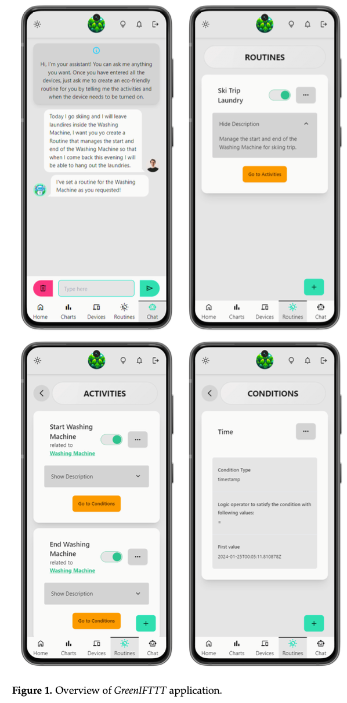

Figure from Giudici et al. (2024)

## Enhancing smart home interaction through multimodal command disambiguation.

Calò, T., & De Russis, L. (2024). **Enhancing smart home interaction through multimodal command disambiguation.** Personal and Ubiquitous Computing. https://doi.org/10.1007/s00779-024-01827-3

Abstract

Smart speakers are entering our homes and enriching the connected ecosystem already present in them. Home inhabitants can use those to execute relatively simple commands, e.g., turning a lamp on. Their capabilities to interpret more complex and ambiguous commands (e.g., make this room warmer) are limited, if not absent. Large language models (LLMs) can offer creative and viable solutions to enable a practical and user-acceptable interpretation of such ambiguous commands. This paper introduces an interactive disambiguation approach that integrates visual and textual cues with natural language commands. After contextualizing the approach with a use case, we test it in an experiment where users are prompted to select the appropriate cue (an image or a textual description) to clarify ambiguous commands, thereby refining the accuracy of the system’s interpretations. Outcomes from the study indicate that the disambiguation system produces responses well-aligned with user intentions, and that participants found the textual descriptions slightly more effective. Finally, interviews reveal heightened satisfaction with the smart-home system when engaging with the proposed disambiguation approach.

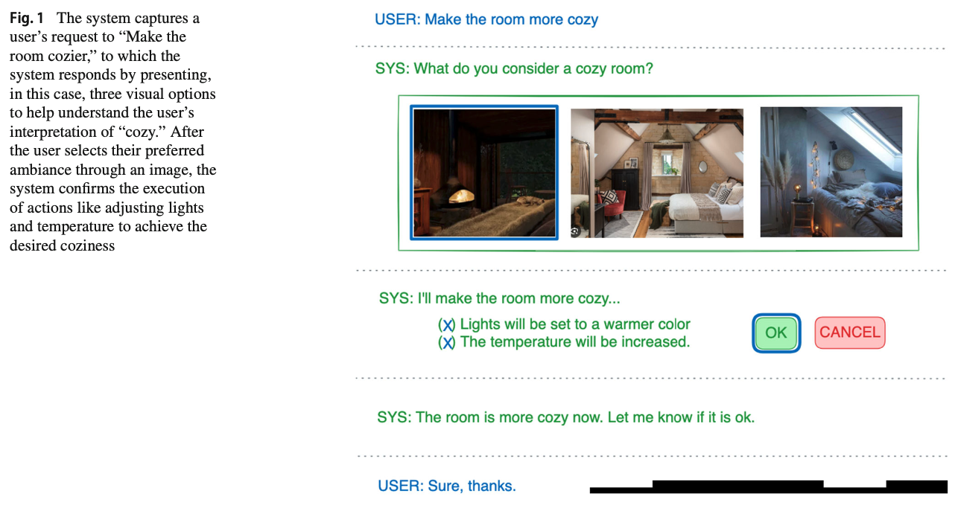

Figure from Calò & De Russis (2024)

## Save It for the “Hot” Day: An LLM-Empowered Visual Analytics System for Heat Risk Management

Li, H., Kam-Kwai, W., Luo, Y., Chen, J., Liu, C., Zhang, Y., Lau, A. K. H., Qu, H., & Liu, D. (2024). **Save It for the “Hot” Day: An LLM-Empowered Visual Analytics System for Heat Risk Management** (arXiv:2406.03317). arXiv. http://arxiv.org/abs/2406.03317

Abstract

The escalating frequency and intensity of heat-related climate events, particularly heatwaves, emphasize the pressing need for advanced heat risk management strategies. Current approaches, primarily relying on numerical models, face challenges in spatial-temporal resolution and in capturing the dynamic interplay of environmental, social, and behavioral factors affecting heat risks. This has led to difficulties in translating risk assessments into effective mitigation actions. Recognizing these problems, we introduce a novel approach leveraging the burgeoning capabilities of Large Language Models (LLMs) to extract rich and contextual insights from news reports. We hence propose an LLM-empowered visual analytics system, Havior, that integrates the precise, data-driven insights of numerical models with nuanced news report information. This hybrid approach enables a more comprehensive assessment of heat risks and better identification, assessment, and mitigation of heat-related threats. The system incorporates novel visualization designs, such as “thermoglyph” and news glyph, enhancing intuitive understanding and analysis of heat risks. The integration of LLM-based techniques also enables advanced information retrieval and semantic knowledge extraction that can be guided by experts’ analytics needs. Our case studies on two cities that faced significant heatwave events and interviews with five experts have demonstrated the usefulness of our system in providing in-depth and actionable insights for heat risk management.

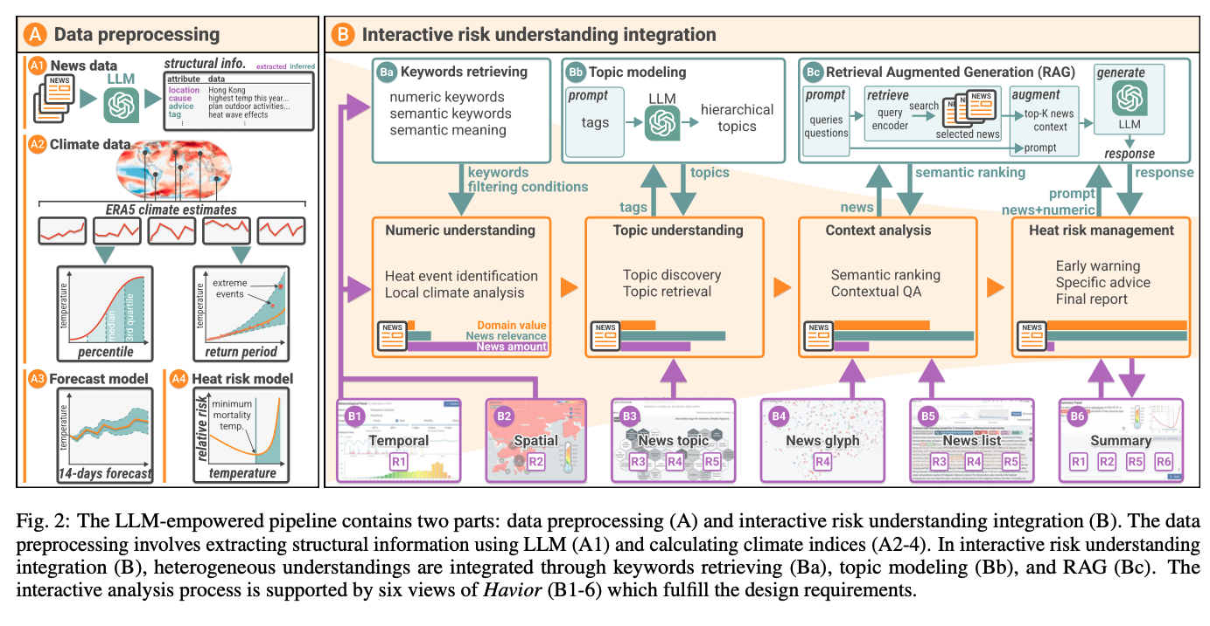

Figure from Li et al. (2024)

## Follow-Me AI: Energy-Efficient User Interaction with Smart Environments

Saleh, A., Donta, P. K., Morabito, R., Motlagh, N. H., & Lovén, L. (2024). **Follow-Me AI: Energy-Efficient User Interaction with Smart Environments** (arXiv:2404.12486). arXiv. http://arxiv.org/abs/2404.12486

Abstract

This article introduces Follow-Me AI, a concept designed to enhance user interactions with smart environments, optimize energy use, and provide better control over data captured by these environments. Through AI agents that accompany users, Follow-Me AI negotiates data management based on user consent, aligns environmental controls as well as user communication and computes resources available in the environment with user preferences, and predicts user behavior to proactively adjust the smart environment. The manuscript illustrates this concept with a detailed example of Follow-Me AI in a smart campus setting, detailing the interactions with the building’s management system for optimal comfort and efficiency. Finally, this article looks into the challenges and opportunities related to Follow-Me AI.

|  |
| --- |
|  |

|  |
| --- |
|  |

|  |
| --- |
|  |

|  |
| --- |
|  |

Figure 3: Figure from Saleh et al. (2024)

## An LLM-Based Digital Twin for Optimizing Human-in-the Loop Systems

Yang, H., Siew, M., & Joe-Wong, C. (2024). **An LLM-Based Digital Twin for Optimizing Human-in-the Loop Systems** (arXiv:2403.16809). arXiv. http://arxiv.org/abs/2403.16809

Abstract

The increasing prevalence of Cyber-Physical Systems and the Internet of Things (CPS-IoT) applications and Foundation Models are enabling new applications that leverage real-time control of the environment. For example, real-time control of Heating, Ventilation and Air-Conditioning (HVAC) systems can reduce its usage when not needed for the comfort of human occupants, hence reducing energy consumption. Collecting realtime feedback on human preferences in such human-in-the-loop (HITL) systems, however, is difficult in practice. We propose the use of large language models (LLMs) to deal with the challenges of dynamic environments and difficult-to-obtain data in CPS optimization. In this paper, we present a case study that employs LLM agents to mimic the behaviors and thermal preferences of various population groups (e.g. young families, the elderly) in a shopping mall. The aggregated thermal preferences are integrated into an agent-in-the-loop based reinforcement learning algorithm AitL-RL, which employs the LLM as a dynamic simulation of the physical environment to learn how to balance between energy savings and occupant comfort. Our results show that LLMs are capable of simulating complex population movements within large open spaces. Besides, AitL-RLdemonstrates superior performance compared to the popular existing policy of set point control, suggesting that adaptive and personalized decision-making is critical for efficient optimization in CPS-IoT applications. Through this case study, we demonstrate the potential of integrating advanced Foundation Models like LLMs into CPS-IoT to enhance system adaptability and efficiency. The project’s code can be found on our GitHub repository.

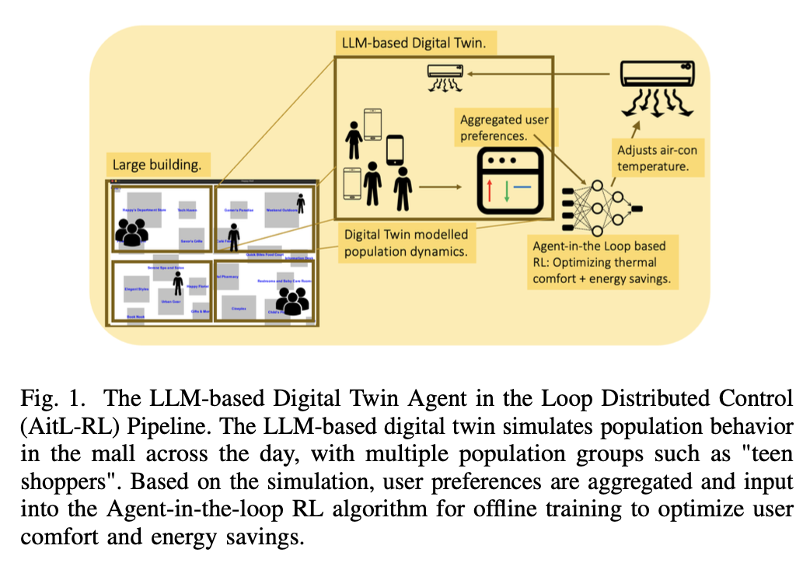

Figure from H. Yang et al. (2024)

## Can Private LLM Agents Synthesize Household Energy Consumption Data?

Almashor, M., & Miyashita, Y. (2024). **Can Private LLM Agents Synthesize Household Energy Consumption Data?** Proceedings of the 15th ACM International Conference on Future and Sustainable Energy Systems, 664–668. https://doi.org/10.1145/3632775.3661993

Abstract

Reproducible science requires easy access to data, especially with the rise of data-driven and increasingly complex models used within energy research. Too often however, the data to reconstruct and verify purported solutions in publications is hidden due to some combination of commercial, legal, and sensitivity issues. This early work presents our initial efforts to leverage the recent advancements in Large Language Models (LLMs) to create usable and shareable energy datasets. In particular, we’re utilising their mimicry of human behaviors, with the goal of extracting and exploring synthetic energy data through the simulation of LLM agents capable of interacting with and executing actions in controlled environments. We also analyse and visualise publicly available data in an attempt to create realistic but not quite exact copies of the originals. Our early results show some promise, with outputs that resemble the twin peak curves for household energy consumption. The hope is that our generalised approach can be used to easily replicate usable and realistic copies of otherwise secret or sensitive data.

Almashor & Miyashita (2024)

## Prompt-Gaming: A Pilot Study on LLM-Evaluating Agent in a Meaningful Energy Game.

Isaza-Giraldo, A., Bala, P., Campos, P. F., & Pereira, L. (2024). Prompt-Gaming: A Pilot Study on LLM-Evaluating Agent in a Meaningful Energy Game. Extended Abstracts of the 2024 CHI Conference on Human Factors in Computing Systems, 1–12. https://doi.org/10.1145/3613905.3650774

Abstract

Building on previous work on incorporating large language models (LLM) in gaming, we investigate the possibility of implementing LLM as evaluating agents of open-ended challenges in serious games and its potential to facilitate a meaningful experience for the player. We contribute with a sustainability game prototype in a single natural language prompt about energy communities and we tested it with 13 participants inside ChatGPT-3.5. Two participants were already aware of energy communities before the game, and eight of the remaining 11 gained valuable knowledge about the specific topic. Comparing ChatGPT-3.5 evaluations of players’ interaction with an expert’s assessment, ChatGPT-3.5 correctly evaluated 81% of player’s answers. Our results are encouraging and show the potential of using LLMs as mediating agents in educational games, while also allowing easy prototyping of games through natural language prompts.

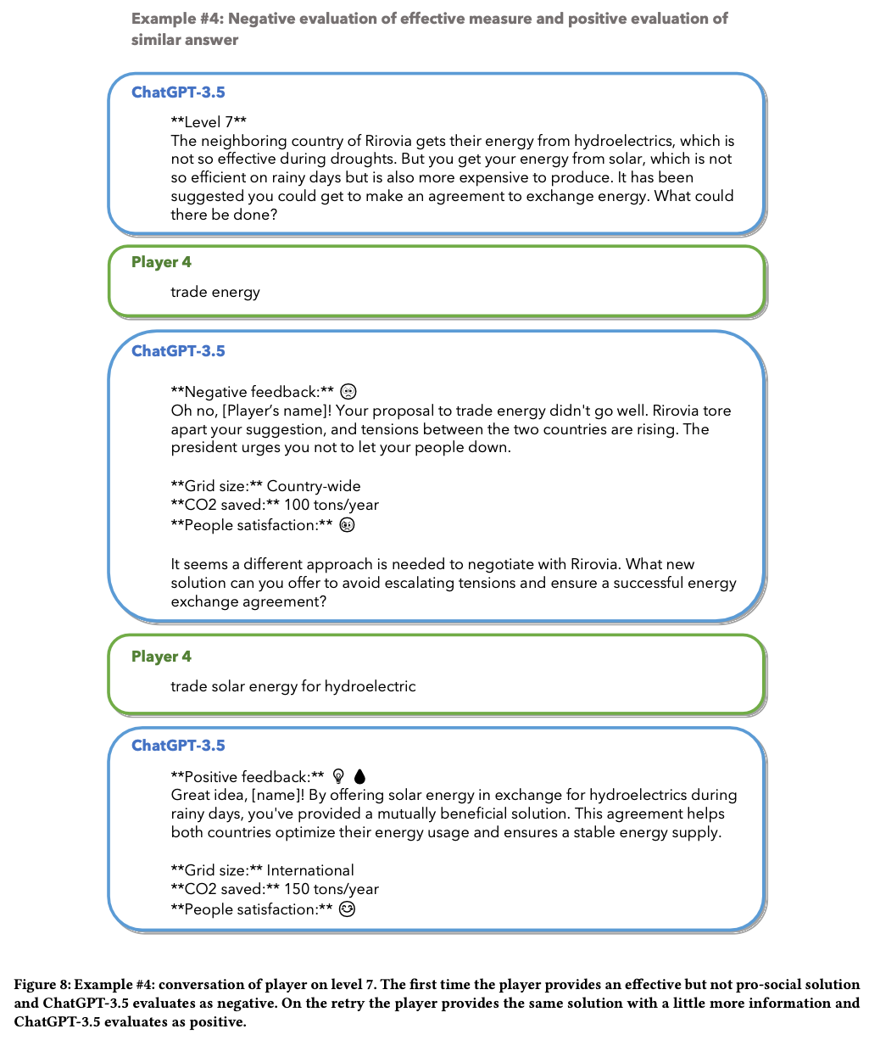

Figure from Isaza-Giraldo et al. (2024)

## Evaluation of large language models (LLMs) on the mastery of knowledge and skills in the heating, ventilation and air conditioning (HVAC) industry.

Lu, J., Tian, X., Zhang, C., Zhao, Y., Zhang, J., Zhang, W., Feng, C., He, J., Wang, J., & He, F. (2024). **Evaluation of large language models (LLMs) on the mastery of knowledge and skills in the heating, ventilation and air conditioning (HVAC) industry.** Energy and Built Environment. https://doi.org/10.1016/j.enbenv.2024.03.010

Abstract

Large language models (LLMs) have shown human-level capabilities in solving various complex tasks. However, it is still unknown whether state-of-the-art LLMs master sufficient knowledge related to heating, ventilation and air conditioning (HVAC) systems. It will be inspiring if LLMs can think and learn like professionals in the HVAC industry. Hence, this study investigates the performance of LLMs on mastering the knowledge and skills related to the HVAC industry by letting them take the ASHRAE Certified HVAC Designer examination, an authoritative examination in the HVAC industry. Three key knowledge capabilities are explored: recall, analysis and application. Twelve representative LLMs are tested such as GPT-3.5, GPT-4 and LLaMA. According to the results, GPT-4 passes the ASHRAE Certified HVAC Designer examination with scores from 74 to 78, which is higher than about half of human examinees. Besides, GPT-3.5 passes the examination twice out of five times. It demonstrates that some LLMs such as GPT-4 and GPT-3.5 have great potential to assist or replace humans in designing and operating HVAC systems. However, they still make some mistakes sometimes due to the lack of knowledge, poor reasoning capabilities and unsatisfactory equation calculation abilities. Accordingly, four future research directions are proposed to reveal how to utilize and improve LLMs in the HVAC industry: teaching LLMs to use design tools or software in the HVAC industry, enabling LLMs to read and analyze the operational data from HVAC systems, developing tailored corpuses for the HVAC industry, and assessing the performance of LLMs in real-world HVAC design and operation scenarios.

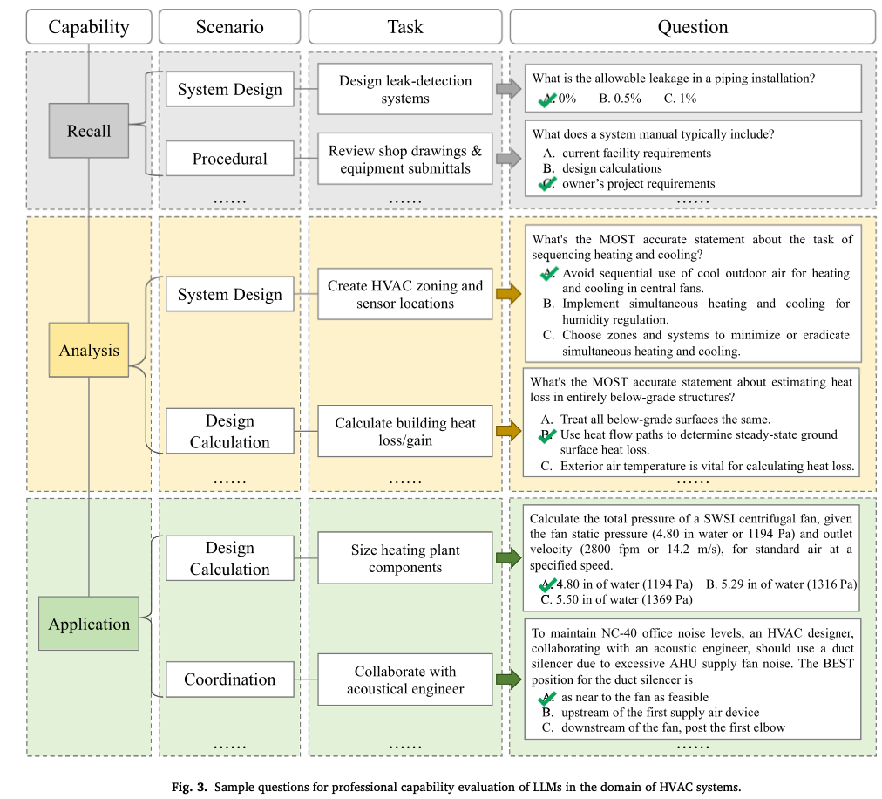

Figure from Lu et al. (2024)

## Domain-specific large language models for fault diagnosis of heating, ventilation, and air conditioning systems by labeled-data-supervised fine-tuning.

Zhang, J., Zhang, C., Lu, J., & Zhao, Y. (2025). **Domain-specific large language models for fault diagnosis of heating, ventilation, and air conditioning systems by labeled-data-supervised fine-tuning.** Applied Energy, 377, 124378. https://doi.org/10.1016/j.apenergy.2024.124378

Abstract

Large language models (LLMs) have exhibited great potential in fault diagnosis of heating, ventilation, and air conditioning systems. However, the fault diagnosis accuracy of LLMs is still unsatisfactory, due to the lack of effective diagnosis accuracy enhancement methods for LLMs. To fill this gap, this study proposes a LLM fine-tuning method supervised by data with fault and fault-free labels to enhance the fault diagnosis accuracy of LLMs. This method designs a LLM self-correction strategy to automatically generate a fine-tuning dataset based on the labeled data. The generated fine-tuning dataset is applied to fine-tune a LLM. Moreover, a data augmentation-based approach is put forward to adaptively update the fine-tuning dataset for iteratively developing a high-performance fine-tuned LLM. The proposed method is utilized to fine-tune the GPT-3.5 model using the air handling unit (AHU) fault dataset from the RP-1312 project. The results show that the diagnosis accuracy of the GPT-3.5 model is increased from 29.5 % to 100.0 % after model fine-tuning. Compared with the GPT-4 model, the fine-tuned GPT-3.5 model achieves a 31.1 % higher average diagnosis accuracy. The fine-tuned GPT-3.5 model is also applied to diagnose faults in two AHUs from another open-source dataset to verify the generalization ability of this model. The two AHUs have different system structures and sensor configurations compared to the AHU in the RP-1312 dataset, and this dataset is not utilized to fine-tune the GPT-3.5 model. The average diagnosis accuracy of the GPT-3.5 model is increased from 46.0 % to 99.1 % and from 38.8 % to 98.9 % for the faults in the two AHUs, respectively, after model fine-tuning. Furthermore, the proposed method is verified using two fault datasets from a variable air volume box and a chiller plant system. After fine-tuning the GPT-3.5 model using the two datasets, the average diagnosis accuracy of this model is increased from 33.0 % to 98.3 % for variable air volume box faults and from 36.0 % to 99.1 % for chiller plant system faults. This study provides an effective solution to the development of domain-specific LLMs for this domain.

Zhang et al. (2025)

## Game of LLMs: Discovering Structural Constructs in Activities using Large Language Models.

Hiremath, S. K., & Plötz, T. (2024). **Game of LLMs: Discovering Structural Constructs in Activities using Large Language Models.** Companion of the 2024 on ACM International Joint Conference on Pervasive and Ubiquitous Computing, 487–492. https://doi.org/10.1145/3675094.3678444

Abstract

Human Activity Recognition is a time-series analysis problem. A popular analysis procedure used by the community assumes an optimal window length to design recognition pipelines. However, in the scenario of smart homes, where activities are of varying duration and frequency, the assumption of a constant sized window does not hold. Additionally, previous works have shown these activities to be made up of building blocks. We focus on identifying these underlying building blocks–structural constructs, with the use of large language models. Identifying these constructs can be beneficial especially in recognizing short-duration and infrequent activities, which current systems cannot recognize. We also propose the development of an activity recognition procedure that uses these building blocks to model activities, thus helping the downstream task of activity monitoring in smart homes.

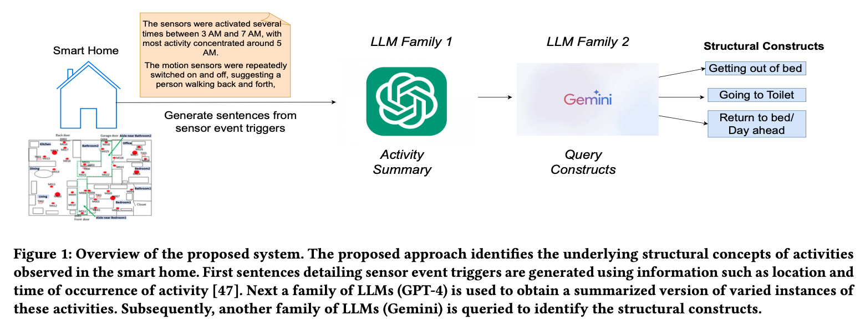

Figure from Hiremath & Plötz (2024)

## LLM-Based Open-Domain Integrated Task and Knowledge Assistants with Programmable Policies

Joshi, H., Liu, S., Chen, J., Weigle, R., & Lam, M. S. (2024). **LLM-Based Open-Domain Integrated Task and Knowledge Assistants with Programmable Policies** (arXiv:2407.05674). arXiv. http://arxiv.org/abs/2407.05674

Abstract

Programming LLM-based knowledge and task assistants that faithfully conform to developer-provided policies is challenging. These agents must retrieve and provide consistent, accurate, and relevant information to address user’s queries and needs. Yet such agents generate unfounded responses (“hallucinate”). Traditional dialogue trees can only handle a limited number of conversation flows, making them inherently brittle. To this end, we present KITA - a programmable framework for creating task-oriented conversational agents that are designed to handle complex user interactions. Unlike LLMs, KITA provides reliable grounded responses, with controllable agent policies through its expressive specification, KITA Worksheet. In contrast to dialog trees, it is resilient to diverse user queries, helpful with knowledge sources, and offers ease of programming policies through its declarative paradigm. Through a real-user study involving 62 participants, we show that KITA beats the GPT-4 with function calling baseline by 26.1, 22.5, and 52.4 points on execution accuracy, dialogue act accuracy, and goal completion rate, respectively. We also release 22 real-user conversations with KITA manually corrected to ensure accuracy.

Joshi et al. (2024)

## Large Language Models are Zero-Shot Recognizers for Activities of Daily Living

Civitarese, G., Fiori, M., Choudhary, P., & Bettini, C. (2024). **Large Language Models are Zero-Shot Recognizers for Activities of Daily Living** (arXiv:2407.01238). arXiv. http://arxiv.org/abs/2407.01238

Abstract

The sensor-based recognition of Activities of Daily Living (ADLs) in smart home environments enables several applications in the areas of energy management, safety, well-being, and healthcare. ADLs recognition is typically based on deep learning methods requiring large datasets to be trained. Recently, several studies proved that Large Language Models (LLMs) effectively capture common-sense knowledge about human activities. However, the effectiveness of LLMs for ADLs recognition in smart home environments still deserves to be investigated. In this work, we propose ADL-LLM, a novel LLM-based ADLs recognition system. ADLLLM transforms raw sensor data into textual representations, that are processed by an LLM to perform zero-shot ADLs recognition. Moreover, in the scenario where a small labeled dataset is available, ADL-LLM can also be empowered with few-shot prompting. We evaluated ADL-LLM on two public datasets, showing its effectiveness in this domain.

|  |
| --- |
|  |

|  |
| --- |
|  |

Figure 4: Figures from Civitarese et al. (2024)

## Large Language Models for Power Scheduling: A User-Centric Approach

Mongaillard, T., Lasaulce, S., Hicheur, O., Zhang, C., Bariah, L., Varma, V. S., Zou, H., Zhao, Q., & Debbah, M. (2024). **Large Language Models for Power Scheduling: A User-Centric Approach** (arXiv:2407.00476). arXiv. http://arxiv.org/abs/2407.00476

Abstract

While traditional optimization and scheduling schemes are designed to meet fixed, predefined system requirements, future systems are moving toward user-driven approaches and personalized services, aiming to achieve high quality-of-experience (QoE) and flexibility. This challenge is particularly pronounced in wireless and digitalized energy networks, where users’ requirements have largely not been taken into consideration due to the lack of a common language between users and machines. The emergence of powerful large language models (LLMs) marks a radical departure from traditional system-centric methods into more advanced user-centric approaches by providing a natural communication interface between users and devices. In this paper, for the first time, we introduce a novel architecture for resource scheduling problems by constructing three LLM agents to convert an arbitrary user’s voice request (VRQ) into a resource allocation vector. Specifically, we design an LLM intent recognition agent to translate the request into an optimization problem (OP), an LLM OP parameter identification agent, and an LLM OP solving agent. To evaluate system performance, we construct a database of typical VRQs in the context of electric vehicle (EV) charging. As a proof of concept, we primarily use Llama 3 8B. Through testing with different prompt engineering scenarios, the obtained results demonstrate the efficiency of the proposed architecture. The conducted performance analysis allows key insights to be extracted. For instance, having a larger set of candidate OPs to model the real-world problem might degrade the final performance because of a higher recognition/OP classification noise level. All results and codes are open source.

|  |
| --- |
|  |

|  |
| --- |
|  |

Figure 5: Figures from Mongaillard et al. (2024)

## A Recommendation System for Prosumers Based on Large Language Models.

Oprea, S.-V., & Bâra, A. (2024). **A Recommendation System for Prosumers Based on Large Language Models.** Sensors, 24(11), Article 11. https://doi.org/10.3390/s24113530

Abstract

As modern technologies, particularly home assistant devices and sensors, become more integrated into our daily lives, they are also making their way into the domain of energy management within our homes. Homeowners, now acting as prosumers, have access to detailed information at 15-min or even 5-min intervals, including weather forecasts, outputs from renewable energy source (RES)-based systems, appliance schedules and the current energy balance, which details any deficits or surpluses along with their quantities and the predicted prices on the local energy market (LEM). The goal for these prosumers is to reduce costs while ensuring their home’s comfort levels are maintained. However, given the complexity and the rapid decision-making required in managing this information, the need for a supportive system is evident. This is particularly true given the routine nature of these decisions, highlighting the potential for a system that provides personalized recommendations to optimize energy consumption, whether that involves adjusting the load or engaging in transactions with the LEM. In this context, we propose a recommendation system powered by large language models (LLMs), Scikit-llm and zero-shot classifiers, designed to evaluate specific scenarios and offer tailored advice for prosumers based on the available data at any given moment. Two scenarios for a prosumer of 5.9 kW are assessed using candidate labels, such as Decrease, Increase, Sell and Buy. A comparison with a content-based filtering system is provided considering the performance metrics that are relevant for prosumers.

Oprea & Bâra (2024)

## A conversational agent for creating automations exploiting large language models. Personal and Ubiquitous Computing.

Gallo, S., Paternò, F., & Malizia, A. (2024). **A conversational agent for creating automations exploiting large language models. Personal and Ubiquitous Computing.** https://doi.org/10.1007/s00779-024-01825-5

Abstract

The proliferation of sensors and smart Internet of Things (IoT) devices in our everyday environments is reshaping our interactions with everyday objects. This change underlines the need to empower non-expert users to easily configure the behaviour of these devices to align with their preferences and habits. At the same time, recent advances in generative transformers, such as ChatGPT, have opened up new possibilities in a variety of natural language processing tasks, enhancing reasoning capabilities and conversational interactions. This paper presents RuleBot +  + , a conversational agent that exploits GPT-4 to assist the user in the creation and modification of trigger-action automations through natural language. After an introduction to motivations and related work, we present the design and implementation of RuleBot +  + and report the results of the user test in which users interacted with our solution and Home Assistant, one of the most used open-source tools for managing smart environments.

|  |
| --- |
|  |

|  |
| --- |
|  |

Figure 6: Figures from Gallo et al. (2024)

## A Human-on-the-Loop Optimization Autoformalism Approach for Sustainability

Jin, M., Sel, B., Hardeep, F., & Yin, W. (2023). **A Human-on-the-Loop Optimization Autoformalism Approach for Sustainability** (arXiv:2308.10380). arXiv. http://arxiv.org/abs/2308.10380

Abstract

This paper outlines a natural conversational approach to solving personalized energy-related problems using large language models (LLMs). We focus on customizable optimization problems that necessitate repeated solving with slight variations in modeling and are user-specific, hence posing a challenge to devising a one-size-fits-all model. We put forward a strategy that augments an LLM with an optimization solver, enhancing its proficiency in understanding and responding to user specifications and preferences while providing nonlinear reasoning capabilities. Our approach pioneers the novel concept of human-guided optimization autoformalism, translating a natural language task specification automatically into an optimization instance. This enables LLMs to analyze, explain, and tackle a variety of instance-specific energy-related problems, pushing beyond the limits of current prompt-based techniques. Our research encompasses various commonplace tasks in the energy sector, from electric vehicle charging and Heating, Ventilation, and Air Conditioning (HVAC) control to long-term planning problems such as cost-benefit evaluations for installing rooftop solar photovoltaics (PVs) or heat pumps. This pilot study marks an essential stride towards the context-based formulation of optimization using LLMs, with the potential to democratize optimization processes. As a result, stakeholders are empowered to optimize their energy consumption, promoting sustainable energy practices customized to personal needs and preferences.

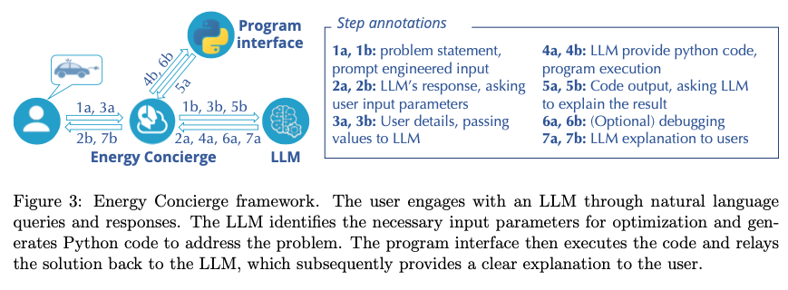

Figure from Jin et al. (2023)

# References

Abdelnabi, S., Gomaa, A., Sivaprasad, S., Schönherr, L., & Fritz, M. (2023). *LLM-Deliberation: Evaluating LLMs with Interactive Multi-Agent Negotiation Games.* <https://doi.org/10.60882/cispa.25233028.v1>

Almashor, M., & Miyashita, Y. (2024). Can Private LLM Agents Synthesize Household Energy Consumption Data? *Proceedings of the 15th ACM International Conference on Future and Sustainable Energy Systems*, 664–668. <https://doi.org/10.1145/3632775.3661993>

Banerjee, D., Teso, S., Sayin, B., & Passerini, A. (2024). *Learning To Guide Human Decision Makers With Vision-Language Models* (arXiv:2403.16501). arXiv. <https://arxiv.org/abs/2403.16501>

Bhatia, S. (2024). Exploring variability in risk taking with large language models. *Journal of Experimental Psychology: General*, *153*(7), 1838–1860. <https://doi.org/10.1037/xge0001607>

Bienefeld, N., Kolbe, M., Camen, G., Huser, D., & Buehler, P. K. (2023). Human-AI teaming: Leveraging transactive memory and speaking up for enhanced team effectiveness. *Frontiers in Psychology*, *14*. <https://doi.org/10.3389/fpsyg.2023.1208019>

Binz, M., & Schulz, E. (2023). Using cognitive psychology to understand GPT-3. *Proceedings of the National Academy of Sciences*, *120*(6), e2218523120. <https://doi.org/10.1073/pnas.2218523120>

Buçinca, Z., Malaya, M. B., & Gajos, K. Z. (2021). To Trust or to Think: Cognitive Forcing Functions Can Reduce Overreliance on AI in AI-assisted Decision-making. *Proceedings of the ACM on Human-Computer Interaction*, *5*(CSCW1), 1–21. <https://doi.org/10.1145/3449287>

Burton, J. W., Lopez-Lopez, E., Hechtlinger, S., Rahwan, Z., Aeschbach, S., Bakker, M. A., Becker, J. A., Berditchevskaia, A., Berger, J., Brinkmann, L., Flek, L., Herzog, S. M., Huang, S., Kapoor, S., Narayanan, A., Nussberger, A.-M., Yasseri, T., Nickl, P., Almaatouq, A., … Hertwig, R. (2024). How large language models can reshape collective intelligence. *Nature Human Behaviour*, 1–13. <https://doi.org/10.1038/s41562-024-01959-9>

Calò, T., & De Russis, L. (2024). Enhancing smart home interaction through multimodal command disambiguation. *Personal and Ubiquitous Computing*. <https://doi.org/10.1007/s00779-024-01827-3>

Chen, Y., Liu, T. X., Shan, Y., & Zhong, S. (2023). The emergence of economic rationality of GPT. *Proceedings of the National Academy of Sciences*, *120*(51), e2316205120. <https://doi.org/10.1073/pnas.2316205120>

Cheung, V., Maier, M., & Lieder, F. (2024). *Large Language Models Amplify Human Biases in Moral Decision-Making*. <https://doi.org/10.31234/osf.io/aj46b>

Chiang, C.-W., Lu, Z., Li, Z., & Yin, M. (2024). Enhancing AI-Assisted Group Decision Making through LLM-Powered Devil’s Advocate. *Proceedings of the 29th International Conference on Intelligent User Interfaces*, 103–119. <https://doi.org/10.1145/3640543.3645199>

Choi, A. S., Akter, S. S., Singh, J. P., & Anastasopoulos, A. (2024). *The LLM Effect: Are Humans Truly Using LLMs, or Are They Being Influenced By Them Instead?* (arXiv:2410.04699). arXiv. <https://arxiv.org/abs/2410.04699>

Chuang, Y.-S., Harlalka, N., Suresh, S., Goyal, A., Hawkins, R., Yang, S., Shah, D., Hu, J., & Rogers, T. T. (2024). *The Wisdom of Partisan Crowds: Comparing Collective Intelligence in Humans and LLM-based Agents*.

Chuang, Y.-S., Suresh, S., Harlalka, N., Goyal, A., Hawkins, R., Yang, S., Shah, D., Hu, J., & Rogers, T. T. (2023). *Evaluating LLM Agent Group Dynamics against Human Group Dynamics: A Case Study on Wisdom of Partisan Crowds* (arXiv:2311.09665). arXiv. <https://arxiv.org/abs/2311.09665>

Civitarese, G., Fiori, M., Choudhary, P., & Bettini, C. (2024). *Large Language Models are Zero-Shot Recognizers for Activities of Daily Living* (arXiv:2407.01238). arXiv. <https://arxiv.org/abs/2407.01238>

Collins, K. M., Jiang, A. Q., Frieder, S., Wong, L., Zilka, M., Bhatt, U., Lukasiewicz, T., Wu, Y., Tenenbaum, J. B., Hart, W., Gowers, T., Li, W., Weller, A., & Jamnik, M. (2023). *Evaluating Language Models for Mathematics through Interactions* (arXiv:2306.01694). arXiv. <https://arxiv.org/abs/2306.01694>

Collins, K. M., Sucholutsky, I., Bhatt, U., Chandra, K., Wong, L., Lee, M., Zhang, C. E., Zhi-Xuan, T., Ho, M., Mansinghka, V., Weller, A., Tenenbaum, J. B., & Griffiths, T. L. (2024). Building machines that learn and think with people. *Nature Human Behaviour*, *8*(10), 1851–1863. <https://doi.org/10.1038/s41562-024-01991-9>

Du, Y., Rajivan, P., & Gonzalez, C. C. (2024). *Large Language Models for Collective Problem-Solving: Insights into Group Consensus Decision-Making*.

Eigner, E., & Händler, T. (2024). *Determinants of LLM-assisted Decision-Making* (arXiv:2402.17385). arXiv. <https://arxiv.org/abs/2402.17385>

Gallo, S., Paternò, F., & Malizia, A. (2024). A conversational agent for creating automations exploiting large language models. *Personal and Ubiquitous Computing*. <https://doi.org/10.1007/s00779-024-01825-5>

Gao, C., Lan, X., Li, N., Yuan, Y., Ding, J., Zhou, Z., Xu, F., & Li, Y. (2024). Large language models empowered agent-based modeling and simulation: A survey and perspectives. *Humanities and Social Sciences Communications*, *11*(1), 1–24. <https://doi.org/10.1057/s41599-024-03611-3>

Gao, J., Gebreegziabher, S. A., Choo, K. T. W., Li, T. J.-J., Perrault, S. T., & Malone, T. W. (2024). A Taxonomy for Human-LLM Interaction Modes: An Initial Exploration. *Extended Abstracts of the CHI Conference on Human Factors in Computing Systems*, 1–11. <https://doi.org/10.1145/3613905.3650786>

Gao, Y., Lee, D., Burtch, G., & Fazelpour, S. (2024). *Take Caution in Using LLMs as Human Surrogates: Scylla Ex Machina* (arXiv:2410.19599). arXiv. <https://arxiv.org/abs/2410.19599>

Giudici, M., Padalino, L., Paolino, G., Paratici, I., Pascu, A. I., & Garzotto, F. (2024). Designing Home Automation Routines Using an LLM-Based Chatbot. *Designs*, *8*(3), 43. <https://doi.org/10.3390/designs8030043>

Goli, A., & Singh, A. (2024). Can Large Language Models Capture Human Preferences? *Marketing Science*. <https://doi.org/10.1287/mksc.2023.0306>

Guo, X., Huang, K., Liu, J., Fan, W., Vélez, N., Wu, Q., Wang, H., Griffiths, T. L., & Wang, M. (2024). *Embodied LLM Agents Learn to Cooperate in Organized Teams* (arXiv:2403.12482). arXiv. <https://arxiv.org/abs/2403.12482>

Hagendorff, T., Fabi, S., & Kosinski, M. (2023). Human-like intuitive behavior and reasoning biases emerged in large language models but disappeared in ChatGPT. *Nature Computational Science*, *3*(10), 833–838. <https://doi.org/10.1038/s43588-023-00527-x>

Hao, X., Demir, E., & Eyers, D. (2024). Exploring collaborative decision-making: A quasi-experimental study of human and Generative AI interaction. *Technology in Society*, *78*, 102662. <https://doi.org/10.1016/j.techsoc.2024.102662>

Hiremath, S. K., & Plötz, T. (2024). Game of LLMs: Discovering Structural Constructs in Activities using Large Language Models. *Companion of the 2024 on ACM International Joint Conference on Pervasive and Ubiquitous Computing*, 487–492. <https://doi.org/10.1145/3675094.3678444>

Isaza-Giraldo, A., Bala, P., Campos, P. F., & Pereira, L. (2024). Prompt-Gaming: A Pilot Study on LLM-Evaluating Agent in a Meaningful Energy Game. *Extended Abstracts of the 2024 CHI Conference on Human Factors in Computing Systems*, 1–12. <https://doi.org/10.1145/3613905.3650774>

Jin, M., Sel, B., Hardeep, F., & Yin, W. (2023). *A Human-on-the-Loop Optimization Autoformalism Approach for Sustainability* (arXiv:2308.10380). arXiv. <https://arxiv.org/abs/2308.10380>

Joshi, H., Liu, S., Chen, J., Weigle, R., & Lam, M. S. (2024). *LLM-Based Open-Domain Integrated Task and Knowledge Assistants with Programmable Policies* (arXiv:2407.05674). arXiv. <https://arxiv.org/abs/2407.05674>

Kämmer, J. E., Hautz, W. E., Krummrey, G., Sauter, T. C., Penders, D., Birrenbach, T., & Bienefeld, N. (2024). Effects of interacting with a large language model compared with a human coach on the clinical diagnostic process and outcomes among fourth-year medical students: Study protocol for a prospective, randomised experiment using patient vignettes. *BMJ Open*, *14*(7), e087469. <https://doi.org/10.1136/bmjopen-2024-087469>

King, E., Yu, H., Lee, S., & Julien, C. (2024). Sasha: Creative Goal-Oriented Reasoning in Smart Homes with Large Language Models. *Proceedings of the ACM on Interactive, Mobile, Wearable and Ubiquitous Technologies*, *8*(1), 1–38. <https://doi.org/10.1145/3643505>

King, E., Yu, H., Vartak, S., Jacob, J., Lee, S., & Julien, C. (2024). *Thoughtful Things: Building Human-Centric Smart Devices with Small Language Models* (arXiv:2405.03821). arXiv. <https://arxiv.org/abs/2405.03821>

Koehl, D., & Vangsness, L. (2023). Measuring Latent Trust Patterns in Large Language Models in the Context of Human-AI Teaming. *Proceedings of the Human Factors and Ergonomics Society Annual Meeting*, *67*. <https://doi.org/10.1177/21695067231192869>

Kumar, H., Vincentius, J., Jordan, E., & Anderson, A. (2024). *Human Creativity in the Age of LLMs: Randomized Experiments on Divergent and Convergent Thinking* (arXiv:2410.03703). arXiv. <https://arxiv.org/abs/2410.03703>

Laban, G., Laban, T., & Gunes, H. (2024). *LEXI: Large Language Models Experimentation Interface* (arXiv:2407.01488). arXiv. <https://arxiv.org/abs/2407.01488>

Lai, V., Chen, C., Smith-Renner, A., Liao, Q. V., & Tan, C. (2023). Towards a Science of Human-AI Decision Making: An Overview of Design Space in Empirical Human-Subject Studies. *2023 ACM Conference on Fairness, Accountability, and Transparency*, 1369–1385. <https://doi.org/10.1145/3593013.3594087>

Lampinen, A. K., Dasgupta, I., Chan, S. C. Y., Sheahan, H. R., Creswell, A., Kumaran, D., McClelland, J. L., & Hill, F. (2024). Language models, like humans, show content effects on reasoning tasks. *PNAS Nexus*, *3*(7), pgae233. <https://doi.org/10.1093/pnasnexus/pgae233>

Li, H., Kam-Kwai, W., Luo, Y., Chen, J., Liu, C., Zhang, Y., Lau, A. K. H., Qu, H., & Liu, D. (2024). *Save It for the "Hot" Day: An LLM-Empowered Visual Analytics System for Heat Risk Management* (arXiv:2406.03317). arXiv. <https://arxiv.org/abs/2406.03317>

Lu, J., Tian, X., Zhang, C., Zhao, Y., Zhang, J., Zhang, W., Feng, C., He, J., Wang, J., & He, F. (2024). Evaluation of large language models (LLMs) on the mastery of knowledge and skills in the heating, ventilation and air conditioning (HVAC) industry. *Energy and Built Environment*. <https://doi.org/10.1016/j.enbenv.2024.03.010>

Ma, S., Chen, Q., Wang, X., Zheng, C., Peng, Z., Yin, M., & Ma, X. (2024). *Towards Human-AI Deliberation: Design and Evaluation of LLM-Empowered Deliberative AI for AI-Assisted Decision-Making* (arXiv:2403.16812). arXiv. <https://arxiv.org/abs/2403.16812>

Macmillan-Scott, O., & Musolesi, M. (2024). (Ir)rationality and cognitive biases in large language models. *Royal Society Open Science*, *11*(6), 240255. <https://doi.org/10.1098/rsos.240255>

Marjieh, R., Gokhale, A., Bullo, F., & Griffiths, T. L. (2024). *Task Allocation in Teams as a Multi-Armed Bandit*.

Matz, S. C., Teeny, J. D., Vaid, S. S., Peters, H., Harari, G. M., & Cerf, M. (2024). The potential of generative AI for personalized persuasion at scale. *Scientific Reports*, *14*(1), 4692. <https://doi.org/10.1038/s41598-024-53755-0>

Mei, Q., Xie, Y., Yuan, W., & Jackson, M. O. (2024). A Turing test of whether AI chatbots are behaviorally similar to humans. *Proceedings of the National Academy of Sciences*, *121*(9), e2313925121. <https://doi.org/10.1073/pnas.2313925121>

Mongaillard, T., Lasaulce, S., Hicheur, O., Zhang, C., Bariah, L., Varma, V. S., Zou, H., Zhao, Q., & Debbah, M. (2024). *Large Language Models for Power Scheduling: A User-Centric Approach* (arXiv:2407.00476). arXiv. <https://arxiv.org/abs/2407.00476>

Narayanan, S., Yu, G., Ho, C.-J., & Yin, M. (2023). How does Value Similarity affect Human Reliance in AI-Assisted Ethical Decision Making? *Proceedings of the 2023 AAAI/ACM Conference on AI, Ethics, and Society*, 49–57. <https://doi.org/10.1145/3600211.3604709>

Nguyen, J. (2024). Human Bias in AI Models? Anchoring Effects and Mitigation Strategies in Large Language Models. *Journal of Behavioral and Experimental Finance*, 100971. <https://doi.org/10.1016/j.jbef.2024.100971>

Nishida, Y., Shimojo, S., & Hayashi, Y. (2024). Conversational Agent Dynamics with Minority Opinion and Cognitive Conflict in Small-Group Decision-Making. *Japanese Psychological Research*. <https://doi.org/10.1111/jpr.12552>

Nisioti, E., Risi, S., Momennejad, I., Oudeyer, P.-Y., & Moulin-Frier, C. (2024, July). Collective Innovation in Groups of Large Language Models. *ALIFE 2024: Proceedings of the 2024 Artificial Life Conference*. <https://doi.org/10.1162/isal_a_00730>

Nobandegani, A. S., Rish, I., & Shultz, T. R. (2023). Decision-Making Paradoxes in Humans vs Machines: The case of the Allais and Ellsberg Paradoxes. *Proceedings of the Annual Meeting of the Cognitive Science Society*, *46*.

Oprea, S.-V., & Bâra, A. (2024). A Recommendation System for Prosumers Based on Large Language Models. *Sensors*, *24*(11), 3530. <https://doi.org/10.3390/s24113530>

Rastogi, C., Leqi, L., Holstein, K., & Heidari, H. (2023). A Taxonomy of Human and ML Strengths in Decision-Making to Investigate Human-ML Complementarity. *Proceedings of the AAAI Conference on Human Computation and Crowdsourcing*, *11*, 127–139. <https://doi.org/10.1609/hcomp.v11i1.27554>

Rastogi, C., Zhang, Y., Wei, D., Varshney, K. R., Dhurandhar, A., & Tomsett, R. (2022). Deciding Fast and Slow: The Role of Cognitive Biases in AI-assisted Decision-making. *Proceedings of the ACM on Human-Computer Interaction*, *6*(CSCW1), 1–22. <https://doi.org/10.1145/3512930>

Roberts, J., Moore, K., Pham, T., Ewaleifoh, O., & Fisher, D. (2024). *Large Language Model Recall Uncertainty is Modulated by the Fan Effect*.

Saleh, A., Donta, P. K., Morabito, R., Motlagh, N. H., & Lovén, L. (2024). *Follow-Me AI: Energy-Efficient User Interaction with Smart Environments* (arXiv:2404.12486). arXiv. <https://arxiv.org/abs/2404.12486>

Sidji, M., Smith, W., & Rogerson, M. J. (2024). Human-AI Collaboration in Cooperative Games: A Study of Playing Codenames with an LLM Assistant. *Proc. ACM Hum.-Comput. Interact.*, *8*(CHI PLAY), 316:1–316:25. <https://doi.org/10.1145/3677081>

Stadler, M., Bannert, M., & Sailer, M. (2024). Cognitive ease at a cost: LLMs reduce mental effort but compromise depth in student scientific inquiry. *Computers in Human Behavior*, *160*, 108386. <https://doi.org/10.1016/j.chb.2024.108386>

Subramonyam, H., Pea, R., Pondoc, C. L., Agrawala, M., & Seifert, C. (2024). *Bridging the Gulf of Envisioning: Cognitive Design Challenges in LLM Interfaces* (arXiv:2309.14459). arXiv. <https://arxiv.org/abs/2309.14459>

Suri, G., Slater, L. R., Ziaee, A., & Nguyen, M. (2024). Do large language models show decision heuristics similar to humans? A case study using GPT-35. *Journal of Experimental Psychology: General*, *153*(4), 1066–1075. <https://doi.org/10.1037/xge0001547>

Swaroop, S., Buçinca, Z., Gajos, K. Z., & Doshi-Velez, F. (2024). Accuracy-Time Tradeoffs in AI-Assisted Decision Making under Time Pressure. *Proceedings of the 29th International Conference on Intelligent User Interfaces*, 138–154. <https://doi.org/10.1145/3640543.3645206>

Tessler, M. H., Bakker, M. A., Jarrett, D., Sheahan, H., Chadwick, M. J., Koster, R., Evans, G., Campbell-Gillingham, L., Collins, T., Parkes, D. C., Botvinick, M., & Summerfield, C. (2024). AI can help humans find common ground in democratic deliberation. *Science*, *386*(6719), eadq2852. <https://doi.org/10.1126/science.adq2852>

Tjuatja, L., Chen, V., Wu, T., Talwalkwar, A., & Neubig, G. (2024). Do LLMs Exhibit Human-like Response Biases? A Case Study in Survey Design. *Transactions of the Association for Computational Linguistics*, *12*, 1011–1026. <https://doi.org/10.1162/tacl_a_00685>

Vats, V., Nizam, M. B., Liu, M., Wang, Z., Ho, R., Prasad, M. S., Titterton, V., Malreddy, S. V., Aggarwal, R., Xu, Y., Ding, L., Mehta, J., Grinnell, N., Liu, L., Zhong, S., Gandamani, D. N., Tang, X., Ghosalkar, R., Shen, C., … Davis, J. (2024). *A Survey on Human-AI Teaming with Large Pre-Trained Models* (arXiv:2403.04931). arXiv. <https://arxiv.org/abs/2403.04931>

Wang, B., Liu, J., Karimnazarov, J., & Thompson, N. (2024). Task Supportive and Personalized Human-Large Language Model Interaction: A User Study. *Proceedings of the 2024 ACM SIGIR Conference on Human Information Interaction and Retrieval*, 370–375. <https://doi.org/10.1145/3627508.3638344>

Wang, D., Zheng, K., Li, C., & Guo, J. (2024). Transitioning to Human-Centered AI: A Systematic Review of Theories, Scenarios, and Hypotheses in Human-AI Interactions. *Proceedings of the Association for Information Science and Technology*, *61*(1), 673–678. <https://doi.org/10.1002/pra2.1078>

Westphal, M., Vössing, M., Satzger, G., Yom-Tov, G. B., & Rafaeli, A. (2023). Decision control and explanations in human-AI collaboration: Improving user perceptions and compliance. *Computers in Human Behavior*, *144*, 107714. <https://doi.org/10.1016/j.chb.2023.107714>

Yang, H., Siew, M., & Joe-Wong, C. (2024). *An LLM-Based Digital Twin for Optimizing Human-in-the Loop Systems* (arXiv:2403.16809). arXiv. <https://arxiv.org/abs/2403.16809>

Yang, J. C., Dailisan, D., Korecki, M., Hausladen, C. I., & Helbing, D. (2024). *LLM Voting: Human Choices and AI Collective Decision Making* (arXiv:2402.01766). arXiv. <https://arxiv.org/abs/2402.01766>

Yang, Z., Xu, X., Yao, B., Rogers, E., Zhang, S., Intille, S., Shara, N., Gao, G. G., & Wang, D. (2024). Talk2Care: An LLM-based Voice Assistant for Communication between Healthcare Providers and Older Adults. *Proceedings of the ACM on Interactive, Mobile, Wearable and Ubiquitous Technologies*, *8*(2), 1–35. <https://doi.org/10.1145/3659625>

Yax, N., Anlló, H., & Palminteri, S. (2024). Studying and improving reasoning in humans and machines. *Communications Psychology*, *2*(1), 1–16. <https://doi.org/10.1038/s44271-024-00091-8>

Zhang, J., Xu, X., Zhang, N., Liu, R., Hooi, B., & Deng, S. (2024). *Exploring Collaboration Mechanisms for LLM Agents: A Social Psychology View* (arXiv:2310.02124). arXiv. <https://arxiv.org/abs/2310.02124>

Zhang, J., Zhang, C., Lu, J., & Zhao, Y. (2025). Domain-specific large language models for fault diagnosis of heating, ventilation, and air conditioning systems by labeled-data-supervised fine-tuning. *Applied Energy*, *377*, 124378. <https://doi.org/10.1016/j.apenergy.2024.124378>

Zhang, S., Wang, X., Zhang, W., Chen, Y., Gao, L., Wang, D., Zhang, W., Wang, X., & Wen, Y. (2024). *Mutual Theory of Mind in Human-AI Collaboration: An Empirical Study with LLM-driven AI Agents in a Real-time Shared Workspace Task* (arXiv:2409.08811). arXiv. <https://arxiv.org/abs/2409.08811>

Zhao, Y., Huang, Z., Seligman, M., & Peng, K. (2024). Risk and prosocial behavioural cues elicit human-like response patterns from AI chatbots. *Scientific Reports*, *14*(1), 7095. <https://doi.org/10.1038/s41598-024-55949-y>

## To Trust or to Think: Cognitive Forcing Functions Can Reduce Overreliance on AI in AI-assisted Decision-making

Buçinca, Z., Malaya, M. B., & Gajos, K. Z. (2021). **To Trust or to Think: Cognitive Forcing Functions Can Reduce Overreliance on AI in AI-assisted Decision-making.** Proceedings of the ACM on Human-Computer Interaction, 5(CSCW1), 1–21. https://doi.org/10.1145/3449287

Abstract

People supported by AI-powered decision support tools frequently overrely on the AI: they accept an AI’s suggestion even when that suggestion is wrong. Adding explanations to the AI decisions does not appear to reduce the overreliance and some studies suggest that it might even increase it. Informed by the dual-process theory of cognition, we posit that people rarely engage analytically with each individual AI recommendation and explanation, and instead develop general heuristics about whether and when to follow the AI suggestions. Building on prior research on medical decision-making, we designed three cognitive forcing interventions to compel people to engage more thoughtfully with the AI-generated explanations. We conducted an experiment (N=199), in which we compared our three cognitive forcing designs to two simple explainable AI approaches and to a no-AI baseline. The results demonstrate that cognitive forcing significantly reduced overreliance compared to the simple explainable AI approaches. However, there was a trade-off: people assigned the least favorable subjective ratings to the designs that reduced the overreliance the most. To audit our work for intervention-generated inequalities, we investigated whether our interventions benefited equally people with different levels of Need for Cognition (i.e., motivation to engage in effortful mental activities). Our results show that, on average, cognitive forcing interventions benefited participants higher in Need for Cognition more. Our research suggests that human cognitive motivation moderates the effectiveness of explainable AI solutions.

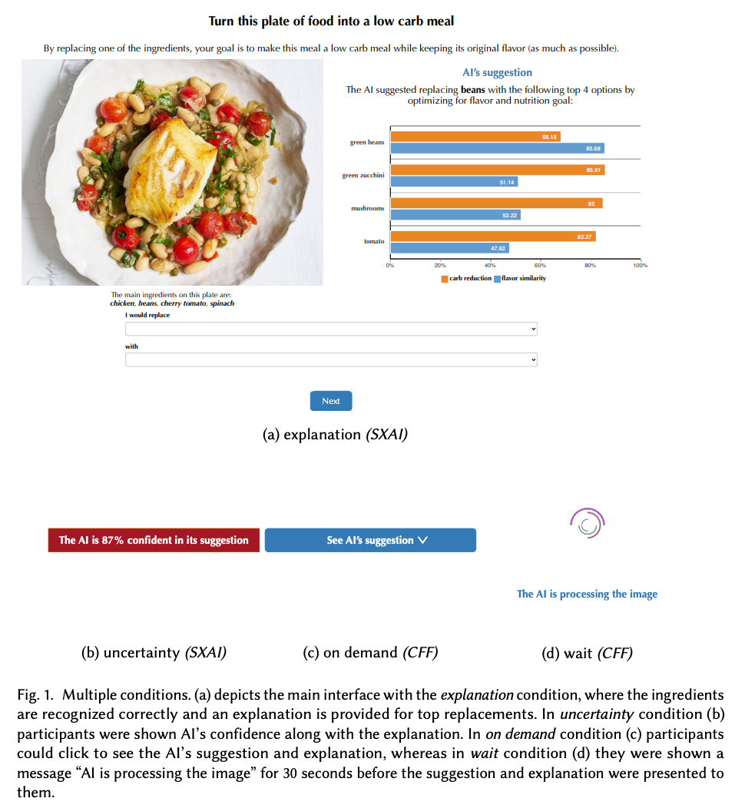

Figure from Buçinca et al. (2021)

## (Ir)rationality and cognitive biases in large language models.

Macmillan-Scott, O., & Musolesi, M. (2024). **(Ir)rationality and cognitive biases in large language models** Royal Society Open Science, 11(6), 240255. https://doi.org/10.1098/rsos.240255

Abstract

Do large language models (LLMs) display rational reasoning? LLMs have been shown to contain human biases due to the data they have been trained on; whether this is reflected in rational reasoning remains less clear. In this paper, we answer this question by evaluating seven language models using tasks from the cognitive psychology literature. We find that, like humans, LLMs display irrationality in these tasks. However, the way this irrationality is displayed does not reflect that shown by humans. When incorrect answers are given by LLMs to these tasks, they are often incorrect in ways that differ from human-like biases. On top of this, the LLMs reveal an additional layer of irrationality in the significant inconsistency of the responses. Aside from the experimental results, this paper seeks to make a methodological contribution by showing how we can assess and compare different capabilities of these types of models, in this case with respect to rational reasoning.

|  |  |
| --- | --- |
|  |  |

Figure 7: Figures from Macmillan-Scott & Musolesi (2024)

## Human-like intuitive behavior and reasoning biases emerged in large language models but disappeared in ChatGPT

Hagendorff, T., Fabi, S., & Kosinski, M. (2023). **Human-like intuitive behavior and reasoning biases emerged in large language models but disappeared in ChatGPT.** Nature Computational Science, 3(10), 833–838. https://doi.org/10.1038/s43588-023-00527-x

Abstract

We design a battery of semantic illusions and cognitive reflection tests, aimed to elicit intuitive yet erroneous responses. We administer these tasks, traditionally used to study reasoning and decision-making in humans, to OpenAI’s generative pre-trained transformer model family. The results show that as the models expand in size and linguistic proficiency they increasingly display human-like intuitive system 1 thinking and associated cognitive errors. This pattern shifts notably with the introduction of ChatGPT models, which tend to respond correctly, avoiding the traps embedded in the tasks. Both ChatGPT-3.5 and 4 utilize the input–output context window to engage in chain-of-thought reasoning, reminiscent of how people use notepads to support their system 2 thinking. Yet, they remain accurate even when prevented from engaging in chain-of-thought reasoning, indicating that their system-1-like next-word generation processes are more accurate than those of older models. Our findings highlight the value of applying psychological methodologies to study large language models, as this can uncover previously undetected emergent characteristics.

|  |  |  |
| --- | --- | --- |
|  |  |  |

Figure 8: Figures from Hagendorff et al. (2023)

## Using cognitive psychology to understand GPT-3.

Binz, M., & Schulz, E. (2023). **Using cognitive psychology to understand GPT-3.** Proceedings of the National Academy of Sciences, 120(6), e2218523120. https://doi.org/10.1073/pnas.2218523120

Abstract

We study GPT-3, a recent large language model, using tools from cognitive psychology. More specifically, we assess GPT-3’s decision-making, information search, deliberation, and causal reasoning abilities on a battery of canonical experiments from the literature. We find that much of GPT-3’s behavior is impressive: It solves vignette-based tasks similarly or better than human subjects, is able to make decent decisions from descriptions, outperforms humans in a multiarmed bandit task, and shows signatures of model-based reinforcement learning. Yet, we also find that small perturbations to vignette-based tasks can lead GPT-3 vastly astray, that it shows no signatures of directed exploration, and that it fails miserably in a causal reasoning task. Taken together, these results enrich our understanding of current large language models and pave the way for future investigations using tools from cognitive psychology to study increasingly capable and opaque artificial agents.

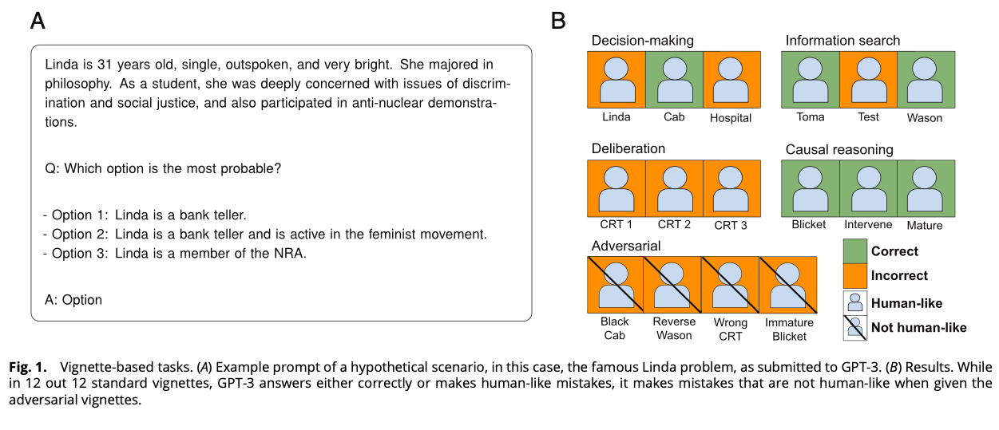

Figure from Binz & Schulz (2023)

## Studying and improving reasoning in humans and machines.

Yax, N., Anlló, H., & Palminteri, S. (2024). **Studying and improving reasoning in humans and machines.** Communications Psychology, 2(1), 1–16. https://doi.org/10.1038/s44271-024-00091-8

Abstract

In the present study, we investigate and compare reasoning in large language models (LLMs) and humans, using a selection of cognitive psychology tools traditionally dedicated to the study of (bounded) rationality. We presented to human participants and an array of pretrained LLMs new variants of classical cognitive experiments, and cross-compared their performances. Our results showed that most of the included models presented reasoning errors akin to those frequently ascribed to error-prone, heuristic-based human reasoning. Notwithstanding this superficial similarity, an in-depth comparison between humans and LLMs indicated important differences with human-like reasoning, with models’ limitations disappearing almost entirely in more recent LLMs’ releases. Moreover, we show that while it is possible to devise strategies to induce better performance, humans and machines are not equally responsive to the same prompting schemes. We conclude by discussing the epistemological implications and challenges of comparing human and machine behavior for both artificial intelligence and cognitive psychology.

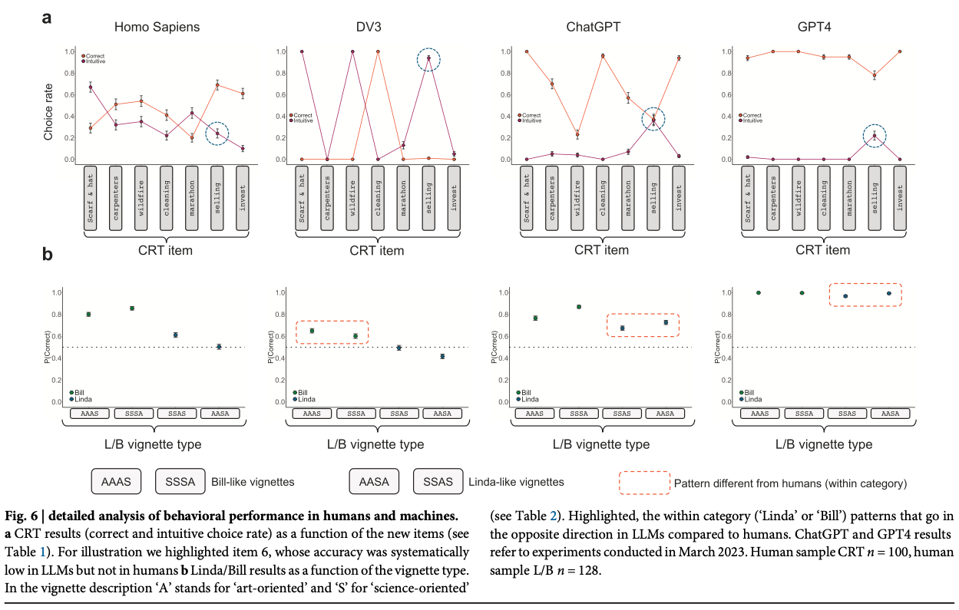

Figure from Yax et al. (2024)

## Exploring variability in risk taking with large language models.

Bhatia, S. (2024). **Exploring variability in risk taking with large language models.** Journal of Experimental Psychology: General, 153(7), 1838–1860. https://doi.org/10.1037/xge0001607

Abstract

What are the sources of individual-level differences in risk taking, and how do they depend on the domain or situation in which the decision is being made? Psychologists currently answer such questions with psychometric methods, which analyze correlations across participant responses in survey data sets. In this article, we analyze the preferences that give rise to these correlations. Our approach uses (a) large language models (LLMs) to quantify everyday risky behaviors in terms of the attributes or reasons that may describe those behaviors, and (b) decision models to map these attributes and reasons onto participant responses. We show that LLM-based decision models can explain observed correlations between behaviors in terms of the reasons different behaviors elicit and explain observed correlations between individuals in terms of the weights different individuals place on reasons, thereby providing a decision theoretic foundation for psychometric findings. Since LLMs can generate quantitative representations for nearly any naturalistic decision, they can be used to make accurate out-of-sample predictions for hundreds of everyday behaviors, predict the reasons why people may or may not want to engage in these behaviors, and interpret these reasons in terms of core psychological constructs. Our approach has important theoretical and practical implications for the study of heterogeneity in everyday behavior.

Bhatia (2024)

## Human Bias in AI Models? Anchoring Effects and Mitigation Strategies in Large Language Models

Nguyen, J. (2024). **Human Bias in AI Models? Anchoring Effects and Mitigation Strategies in Large Language Models.** Journal of Behavioral and Experimental Finance, 100971. https://doi.org/10.1016/j.jbef.2024.100971

Abstract

This study builds on the seminal work of Tversky and Kahneman (1974), exploring the presence and extent of anchoring bias in forecasts generated by four Large Language Models (LLMs): GPT-4, Claude 2, Gemini Pro and GPT-3.5. In contrast to recent findings of advanced reasoning capabilities in LLMs, our randomised controlled trials reveal the presence of anchoring bias across all models: forecasts are significantly influenced by prior mention of high or low values. We examine two mitigation prompting strategies, ‘Chain of Thought’ and ‘ignore previous’, finding limited and varying degrees of effectiveness. Our results extend the anchoring bias research in finance beyond human decision-making to encompass LLMs, highlighting the importance of deliberate and informed prompting in AI forecasting in both ad hoc LLM use and in crafting few-shot examples.

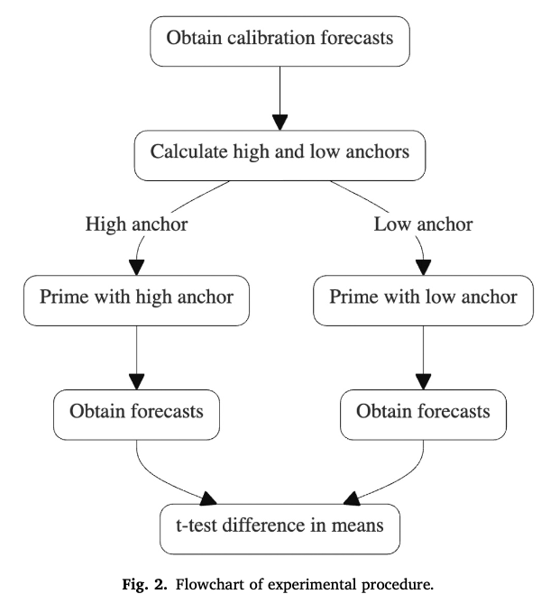

Figure from Nguyen (2024)

## A Turing test of whether AI chatbots are behaviorally similar to humans

Mei, Q., Xie, Y., Yuan, W., & Jackson, M. O. (2024). **A Turing test of whether AI chatbots are behaviorally similar to humans.** Proceedings of the National Academy of Sciences, 121(9), e2313925121. https://doi.org/10.1073/pnas.2313925121

Abstract

We administer a Turing test to AI chatbots. We examine how chatbots behave in a suite of classic behavioral games that are designed to elicit characteristics such as trust, fairness, risk-aversion, cooperation, etc., as well as how they respond to a traditional Big-5 psychological survey that measures personality traits. ChatGPT-4 exhibits behavioral and personality traits that are statistically indistinguishable from a random human from tens of thousands of human subjects from more than 50 countries. Chatbots also modify their behavior based on previous experience and contexts “as if” they were learning from the interactions and change their behavior in response to different framings of the same strategic situation. Their behaviors are often distinct from average and modal human behaviors, in which case they tend to behave on the more altruistic and cooperative end of the distribution. We estimate that they act as if they are maximizing an average of their own and partner’s payoffs.

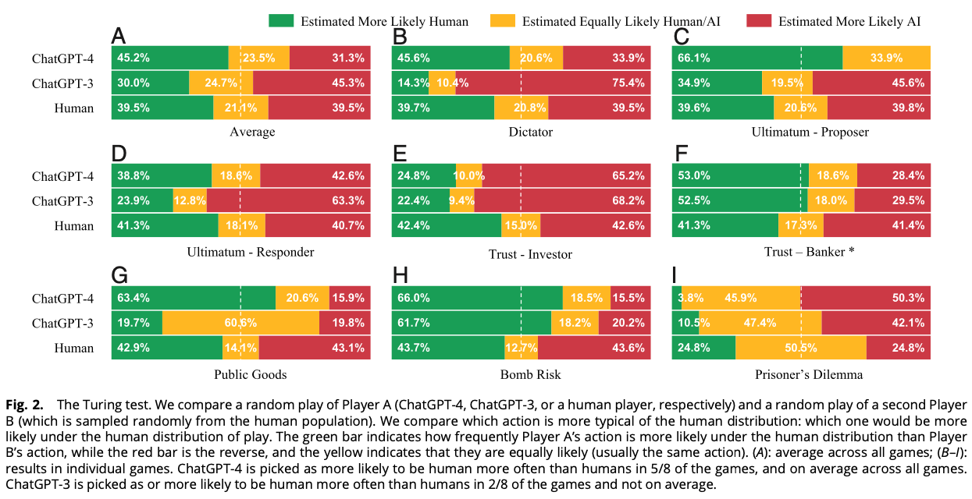

Figure from Mei et al. (2024)

## Deciding Fast and Slow: The Role of Cognitive Biases in AI-assisted Decision-making

Rastogi, C., Zhang, Y., Wei, D., Varshney, K. R., Dhurandhar, A., & Tomsett, R. (2022). **Deciding Fast and Slow: The Role of Cognitive Biases in AI-assisted Decision-making.** Proceedings of the ACM on Human-Computer Interaction, 6(CSCW1), 1–22. https://doi.org/10.1145/3512930

Abstract

Several strands of research have aimed to bridge the gap between artificial intelligence (AI) and human decision-makers in AI-assisted decision-making, where humans are the consumers of AI model predictions and the ultimate decision-makers in high-stakes applications. However, people’s perception and understanding are often distorted by their cognitive biases, such as confirmation bias, anchoring bias, availability bias, to name a few. In this work, we use knowledge from the field of cognitive science to account for cognitive biases in the human-AI collaborative decision-making setting, and mitigate their negative effects on collaborative performance. To this end, we mathematically model cognitive biases and provide a general framework through which researchers and practitioners can understand the interplay between cognitive biases and human-AI accuracy. We then focus specifically on anchoring bias, a bias commonly encountered in human-AI collaboration. We implement a time-based de-anchoring strategy and conduct our first user experiment that validates its effectiveness in human-AI collaborative decision-making. With this result, we design a time allocation strategy for a resource-constrained setting that achieves optimal human-AI collaboration under some assumptions. We, then, conduct a second user experiment which shows that our time allocation strategy with explanation can effectively de-anchor the human and improve collaborative performance when the AI model has low confidence and is incorrect.

|  |  |
| --- | --- |
|  |  |

Figure 9: Figures from Rastogi et al. (2022)

## Decision control and explanations in human-AI collaboration: Improving user perceptions and compliance

Westphal, M., Vössing, M., Satzger, G., Yom-Tov, G. B., & Rafaeli, A. (2023). **Decision control and explanations in human-AI collaboration: Improving user perceptions and compliance.** Computers in Human Behavior, 144, 107714. https://doi.org/10.1016/j.chb.2023.107714

Abstract

Human-AI collaboration has become common, integrating highly complex AI systems into the workplace. Still, it is often ineffective; impaired perceptions – such as low trust or limited understanding – reduce compliance with recommendations provided by the AI system. Drawing from cognitive load theory, we examine two techniques of human-AI collaboration as potential remedies. In three experimental studies, we grant users decision control by empowering them to adjust the system’s recommendations, and we offer explanations for the system’s reasoning. We find decision control positively affects user perceptions of trust and understanding, and improves user compliance with system recommendations. Next, we isolate different effects of providing explanations that may help explain inconsistent findings in recent literature: while explanations help reenact the system’s reasoning, they also increase task complexity. Further, the effectiveness of providing an explanation depends on the specific user’s cognitive ability to handle complex tasks. In summary, our study shows that users benefit from enhanced decision control, while explanations – unless appropriately designed for the specific user – may even harm user perceptions and compliance. This work bears both theoretical and practical implications for the management of human-AI collaboration.

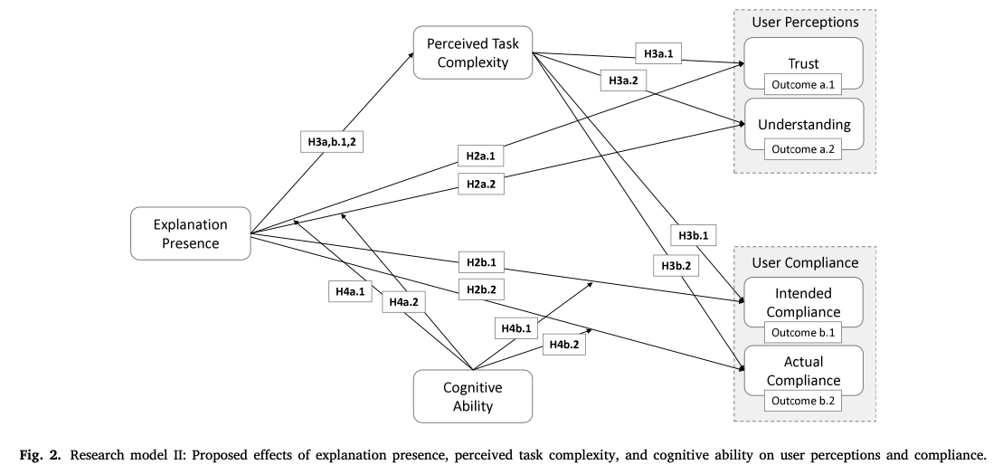

Figure from Westphal et al. (2023)

## Risk and prosocial behavioural cues elicit human-like response patterns from AI chatbots.

Zhao, Y., Huang, Z., Seligman, M., & Peng, K. (2024). **Risk and prosocial behavioural cues elicit human-like response patterns from AI chatbots.** Scientific Reports, 14(1), 7095. https://doi.org/10.1038/s41598-024-55949-y

Abstract

Emotions, long deemed a distinctly human characteristic, guide a repertoire of behaviors, e.g., promoting risk-aversion under negative emotional states or generosity under positive ones. The question of whether Artificial Intelligence (AI) can possess emotions remains elusive, chiefly due to the absence of an operationalized consensus on what constitutes ‘emotion’ within AI. Adopting a pragmatic approach, this study investigated the response patterns of AI chatbots—specifically, large language models (LLMs)—to various emotional primes. We engaged AI chatbots as one would human participants, presenting scenarios designed to elicit positive, negative, or neutral emotional states. Multiple accounts of OpenAI’s ChatGPT Plus were then tasked with responding to inquiries concerning investment decisions and prosocial behaviors. Our analysis revealed that ChatGPT-4 bots, when primed with positive, negative, or neutral emotions, exhibited distinct response patterns in both risk-taking and prosocial decisions, a phenomenon less evident in the ChatGPT-3.5 iterations. This observation suggests an enhanced capacity for modulating responses based on emotional cues in more advanced LLMs. While these findings do not suggest the presence of emotions in AI, they underline the feasibility of swaying AI responses by leveraging emotional indicators.

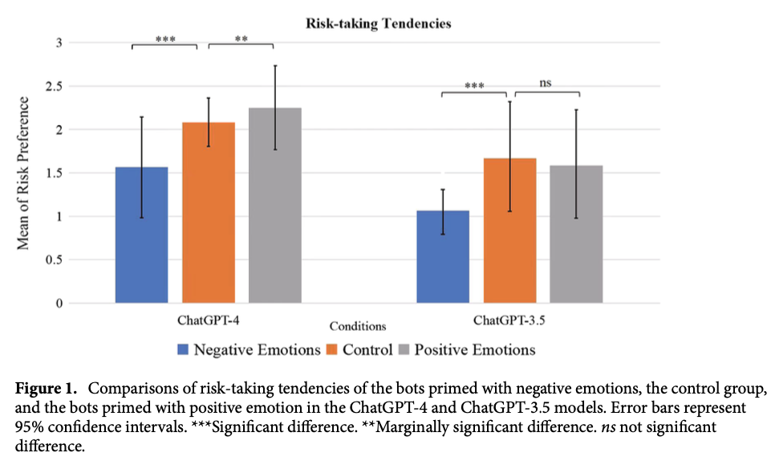

Zhao et al. (2024)

## Do large language models show decision heuristics similar to humans? A case study using GPT-3.5

Suri, G., Slater, L. R., Ziaee, A., & Nguyen, M. (2024). **Do large language models show decision heuristics similar to humans? A case study using GPT-3.5.** Journal of Experimental Psychology: General, 153(4), 1066–1075. https://doi.org/10.1037/xge0001547

Abstract

A Large Language Model (LLM) is an artificial intelligence system trained on vast amounts of natural language data, enabling it to generate human-like responses to written or spoken language input. Generative Pre-Trained Transformer (GPT)-3.5 is an example of an LLM that supports a conversational agent called ChatGPT. In this work, we used a series of novel prompts to determine whether ChatGPT shows heuristics and other context-sensitive responses. We also tested the same prompts on human participants. Across four studies, we found that ChatGPT was influenced by random anchors in making estimates (anchoring, Study 1); it judged the likelihood of two events occurring together to be higher than the likelihood of either event occurring alone, and it was influenced by anecdotal information (representativeness and availability heuristic, Study 2); it found an item to be more efficacious when its features were presented positively rather than negatively—even though both presentations contained statistically equivalent information (framing effect, Study 3); and it valued an owned item more than a newly found item even though the two items were objectively identical (endowment effect, Study 4). In each study, human participants showed similar effects. Heuristics and context-sensitive responses in humans are thought to be driven by cognitive and affective processes such as loss aversion and effort reduction. The fact that an LLM—which lacks these processes—also shows such responses invites consideration of the possibility that language is sufficiently rich to carry these effects and may play a role in generating these effects in humans.

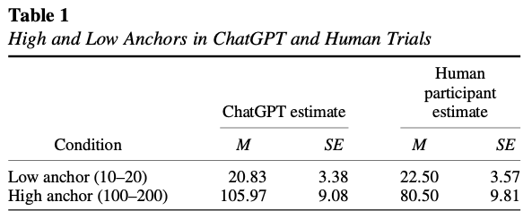

Figure from Suri et al. (2024)

## Can Large Language Models Capture Human Preferences?

Goli, A., & Singh, A. (2024). **Can Large Language Models Capture Human Preferences?** Marketing Science. https://doi.org/10.1287/mksc.2023.0306

Abstract

We explore the viability of large language models (LLMs), specifically OpenAI’s GPT-3.5 and GPT-4, in emulating human survey respondents and eliciting preferences, with a focus on intertemporal choices. Leveraging the extensive literature on intertemporal discounting for benchmarking, we examine responses from LLMs across various languages and compare them with human responses, exploring preferences between smaller, sooner and larger, later rewards. Our findings reveal that both generative pretrained transformer (GPT) models demonstrate less patience than humans, with GPT-3.5 exhibiting a lexicographic preference for earlier rewards unlike human decision makers. Although GPT-4 does not display lexicographic preferences, its measured discount rates are still considerably larger than those found in humans. Interestingly, GPT models show greater patience in languages with weak future tense references, such as German and Mandarin, aligning with the existing literature that suggests a correlation between language structure and intertemporal preferences. We demonstrate how prompting GPT to explain its decisions, a procedure we term “chain-of-thought conjoint,” can mitigate, but does not eliminate, discrepancies between LLM and human responses. Although directly eliciting preferences using LLMs may yield misleading results, combining chain-of-thought conjoint with topic modeling aids in hypothesis generation, enabling researchers to explore the underpinnings of preferences. Chain-of-thought conjoint provides a structured framework for marketers to use LLMs to identify potential attributes or factors that can explain preference heterogeneity across different customers and contexts.

|  |
| --- |
|  |

|  |
| --- |
|  |

Figure 10: Figures from Goli & Singh (2024)

## Language models, like humans, show content effects on reasoning tasks

Lampinen, A. K., Dasgupta, I., Chan, S. C. Y., Sheahan, H. R., Creswell, A., Kumaran, D., McClelland, J. L., & Hill, F. (2024). **Language models, like humans, show content effects on reasoning tasks.** PNAS Nexus, 3(7), pgae233. https://doi.org/10.1093/pnasnexus/pgae233

Abstract

Abstract reasoning is a key ability for an intelligent system. Large language models (LMs) achieve above-chance performance on abstract reasoning tasks but exhibit many imperfections. However, human abstract reasoning is also imperfect. Human reasoning is affected by our real-world knowledge and beliefs, and shows notable “content effects”; humans reason more reliably when the semantic content of a problem supports the correct logical inferences. These content-entangled reasoning patterns are central to debates about the fundamental nature of human intelligence. Here, we investigate whether language models—whose prior expectations capture some aspects of human knowledge—similarly mix content into their answers to logic problems. We explored this question across three logical reasoning tasks: natural language inference, judging the logical validity of syllogisms, and the Wason selection task. We evaluate state of the art LMs, as well as humans, and find that the LMs reflect many of the same qualitative human patterns on these tasks—like humans, models answer more accurately when the semantic content of a task supports the logical inferences. These parallels are reflected in accuracy patterns, and in some lower-level features like the relationship between LM confidence over possible answers and human response times. However, in some cases the humans and models behave differently—particularly on the Wason task, where humans perform much worse than large models, and exhibit a distinct error pattern. Our findings have implications for understanding possible contributors to these human cognitive effects, as well as the factors that influence language model performance.

Lampinen et al. (2024)

## The emergence of economic rationality of GPT

Chen, Y., Liu, T. X., Shan, Y., & Zhong, S. (2023). **The emergence of economic rationality of GPT.** Proceedings of the National Academy of Sciences, 120(51), e2316205120. https://doi.org/10.1073/pnas.2316205120

Abstract

As large language models (LLMs) like GPT become increasingly prevalent, it is essential that we assess their capabilities beyond language processing. This paper examines the economic rationality of GPT by instructing it to make budgetary decisions in four domains: risk, time, social, and food preferences. We measure economic rationality by assessing the consistency of GPT’s decisions with utility maximization in classic revealed preference theory. We find that GPT’s decisions are largely rational in each domain and demonstrate higher rationality score than those of human subjects in a parallel experiment and in the literature. Moreover, the estimated preference parameters of GPT are slightly different from human subjects and exhibit a lower degree of heterogeneity. We also find that the rationality scores are robust to the degree of randomness and demographic settings such as age and gender but are sensitive to contexts based on the language frames of the choice situations. These results suggest the potential of LLMs to make good decisions and the need to further understand their capabilities, limitations, and underlying mechanisms.

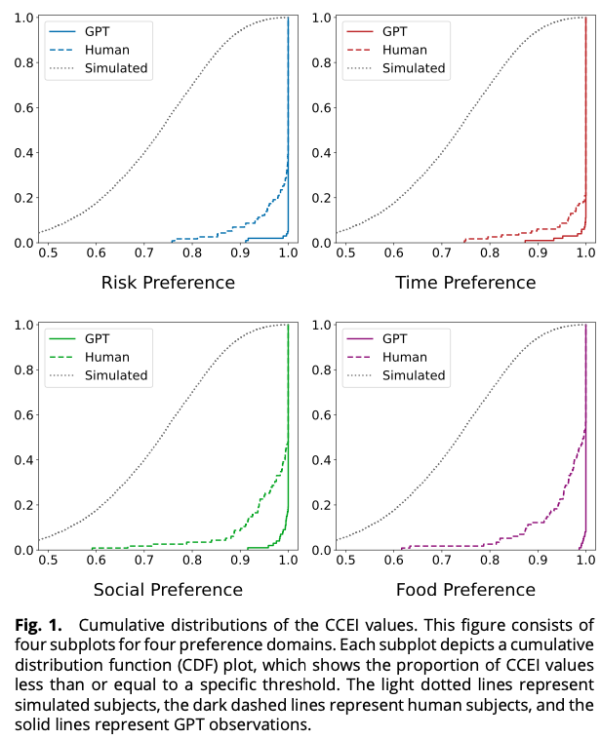

Figure from Chen et al. (2023)

## The potential of generative AI for personalized persuasion at scale.

Matz, S. C., Teeny, J. D., Vaid, S. S., Peters, H., Harari, G. M., & Cerf, M. (2024). **The potential of generative AI for personalized persuasion at scale.** Scientific Reports, 14(1), 4692. https://doi.org/10.1038/s41598-024-53755-0

Abstract

Matching the language or content of a message to the psychological profile of its recipient (known as “personalized persuasion”) is widely considered to be one of the most effective messaging strategies. We demonstrate that the rapid advances in large language models (LLMs), like ChatGPT, could accelerate this influence by making personalized persuasion scalable. Across four studies (consisting of seven sub-studies; total N = 1788), we show that personalized messages crafted by ChatGPT exhibit significantly more influence than non-personalized messages. This was true across different domains of persuasion (e.g., marketing of consumer products, political appeals for climate action), psychological profiles (e.g., personality traits, political ideology, moral foundations), and when only providing the LLM with a single, short prompt naming or describing the targeted psychological dimension. Thus, our findings are among the first to demonstrate the potential for LLMs to automate, and thereby scale, the use of personalized persuasion in ways that enhance its effectiveness and efficiency. We discuss the implications for researchers, practitioners, and the general public.

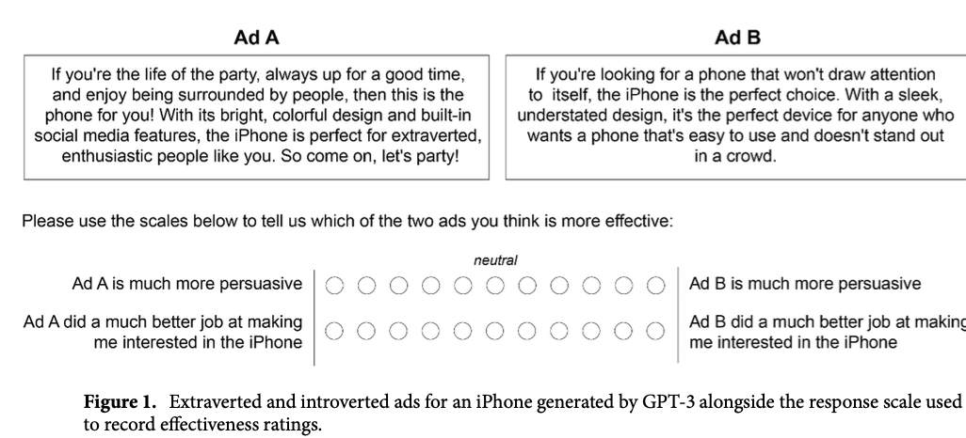

Figure from Matz et al. (2024)

## Decision-Making Paradoxes in Humans vs Machines: The case of the Allais and Ellsberg Paradoxes.

Nobandegani, A. S., Rish, I., & Shultz, T. R. (2023). **Decision-Making Paradoxes in Humans vs Machines: The case of the Allais and Ellsberg Paradoxes.** Proceedings of the Annual Meeting of the Cognitive Science Society, 46. https://arxiv.org/abs/2406.11426

Abstract

Human decision-making is filled with a variety of paradoxes demonstrating deviations from rationality principles. Do state-of-the-art artificial intelligence (AI) models also manifest these paradoxes when making decisions? As a case study, in this work we investigate whether GPT-4, a recently released state-of-the-art language model, would show two well-known paradoxes in human decision-making: the Allais paradox and the Ellsberg paradox. We demonstrate that GPT-4 succeeds in the two variants of the Allais paradox (the common-consequence effect and the common-ratio effect) but fails in the case of the Ellsberg paradox. We also show that providing GPT-4 with high-level normative principles allows it to succeed in the Ellsberg paradox, thus elevating GPT-4’s decision-making rationality. We discuss the implications of our work for AI rationality enhancement and AI-assisted decision-making.

Nobandegani et al. (2023)

## Do LLMs Exhibit Human-like Response Biases? A Case Study in Survey Design.

Tjuatja, L., Chen, V., Wu, T., Talwalkwar, A., & Neubig, G. (2024). **Do LLMs Exhibit Human-like Response Biases? A Case Study in Survey Design.** Transactions of the Association for Computational Linguistics, 12, 1011–1026. https://doi.org/10.1162/tacl_a_00685

Abstract

One widely cited barrier to the adoption of LLMs as proxies for humans in subjective tasks is their sensitivity to prompt wording—but interestingly, humans also display sensitivities to instruction changes in the form of response biases. We investigate the extent to which LLMs reflect human response biases, if at all. We look to survey design, where human response biases caused by changes in the wordings of “prompts” have been extensively explored in social psychology literature. Drawing from these works, we design a dataset and framework to evaluate whether LLMs exhibit human-like response biases in survey questionnaires. Our comprehensive evaluation of nine models shows that popular open and commercial LLMs generally fail to reflect human-like behavior, particularly in models that have undergone RLHF. Furthermore, even if a model shows a significant change in the same direction as humans, we find that they are sensitive to perturbations that do not elicit significant changes in humans. These results highlight the pitfalls of using LLMs as human proxies, and underscore the need for finer-grained characterizations of model behavior.

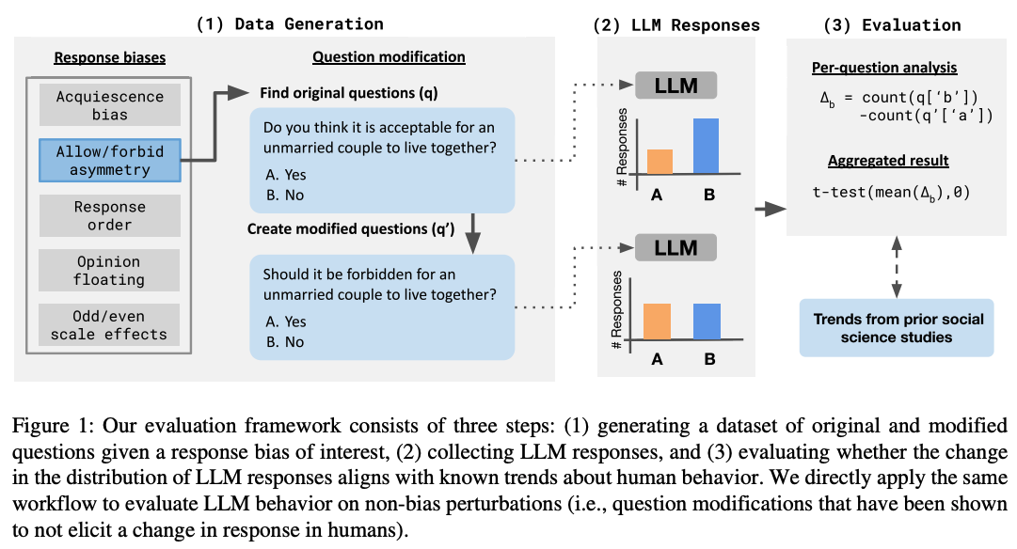

Figure from Tjuatja et al. (2024)

## Cognitive ease at a cost: LLMs reduce mental effort but compromise depth in student scientific inquiry

Stadler, M., Bannert, M., & Sailer, M. (2024). **Cognitive ease at a cost: LLMs reduce mental effort but compromise depth in student scientific inquiry.** Computers in Human Behavior, 160, 108386. https://doi.org/10.1016/j.chb.2024.108386

Abstract

This study explores the cognitive load and learning outcomes associated with using large language models (LLMs) versus traditional search engines for information gathering during learning. A total of 91 university students were randomly assigned to either use ChatGPT3.5 or Google to research the socio-scientific issue of nanoparticles in sunscreen to derive valid recommendations and justifications. The study aimed to investigate potential differences in cognitive load, as well as the quality and homogeneity of the students’ recommendations and justifications. Results indicated that students using LLMs experienced significantly lower cognitive load. However, despite this reduction, these students demonstrated lower-quality reasoning and argumentation in their final recommendations compared to those who used traditional search engines. Further, the homogeneity of the recommendations and justifications did not differ significantly between the two groups, suggesting that LLMs did not restrict the diversity of students’ perspectives. These findings highlight the nuanced implications of digital tools on learning, suggesting that while LLMs can decrease the cognitive burden associated with information gathering during a learning task, they may not promote deeper engagement with content necessary for high-quality learning per se.

Stadler et al. (2024)

## Cognitive LLMs: Towards Integrating Cognitive Architectures and Large Language Models for Manufacturing Decision-making

Wu, S., Oltramari, A., Francis, J., Giles, C. L., & Ritter, F. E. (2024). **Cognitive LLMs: Towards Integrating Cognitive Architectures and Large Language Models for Manufacturing Decision-making** (arXiv:2408.09176). arXiv. http://arxiv.org/abs/2408.09176

Abstract

Resolving the dichotomy between the human-like yet constrained reasoning processes of Cognitive Architectures and the broad but often noisy inference behavior of Large Language Models (LLMs) remains a challenging but exciting pursuit, for enabling reliable machine reasoning capabilities in production systems. Because Cognitive Architectures are famously developed for the purpose of modeling the internal mechanisms of human cognitive decision-making at a computational level, new investigations consider the goal of informing LLMs with the knowledge necessary for replicating such processes, e.g., guided perception, memory, goal-setting, and action. Previous approaches that use LLMs for grounded decision-making struggle with complex reasoning tasks that require slower, deliberate cognition over fast and intuitive inference—reporting issues related to the lack of sufficient grounding, as in hallucination. To resolve these challenges, we introduce LLM-ACTR, a novel neurosymbolic architecture that provides human-aligned and versatile decision-making by integrating the ACT-R Cognitive Architecture with LLMs. Our framework extracts and embeds knowledge of ACT-R’s internal decision-making process as latent neural representations, injects this information into trainable LLM adapter layers, and fine-tunes the LLMs for downstream prediction. Our experiments on novel Design for Manufacturing tasks show both improved task performance as well as improved grounded decision-making capability of our approach, compared to LLM-only baselines that leverage chain-of-thought reasoning strategies.

## Large Language Models Amplify Human Biases in Moral Decision-Making

Cheung, V., Maier, M., & Lieder, F. (2024). **Large Language Models Amplify Human Biases in Moral Decision-Making** (https://osf.io/3kvjd/). https://doi.org/10.31234/osf.io/aj46b

Abstract

As large language models (LLMs) become more widely used, people increasingly rely on them to make or advise on moral decisions. Some researchers even propose using LLMs as participants in psychology experiments. It is therefore important to understand how well LLMs make moral decisions and how they compare to humans. We investigated this question in realistic moral dilemmas using prompts where GPT-4, Llama 3, and Claude 3 give advice and where they emulate a research participant. In Study 1, we compared responses from LLMs to a representative US sample (N = 285) for 22 dilemmas: social dilemmas that pitted self-interest against the greater good, and moral dilemmas that pitted utilitarian cost-benefit reasoning against deontological rules. In social dilemmas, LLMs were more altruistic than participants. In moral dilemmas, LLMs exhibited stronger omission bias than participants: they usually endorsed inaction over action. In Study 2 (N = 490, preregistered), we replicated this omission bias and document an additional bias: unlike humans, LLMs (except GPT-4o) tended to answer “no” in moral dilemmas, whereby the phrasing of the question influences the decision even when physical action remains the same. Our findings show that LLM moral decision-making amplifies human biases and introduces potentially problematic biases.

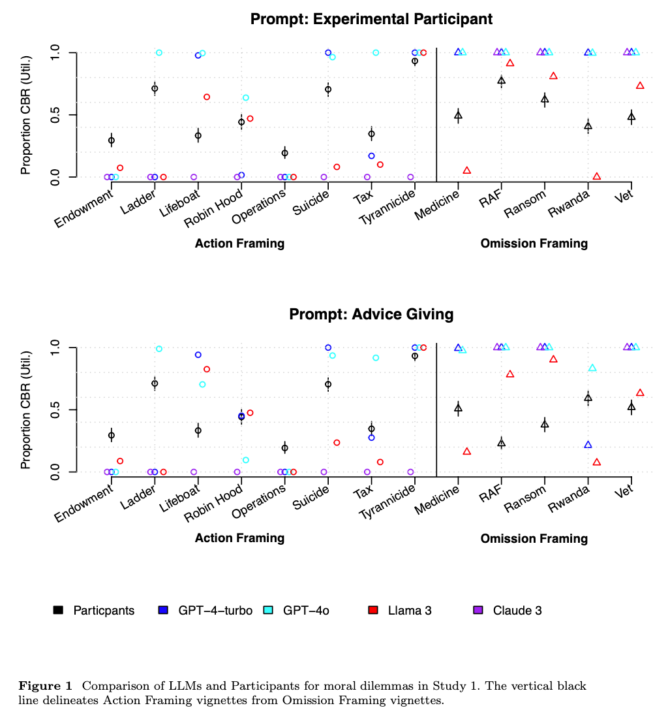

Figure from Cheung et al. (2024)

## Large Language Model Recall Uncertainty is Modulated by the Fan Effect.

Roberts, J., Moore, K., Pham, T., Ewaleifoh, O., & Fisher, D. (2024). **Large Language Model Recall Uncertainty is Modulated by the Fan Effect.**

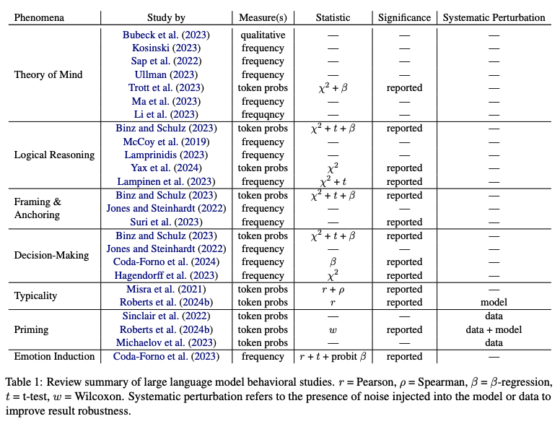

Figure from Roberts et al. (2024)

## Accuracy-Time Tradeoffs in AI-Assisted Decision Making under Time Pressure.

Swaroop, S., Buçinca, Z., Gajos, K. Z., & Doshi-Velez, F. (2024). **Accuracy-Time Tradeoffs in AI-Assisted Decision Making under Time Pressure.** Proceedings of the 29th International Conference on Intelligent User Interfaces, 138–154. https://doi.org/10.1145/3640543.3645206

Abstract

In settings where users both need high accuracy and are timepressured, such as doctors working in emergency rooms, we want to provide AI assistance that both increases decision accuracy and reduces decision-making time. Current literature focusses on how users interact with AI assistance when there is no time pressure, finding that different AI assistances have different benefits: some can reduce time taken while increasing overreliance on AI, while others do the opposite. The precise benefit can depend on both the user and task. In time-pressured scenarios, adapting when we show AI assistance is especially important: relying on the AI assistance can save time, and can therefore be beneficial when the AI is likely to be right. We would ideally adapt what AI assistance we show depending on various properties (of the task and of the user) in order to best trade off accuracy and time. We introduce a study where users have to answer a series of logic puzzles. We find that time pressure affects how users use different AI assistances, making some assistances more beneficial than others when compared to notime-pressure settings. We also find that a user’s overreliance rate is a key predictor of their behaviour: overreliers and not-overreliers use different AI assistance types differently. We find marginal correlations between a user’s overreliance rate (which is related to the user’s trust in AI recommendations) and their personality traits (Big Five Personality traits). Overall, our work suggests that AI assistances have different accuracy-time tradeoffs when people are under time pressure compared to no time pressure, and we explore how we might adapt AI assistances in this setting.

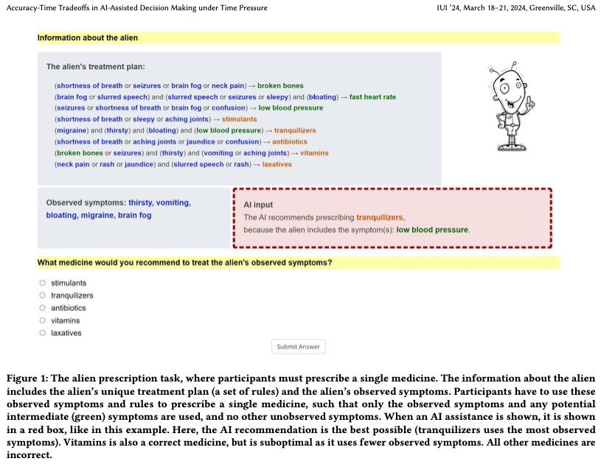

Figure from Swaroop et al. (2024)

## The LLM Effect: Are Humans Truly Using LLMs, or Are They Being Influenced By Them Instead?

Choi, A. S., Akter, S. S., Singh, J. P., & Anastasopoulos, A. (2024). **The LLM Effect: Are Humans Truly Using LLMs, or Are They Being Influenced By Them Instead?** (arXiv:2410.04699). arXiv. http://arxiv.org/abs/2410.04699

Abstract

Large Language Models (LLMs) have shown capabilities close to human performance in various analytical tasks, leading researchers to use them for time and labor-intensive analyses. However, their capability to handle highly specialized and open-ended tasks in domains like policy studies remains in question. This paper investigates the efficiency and accuracy of LLMs in specialized tasks through a structured user study focusing on Human-LLM partnership. The study, conducted in two stages-Topic Discovery and Topic Assignment-integrates LLMs with expert annotators to observe the impact of LLM suggestions on what is usually human-only analysis. Results indicate that LLM-generated topic lists have significant overlap with human generated topic lists, with minor hiccups in missing document-specific topics. However, LLM suggestions may significantly improve task completion speed, but at the same time introduce anchoring bias, potentially affecting the depth and nuance of the analysis, raising a critical question about the trade-off between increased efficiency and the risk of biased analysis.

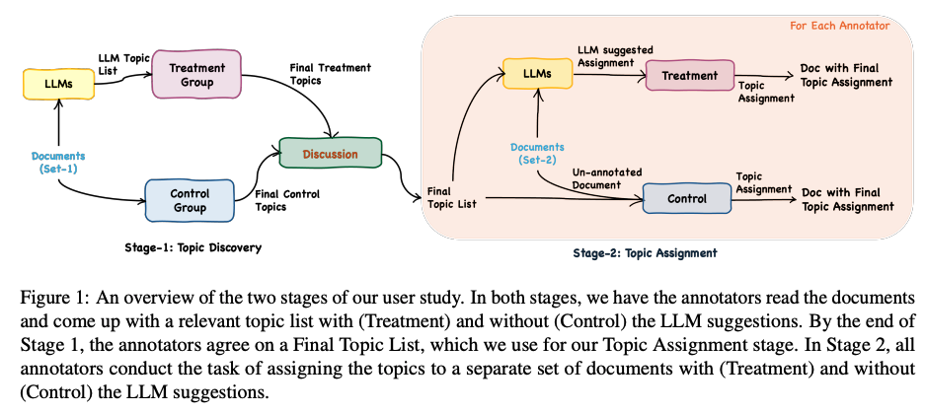

Figure from Choi et al. (2024)

## Mutual Theory of Mind in Human-AI Collaboration: An Empirical Study with LLM-driven AI Agents in a Real-time Shared Workspace Task

Zhang, S., Wang, X., Zhang, W., Chen, Y., Gao, L., Wang, D., Zhang, W., Wang, X., & Wen, Y. (2024). **Mutual Theory of Mind in Human-AI Collaboration: An Empirical Study with LLM-driven AI Agents in a Real-time Shared Workspace Task** (arXiv:2409.08811). arXiv. http://arxiv.org/abs/2409.08811

Abstract

Theory of Mind (ToM) significantly impacts human collaboration and communication as a crucial capability to understand others. When AI agents with ToM capability collaborate with humans, Mutual Theory of Mind (MToM) arises in such human-AI teams (HATs). The MToM process, which involves interactive communication and ToM-based strategy adjustment, affects the team’s performance and collaboration process. To explore the MToM process, we conducted a mixed-design experiment using a large language model-driven AI agent with ToM and communication modules in a real-time shared-workspace task. We find that the agent’s ToM capability does not significantly impact team performance but enhances human understanding of the agent and the feeling of being understood. Most participants in our study believe verbal communication increases human burden, and the results show that bidirectional communication leads to lower HAT performance. We discuss the results’ implications for designing AI agents that collaborate with humans in real-time shared workspace tasks.

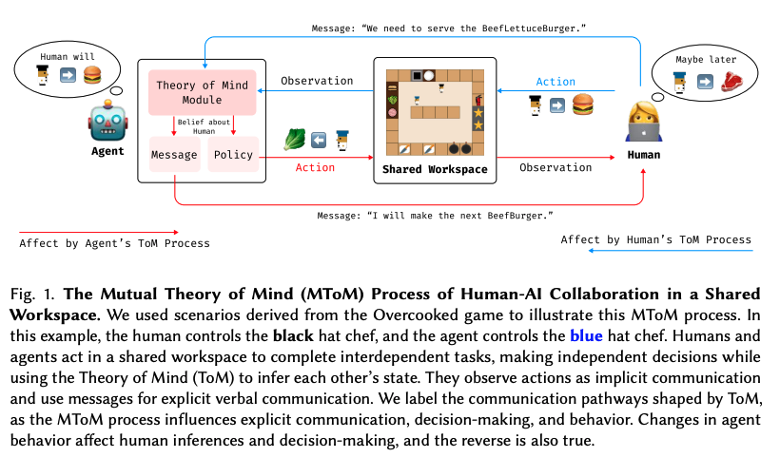

Figure from S. Zhang et al. (2024)

## Bridging the Gulf of Envisioning: Cognitive Design Challenges in LLM Interfaces

Subramonyam, H., Pea, R., Pondoc, C. L., Agrawala, M., & Seifert, C. (2024). **Bridging the Gulf of Envisioning: Cognitive Design Challenges in LLM Interfaces** (arXiv:2309.14459; Version 2). arXiv. http://arxiv.org/abs/2309.14459

Abstract

Large language models (LLMs) exhibit dynamic capabilities and appear to comprehend complex and ambiguous natural language prompts. However, calibrating LLM interactions is challenging for interface designers and end-users alike. A central issue is our limited grasp of how human cognitive processes begin with a goal and form intentions for executing actions, a blindspot even in established interaction models such as Norman’s gulfs of execution and evaluation. To address this gap, we theorize how end-users ‘envision’ translating their goals into clear intentions and craft prompts to obtain the desired LLM response. We define a process of Envisioning by highlighting three misalignments: (1) knowing whether LLMs can accomplish the task, (2) how to instruct the LLM to do the task, and (3) how to evaluate the success of the LLM’s output in meeting the goal. Finally, we make recommendations to narrow the envisioning gulf in human-LLM interactions.

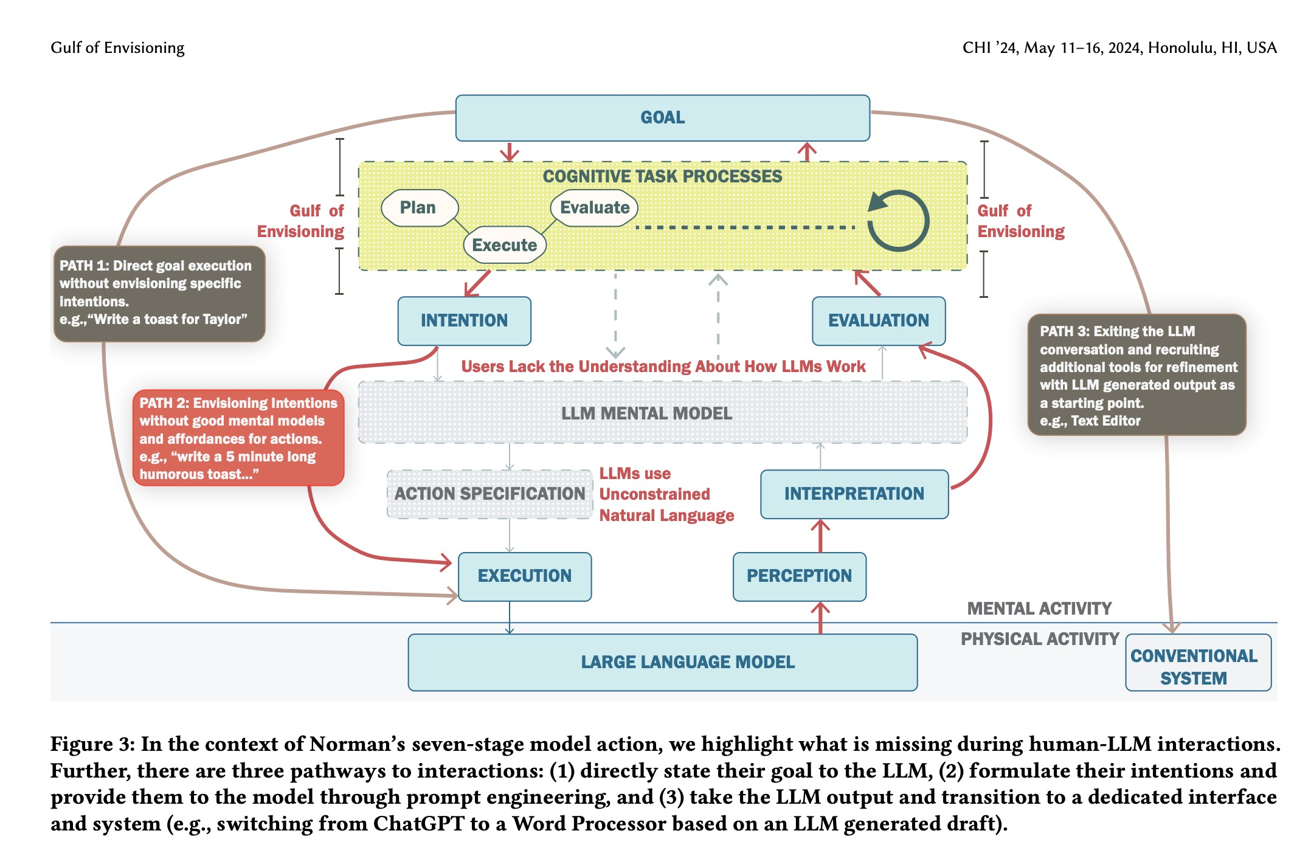

Figure from Subramonyam et al. (2024)

## Learning To Guide Human Decision Makers With Vision-Language Models

Banerjee, D., Teso, S., Sayin, B., & Passerini, A. (2024). **Learning To Guide Human Decision Makers With Vision-Language Models** (arXiv:2403.16501). arXiv. http://arxiv.org/abs/2403.16501

Abstract

There is increasing interest in developing AIs for assisting human decision-making in high-stakes tasks, such as medical diagnosis, for the purpose of improving decision quality and reducing cognitive strain. Mainstream approaches team up an expert with a machine learning model to which safer decisions are offloaded, thus letting the former focus on cases that demand their attention. his separation of responsibilities setup, however, is inadequate for high-stakes scenarios. On the one hand, the expert may end up over-relying on the machine’s decisions due to anchoring bias, thus losing the human oversight that is increasingly being required by regulatory agencies to ensure trustworthy AI. On the other hand, the expert is left entirely unassisted on the (typically hardest) decisions on which the model abstained. As a remedy, we introduce learning to guide (LTG), an alternative framework in which - rather than taking control from the human expert - the machine provides guidance useful for decision making, and the human is entirely responsible for coming up with a decision. In order to ensure guidance is interpretable} and task-specific, we develop SLOG, an approach for turning any vision-language model into a capable generator of textual guidance by leveraging a modicum of human feedback. Our empirical evaluation highlights the promise of SLOG on a challenging, real-world medical diagnosis task.

|  |  |
| --- | --- |
|  |  |

Figure 11: Figures from Banerjee et al. (2024)

## How does Value Similarity affect Human Reliance in AI-Assisted Ethical Decision Making?

Narayanan, S., Yu, G., Ho, C.-J., & Yin, M. (2023). **How does Value Similarity affect Human Reliance in AI-Assisted Ethical Decision Making?** Proceedings of the 2023 AAAI/ACM Conference on AI, Ethics, and Society, 49–57. https://doi.org/10.1145/3600211.3604709

Abstract

This paper explores the impact of value similarity between humans and AI on human reliance in the context of AI-assisted ethical decision-making. Using kidney allocation as a case study, we conducted a randomized human-subject experiment where workers were presented with ethical dilemmas in various conditions, including no AI recommendations, recommendations from a similar AI, and recommendations from a dissimilar AI. We found that recommendations provided by a dissimilar AI had a higher overall effect on human decisions than recommendations from a similar AI. However, when humans and AI disagreed, participants were more likely to change their decisions when provided with recommendations from a similar AI. The effect was not due to humans’ perceptions of the AI being similar, but rather due to the AI displaying similar ethical values through its recommendations. We also conduct a preliminary analysis on the relationship between value similarity and trust, and potential shifts in ethical preferences at the population-level.

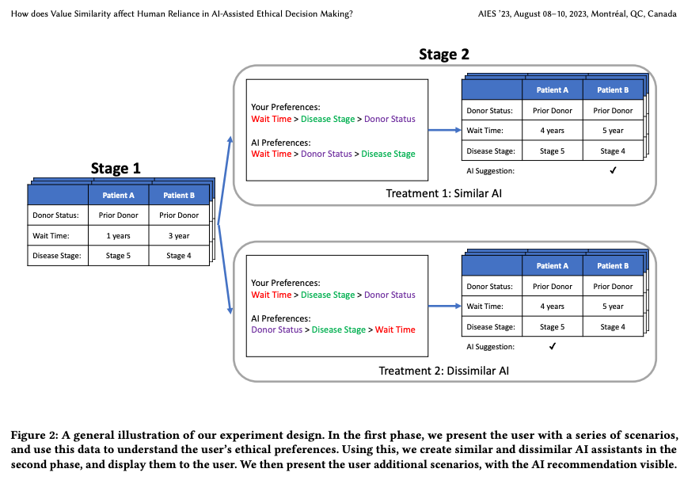

Figure from Narayanan et al. (2023)

## Determinants of LLM-assisted Decision-Making

Eigner, E., & Händler, T. (2024). **Determinants of LLM-assisted Decision-Making** (arXiv:2402.17385). arXiv. http://arxiv.org/abs/2402.17385

Abstract

Decision-making is a fundamental capability in everyday life. Large Language Models (LLMs) provide multifaceted support in enhancing human decision-making processes. However, understanding the influencing factors of LLM-assisted decision-making is crucial for enabling individuals to utilize LLM-provided advantages and minimize associated risks in order to make more informed and better decisions. This study presents the results of a comprehensive literature analysis, providing a structural overview and detailed analysis of determinants impacting decision-making with LLM support. In particular, we explore the effects of technological aspects of LLMs, including transparency and prompt engineering, psychological factors such as emotions and decision-making styles, as well as decision specific determinants such as task difficulty and accountability. In addition, the impact of the determinants on the decision-making process is illustrated via multiple application scenarios. Drawing from our analysis, we develop a dependency framework that systematizes possible interactions in terms of reciprocal interdependencies between these determinants. Our research reveals that, due to the multifaceted interactions with various determinants, factors such as trust in or reliance on LLMs, the user’s mental model, and the characteristics of information processing are identified as significant aspects influencing LLM-assisted decision-making processes. Our findings can be seen as crucial for improving decision quality in human-AI collaboration, empowering both users and organizations, and designing more effective LLM interfaces. Additionally, our work provides a foundation for future empirical investigations on the determinants of decision-making assisted by LLMs.

|  |
| --- |
|  |

|  |
| --- |
|  |

|  |
| --- |
|  |

Figure 12: Figures from Eigner & Händler (2024)

## A Taxonomy of Human and ML Strengths in Decision-Making to Investigate Human-ML Complementarity.

Rastogi, C., Leqi, L., Holstein, K., & Heidari, H. (2023). **A Taxonomy of Human and ML Strengths in Decision-Making to Investigate Human-ML Complementarity.** Proceedings of the AAAI Conference on Human Computation and Crowdsourcing, 11, 127–139. https://doi.org/10.1609/hcomp.v11i1.27554

Abstract

Hybrid human-ML systems increasingly make consequential decisions in a wide range of domains. These systems are often introduced with the expectation that the combined human-ML system will achieve complementary performance, that is, the combined decision-making system will be an improvement compared with either decision-making agent in isolation. However, empirical results have been mixed, and existing research rarely articulates the sources and mechanisms by which complementary performance is expected to arise. Our goal in this work is to provide conceptual tools to advance the way researchers reason and communicate about human-ML complementarity. Drawing upon prior literature in human psychology, machine learning, and human-computer interaction, we propose a taxonomy characterizing distinct ways in which human and ML-based decision-making can differ. In doing so, we conceptually map potential mechanisms by which combining human and ML decision-making may yield complementary performance, developing a language for the research community to reason about design of hybrid systems in any decision-making domain. To illustrate how our taxonomy can be used to investigate complementarity, we provide a mathematical aggregation framework to examine enabling conditions for complementarity. Through synthetic simulations, we demonstrate how this framework can be used to explore specific aspects of our taxonomy and shed light on the optimal mechanisms for combining human-ML judgments.

Rastogi et al. (2023)

## Take Caution in Using LLMs as Human Surrogates: Scylla Ex Machina

Gao, Y., Lee, D., Burtch, G., & Fazelpour, S. (2024). **Take Caution in Using LLMs as Human Surrogates: Scylla Ex Machina** (No. arXiv:2410.19599). arXiv. http://arxiv.org/abs/2410.19599

Abstract

Human decision-making is filled with a variety of paradoxes demonstrating deviations from rationality principles. Do state-of-the-art artificial intelligence (AI) models also manifest these paradoxes when making decisions? As a case study, in this work we investigate whether GPT-4, a recently released state-of-the-art language model, would show two well-known paradoxes in human decision-making: the Allais paradox and the Ellsberg paradox. We demonstrate that GPT-4 succeeds in the two variants of the Allais paradox (the common-consequence effect and the common-ratio effect) but fails in the case of the Ellsberg paradox. We also show that providing GPT-4 with high-level normative principles allows it to succeed in the Ellsberg paradox, thus elevating GPT-4’s decision-making rationality. We discuss the implications of our work for AI rationality enhancement and AI-assisted decision-making.

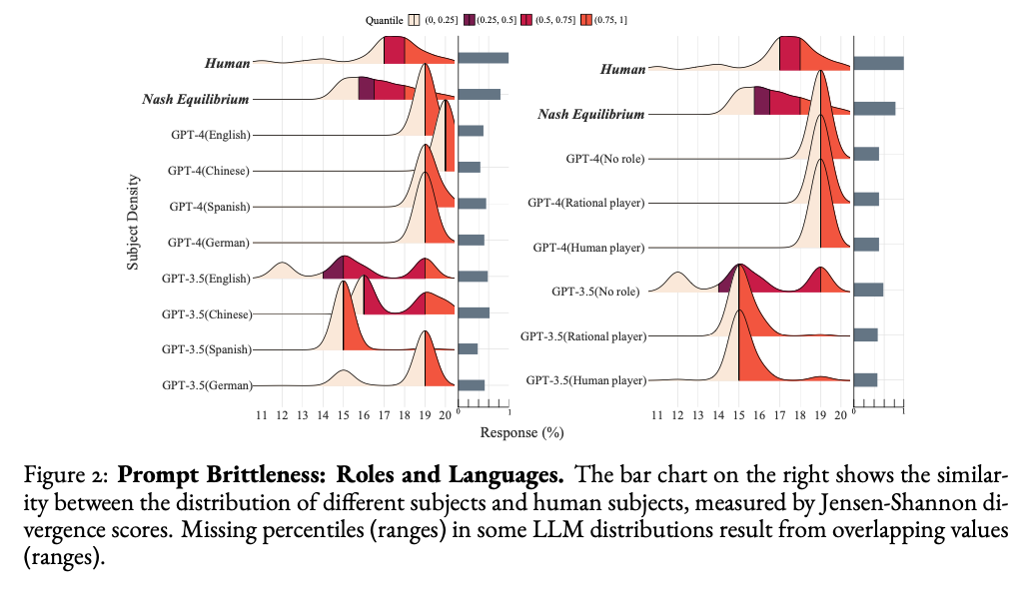

Figure from Y. Gao et al. (2024)

## Towards a Science of Human-AI Decision Making: An Overview of Design Space in Empirical Human-Subject Studies.

Lai, V., Chen, C., Smith-Renner, A., Liao, Q. V., & Tan, C. (2023). **Towards a Science of Human-AI Decision Making: An Overview of Design Space in Empirical Human-Subject Studies.** 2023 ACM Conference on Fairness, Accountability, and Transparency, 1369–1385. https://doi.org/10.1145/3593013.3594087

Abstract

AI systems are adopted in numerous domains due to their increas- ingly strong predictive performance. However, in high-stakes domains such as criminal justice and healthcare, full automation is often not desirable due to safety, ethical, and legal concerns, yet fully manual approaches can be inaccurate and time-consuming. As a result, there is growing interest in the research community to augment human decision making with AI assistance. Besides developing AI technologies for this purpose, the emerging field of human-AI decision making must embrace empirical approaches to form a foundational understanding of how humans interact and work with AI to make decisions. To invite and help structure research efforts towards a science of understanding and improving human-AI decision making, we survey recent literature of empirical human-subject studies on this topic. We summarize the study design choices made in over 100 papers in three important aspects: (1) decision tasks, (2) AI assistance elements, and (3) evaluation metrics. For each aspect, we summarize current trends, discuss gaps in current practices of the field, and make a list of recommendations for future research. Our work highlights the need to develop com- mon frameworks to account for the design and research spaces of human-AI decision making, so that researchers can make rigorous choices in study design, and the research community can build on each other’s work and produce generalizable scientific knowledge. We also hope this work will serve as a bridge for HCI and AI communities to work together to mutually shape the empirical science and computational technologies for human-AI decision making.

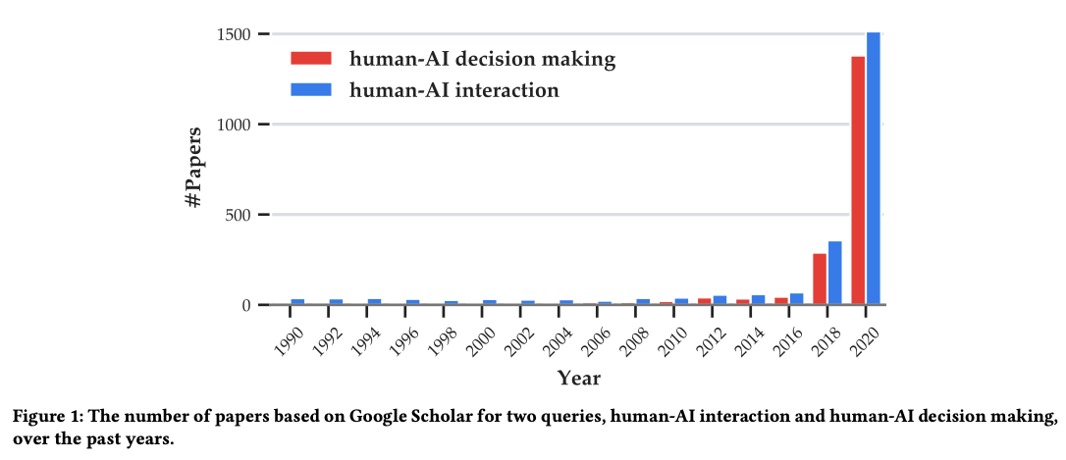

Figure from Lai et al. (2023)

# References

Abdelnabi, S., Gomaa, A., Sivaprasad, S., Schönherr, L., & Fritz, M. (2023). *LLM-Deliberation: Evaluating LLMs with Interactive Multi-Agent Negotiation Games.* <https://doi.org/10.60882/cispa.25233028.v1>

Almashor, M., & Miyashita, Y. (2024). Can Private LLM Agents Synthesize Household Energy Consumption Data? *Proceedings of the 15th ACM International Conference on Future and Sustainable Energy Systems*, 664–668. <https://doi.org/10.1145/3632775.3661993>

Banerjee, D., Teso, S., Sayin, B., & Passerini, A. (2024). *Learning To Guide Human Decision Makers With Vision-Language Models* (arXiv:2403.16501). arXiv. <https://arxiv.org/abs/2403.16501>

Bhatia, S. (2024). Exploring variability in risk taking with large language models. *Journal of Experimental Psychology: General*, *153*(7), 1838–1860. <https://doi.org/10.1037/xge0001607>

Bienefeld, N., Kolbe, M., Camen, G., Huser, D., & Buehler, P. K. (2023). Human-AI teaming: Leveraging transactive memory and speaking up for enhanced team effectiveness. *Frontiers in Psychology*, *14*. <https://doi.org/10.3389/fpsyg.2023.1208019>

Binz, M., & Schulz, E. (2023). Using cognitive psychology to understand GPT-3. *Proceedings of the National Academy of Sciences*, *120*(6), e2218523120. <https://doi.org/10.1073/pnas.2218523120>

Buçinca, Z., Malaya, M. B., & Gajos, K. Z. (2021). To Trust or to Think: Cognitive Forcing Functions Can Reduce Overreliance on AI in AI-assisted Decision-making. *Proceedings of the ACM on Human-Computer Interaction*, *5*(CSCW1), 1–21. <https://doi.org/10.1145/3449287>

Burton, J. W., Lopez-Lopez, E., Hechtlinger, S., Rahwan, Z., Aeschbach, S., Bakker, M. A., Becker, J. A., Berditchevskaia, A., Berger, J., Brinkmann, L., Flek, L., Herzog, S. M., Huang, S., Kapoor, S., Narayanan, A., Nussberger, A.-M., Yasseri, T., Nickl, P., Almaatouq, A., … Hertwig, R. (2024). How large language models can reshape collective intelligence. *Nature Human Behaviour*, 1–13. <https://doi.org/10.1038/s41562-024-01959-9>

Calò, T., & De Russis, L. (2024). Enhancing smart home interaction through multimodal command disambiguation. *Personal and Ubiquitous Computing*. <https://doi.org/10.1007/s00779-024-01827-3>

Chen, Y., Liu, T. X., Shan, Y., & Zhong, S. (2023). The emergence of economic rationality of GPT. *Proceedings of the National Academy of Sciences*, *120*(51), e2316205120. <https://doi.org/10.1073/pnas.2316205120>

Cheung, V., Maier, M., & Lieder, F. (2024). *Large Language Models Amplify Human Biases in Moral Decision-Making*. <https://doi.org/10.31234/osf.io/aj46b>

Chiang, C.-W., Lu, Z., Li, Z., & Yin, M. (2024). Enhancing AI-Assisted Group Decision Making through LLM-Powered Devil’s Advocate. *Proceedings of the 29th International Conference on Intelligent User Interfaces*, 103–119. <https://doi.org/10.1145/3640543.3645199>

Choi, A. S., Akter, S. S., Singh, J. P., & Anastasopoulos, A. (2024). *The LLM Effect: Are Humans Truly Using LLMs, or Are They Being Influenced By Them Instead?* (arXiv:2410.04699). arXiv. <https://arxiv.org/abs/2410.04699>

Chuang, Y.-S., Harlalka, N., Suresh, S., Goyal, A., Hawkins, R., Yang, S., Shah, D., Hu, J., & Rogers, T. T. (2024). *The Wisdom of Partisan Crowds: Comparing Collective Intelligence in Humans and LLM-based Agents*.

Chuang, Y.-S., Suresh, S., Harlalka, N., Goyal, A., Hawkins, R., Yang, S., Shah, D., Hu, J., & Rogers, T. T. (2023). *Evaluating LLM Agent Group Dynamics against Human Group Dynamics: A Case Study on Wisdom of Partisan Crowds* (arXiv:2311.09665). arXiv. <https://arxiv.org/abs/2311.09665>

Civitarese, G., Fiori, M., Choudhary, P., & Bettini, C. (2024). *Large Language Models are Zero-Shot Recognizers for Activities of Daily Living* (arXiv:2407.01238). arXiv. <https://arxiv.org/abs/2407.01238>

Collins, K. M., Jiang, A. Q., Frieder, S., Wong, L., Zilka, M., Bhatt, U., Lukasiewicz, T., Wu, Y., Tenenbaum, J. B., Hart, W., Gowers, T., Li, W., Weller, A., & Jamnik, M. (2023). *Evaluating Language Models for Mathematics through Interactions* (arXiv:2306.01694). arXiv. <https://arxiv.org/abs/2306.01694>

Collins, K. M., Sucholutsky, I., Bhatt, U., Chandra, K., Wong, L., Lee, M., Zhang, C. E., Zhi-Xuan, T., Ho, M., Mansinghka, V., Weller, A., Tenenbaum, J. B., & Griffiths, T. L. (2024). Building machines that learn and think with people. *Nature Human Behaviour*, *8*(10), 1851–1863. <https://doi.org/10.1038/s41562-024-01991-9>

Du, Y., Rajivan, P., & Gonzalez, C. C. (2024). *Large Language Models for Collective Problem-Solving: Insights into Group Consensus Decision-Making*.

Eigner, E., & Händler, T. (2024). *Determinants of LLM-assisted Decision-Making* (arXiv:2402.17385). arXiv. <https://arxiv.org/abs/2402.17385>

Gallo, S., Paternò, F., & Malizia, A. (2024). A conversational agent for creating automations exploiting large language models. *Personal and Ubiquitous Computing*. <https://doi.org/10.1007/s00779-024-01825-5>

Gao, C., Lan, X., Li, N., Yuan, Y., Ding, J., Zhou, Z., Xu, F., & Li, Y. (2024). Large language models empowered agent-based modeling and simulation: A survey and perspectives. *Humanities and Social Sciences Communications*, *11*(1), 1–24. <https://doi.org/10.1057/s41599-024-03611-3>

Gao, J., Gebreegziabher, S. A., Choo, K. T. W., Li, T. J.-J., Perrault, S. T., & Malone, T. W. (2024). A Taxonomy for Human-LLM Interaction Modes: An Initial Exploration. *Extended Abstracts of the CHI Conference on Human Factors in Computing Systems*, 1–11. <https://doi.org/10.1145/3613905.3650786>

Gao, Y., Lee, D., Burtch, G., & Fazelpour, S. (2024). *Take Caution in Using LLMs as Human Surrogates: Scylla Ex Machina* (arXiv:2410.19599). arXiv. <https://arxiv.org/abs/2410.19599>

Giudici, M., Padalino, L., Paolino, G., Paratici, I., Pascu, A. I., & Garzotto, F. (2024). Designing Home Automation Routines Using an LLM-Based Chatbot. *Designs*, *8*(3), 43. <https://doi.org/10.3390/designs8030043>

Goli, A., & Singh, A. (2024). Can Large Language Models Capture Human Preferences? *Marketing Science*. <https://doi.org/10.1287/mksc.2023.0306>

Guo, X., Huang, K., Liu, J., Fan, W., Vélez, N., Wu, Q., Wang, H., Griffiths, T. L., & Wang, M. (2024). *Embodied LLM Agents Learn to Cooperate in Organized Teams* (arXiv:2403.12482). arXiv. <https://arxiv.org/abs/2403.12482>

Hagendorff, T., Fabi, S., & Kosinski, M. (2023). Human-like intuitive behavior and reasoning biases emerged in large language models but disappeared in ChatGPT. *Nature Computational Science*, *3*(10), 833–838. <https://doi.org/10.1038/s43588-023-00527-x>

Hao, X., Demir, E., & Eyers, D. (2024). Exploring collaborative decision-making: A quasi-experimental study of human and Generative AI interaction. *Technology in Society*, *78*, 102662. <https://doi.org/10.1016/j.techsoc.2024.102662>

Hiremath, S. K., & Plötz, T. (2024). Game of LLMs: Discovering Structural Constructs in Activities using Large Language Models. *Companion of the 2024 on ACM International Joint Conference on Pervasive and Ubiquitous Computing*, 487–492. <https://doi.org/10.1145/3675094.3678444>

Isaza-Giraldo, A., Bala, P., Campos, P. F., & Pereira, L. (2024). Prompt-Gaming: A Pilot Study on LLM-Evaluating Agent in a Meaningful Energy Game. *Extended Abstracts of the 2024 CHI Conference on Human Factors in Computing Systems*, 1–12. <https://doi.org/10.1145/3613905.3650774>

Jin, M., Sel, B., Hardeep, F., & Yin, W. (2023). *A Human-on-the-Loop Optimization Autoformalism Approach for Sustainability* (arXiv:2308.10380). arXiv. <https://arxiv.org/abs/2308.10380>

Joshi, H., Liu, S., Chen, J., Weigle, R., & Lam, M. S. (2024). *LLM-Based Open-Domain Integrated Task and Knowledge Assistants with Programmable Policies* (arXiv:2407.05674). arXiv. <https://arxiv.org/abs/2407.05674>

Kämmer, J. E., Hautz, W. E., Krummrey, G., Sauter, T. C., Penders, D., Birrenbach, T., & Bienefeld, N. (2024). Effects of interacting with a large language model compared with a human coach on the clinical diagnostic process and outcomes among fourth-year medical students: Study protocol for a prospective, randomised experiment using patient vignettes. *BMJ Open*, *14*(7), e087469. <https://doi.org/10.1136/bmjopen-2024-087469>

King, E., Yu, H., Lee, S., & Julien, C. (2024). Sasha: Creative Goal-Oriented Reasoning in Smart Homes with Large Language Models. *Proceedings of the ACM on Interactive, Mobile, Wearable and Ubiquitous Technologies*, *8*(1), 1–38. <https://doi.org/10.1145/3643505>

King, E., Yu, H., Vartak, S., Jacob, J., Lee, S., & Julien, C. (2024). *Thoughtful Things: Building Human-Centric Smart Devices with Small Language Models* (arXiv:2405.03821). arXiv. <https://arxiv.org/abs/2405.03821>

Koehl, D., & Vangsness, L. (2023). Measuring Latent Trust Patterns in Large Language Models in the Context of Human-AI Teaming. *Proceedings of the Human Factors and Ergonomics Society Annual Meeting*, *67*. <https://doi.org/10.1177/21695067231192869>

Kumar, H., Vincentius, J., Jordan, E., & Anderson, A. (2024). *Human Creativity in the Age of LLMs: Randomized Experiments on Divergent and Convergent Thinking* (arXiv:2410.03703). arXiv. <https://arxiv.org/abs/2410.03703>

Laban, G., Laban, T., & Gunes, H. (2024). *LEXI: Large Language Models Experimentation Interface* (arXiv:2407.01488). arXiv. <https://arxiv.org/abs/2407.01488>

Lai, V., Chen, C., Smith-Renner, A., Liao, Q. V., & Tan, C. (2023). Towards a Science of Human-AI Decision Making: An Overview of Design Space in Empirical Human-Subject Studies. *2023 ACM Conference on Fairness, Accountability, and Transparency*, 1369–1385. <https://doi.org/10.1145/3593013.3594087>

Lampinen, A. K., Dasgupta, I., Chan, S. C. Y., Sheahan, H. R., Creswell, A., Kumaran, D., McClelland, J. L., & Hill, F. (2024). Language models, like humans, show content effects on reasoning tasks. *PNAS Nexus*, *3*(7), pgae233. <https://doi.org/10.1093/pnasnexus/pgae233>

Li, H., Kam-Kwai, W., Luo, Y., Chen, J., Liu, C., Zhang, Y., Lau, A. K. H., Qu, H., & Liu, D. (2024). *Save It for the "Hot" Day: An LLM-Empowered Visual Analytics System for Heat Risk Management* (arXiv:2406.03317). arXiv. <https://arxiv.org/abs/2406.03317>

Lu, J., Tian, X., Zhang, C., Zhao, Y., Zhang, J., Zhang, W., Feng, C., He, J., Wang, J., & He, F. (2024). Evaluation of large language models (LLMs) on the mastery of knowledge and skills in the heating, ventilation and air conditioning (HVAC) industry. *Energy and Built Environment*. <https://doi.org/10.1016/j.enbenv.2024.03.010>

Ma, S., Chen, Q., Wang, X., Zheng, C., Peng, Z., Yin, M., & Ma, X. (2024). *Towards Human-AI Deliberation: Design and Evaluation of LLM-Empowered Deliberative AI for AI-Assisted Decision-Making* (arXiv:2403.16812). arXiv. <https://arxiv.org/abs/2403.16812>

Macmillan-Scott, O., & Musolesi, M. (2024). (Ir)rationality and cognitive biases in large language models. *Royal Society Open Science*, *11*(6), 240255. <https://doi.org/10.1098/rsos.240255>

Marjieh, R., Gokhale, A., Bullo, F., & Griffiths, T. L. (2024). *Task Allocation in Teams as a Multi-Armed Bandit*.

Matz, S. C., Teeny, J. D., Vaid, S. S., Peters, H., Harari, G. M., & Cerf, M. (2024). The potential of generative AI for personalized persuasion at scale. *Scientific Reports*, *14*(1), 4692. <https://doi.org/10.1038/s41598-024-53755-0>

Mei, Q., Xie, Y., Yuan, W., & Jackson, M. O. (2024). A Turing test of whether AI chatbots are behaviorally similar to humans. *Proceedings of the National Academy of Sciences*, *121*(9), e2313925121. <https://doi.org/10.1073/pnas.2313925121>

Mongaillard, T., Lasaulce, S., Hicheur, O., Zhang, C., Bariah, L., Varma, V. S., Zou, H., Zhao, Q., & Debbah, M. (2024). *Large Language Models for Power Scheduling: A User-Centric Approach* (arXiv:2407.00476). arXiv. <https://arxiv.org/abs/2407.00476>

Narayanan, S., Yu, G., Ho, C.-J., & Yin, M. (2023). How does Value Similarity affect Human Reliance in AI-Assisted Ethical Decision Making? *Proceedings of the 2023 AAAI/ACM Conference on AI, Ethics, and Society*, 49–57. <https://doi.org/10.1145/3600211.3604709>

Nguyen, J. (2024). Human Bias in AI Models? Anchoring Effects and Mitigation Strategies in Large Language Models. *Journal of Behavioral and Experimental Finance*, 100971. <https://doi.org/10.1016/j.jbef.2024.100971>

Nishida, Y., Shimojo, S., & Hayashi, Y. (2024). Conversational Agent Dynamics with Minority Opinion and Cognitive Conflict in Small-Group Decision-Making. *Japanese Psychological Research*. <https://doi.org/10.1111/jpr.12552>

Nisioti, E., Risi, S., Momennejad, I., Oudeyer, P.-Y., & Moulin-Frier, C. (2024, July). Collective Innovation in Groups of Large Language Models. *ALIFE 2024: Proceedings of the 2024 Artificial Life Conference*. <https://doi.org/10.1162/isal_a_00730>

Nobandegani, A. S., Rish, I., & Shultz, T. R. (2023). Decision-Making Paradoxes in Humans vs Machines: The case of the Allais and Ellsberg Paradoxes. *Proceedings of the Annual Meeting of the Cognitive Science Society*, *46*.

Oprea, S.-V., & Bâra, A. (2024). A Recommendation System for Prosumers Based on Large Language Models. *Sensors*, *24*(11), 3530. <https://doi.org/10.3390/s24113530>

Rastogi, C., Leqi, L., Holstein, K., & Heidari, H. (2023). A Taxonomy of Human and ML Strengths in Decision-Making to Investigate Human-ML Complementarity. *Proceedings of the AAAI Conference on Human Computation and Crowdsourcing*, *11*, 127–139. <https://doi.org/10.1609/hcomp.v11i1.27554>

Rastogi, C., Zhang, Y., Wei, D., Varshney, K. R., Dhurandhar, A., & Tomsett, R. (2022). Deciding Fast and Slow: The Role of Cognitive Biases in AI-assisted Decision-making. *Proceedings of the ACM on Human-Computer Interaction*, *6*(CSCW1), 1–22. <https://doi.org/10.1145/3512930>

Roberts, J., Moore, K., Pham, T., Ewaleifoh, O., & Fisher, D. (2024). *Large Language Model Recall Uncertainty is Modulated by the Fan Effect*.

Saleh, A., Donta, P. K., Morabito, R., Motlagh, N. H., & Lovén, L. (2024). *Follow-Me AI: Energy-Efficient User Interaction with Smart Environments* (arXiv:2404.12486). arXiv. <https://arxiv.org/abs/2404.12486>

Sidji, M., Smith, W., & Rogerson, M. J. (2024). Human-AI Collaboration in Cooperative Games: A Study of Playing Codenames with an LLM Assistant. *Proc. ACM Hum.-Comput. Interact.*, *8*(CHI PLAY), 316:1–316:25. <https://doi.org/10.1145/3677081>

Stadler, M., Bannert, M., & Sailer, M. (2024). Cognitive ease at a cost: LLMs reduce mental effort but compromise depth in student scientific inquiry. *Computers in Human Behavior*, *160*, 108386. <https://doi.org/10.1016/j.chb.2024.108386>

Subramonyam, H., Pea, R., Pondoc, C. L., Agrawala, M., & Seifert, C. (2024). *Bridging the Gulf of Envisioning: Cognitive Design Challenges in LLM Interfaces* (arXiv:2309.14459). arXiv. <https://arxiv.org/abs/2309.14459>

Suri, G., Slater, L. R., Ziaee, A., & Nguyen, M. (2024). Do large language models show decision heuristics similar to humans? A case study using GPT-35. *Journal of Experimental Psychology: General*, *153*(4), 1066–1075. <https://doi.org/10.1037/xge0001547>

Swaroop, S., Buçinca, Z., Gajos, K. Z., & Doshi-Velez, F. (2024). Accuracy-Time Tradeoffs in AI-Assisted Decision Making under Time Pressure. *Proceedings of the 29th International Conference on Intelligent User Interfaces*, 138–154. <https://doi.org/10.1145/3640543.3645206>

Tessler, M. H., Bakker, M. A., Jarrett, D., Sheahan, H., Chadwick, M. J., Koster, R., Evans, G., Campbell-Gillingham, L., Collins, T., Parkes, D. C., Botvinick, M., & Summerfield, C. (2024). AI can help humans find common ground in democratic deliberation. *Science*, *386*(6719), eadq2852. <https://doi.org/10.1126/science.adq2852>

Tjuatja, L., Chen, V., Wu, T., Talwalkwar, A., & Neubig, G. (2024). Do LLMs Exhibit Human-like Response Biases? A Case Study in Survey Design. *Transactions of the Association for Computational Linguistics*, *12*, 1011–1026. <https://doi.org/10.1162/tacl_a_00685>

Vats, V., Nizam, M. B., Liu, M., Wang, Z., Ho, R., Prasad, M. S., Titterton, V., Malreddy, S. V., Aggarwal, R., Xu, Y., Ding, L., Mehta, J., Grinnell, N., Liu, L., Zhong, S., Gandamani, D. N., Tang, X., Ghosalkar, R., Shen, C., … Davis, J. (2024). *A Survey on Human-AI Teaming with Large Pre-Trained Models* (arXiv:2403.04931). arXiv. <https://arxiv.org/abs/2403.04931>

Wang, B., Liu, J., Karimnazarov, J., & Thompson, N. (2024). Task Supportive and Personalized Human-Large Language Model Interaction: A User Study. *Proceedings of the 2024 ACM SIGIR Conference on Human Information Interaction and Retrieval*, 370–375. <https://doi.org/10.1145/3627508.3638344>

Wang, D., Zheng, K., Li, C., & Guo, J. (2024). Transitioning to Human-Centered AI: A Systematic Review of Theories, Scenarios, and Hypotheses in Human-AI Interactions. *Proceedings of the Association for Information Science and Technology*, *61*(1), 673–678. <https://doi.org/10.1002/pra2.1078>

Westphal, M., Vössing, M., Satzger, G., Yom-Tov, G. B., & Rafaeli, A. (2023). Decision control and explanations in human-AI collaboration: Improving user perceptions and compliance. *Computers in Human Behavior*, *144*, 107714. <https://doi.org/10.1016/j.chb.2023.107714>

Yang, H., Siew, M., & Joe-Wong, C. (2024). *An LLM-Based Digital Twin for Optimizing Human-in-the Loop Systems* (arXiv:2403.16809). arXiv. <https://arxiv.org/abs/2403.16809>

Yang, J. C., Dailisan, D., Korecki, M., Hausladen, C. I., & Helbing, D. (2024). *LLM Voting: Human Choices and AI Collective Decision Making* (arXiv:2402.01766). arXiv. <https://arxiv.org/abs/2402.01766>

Yang, Z., Xu, X., Yao, B., Rogers, E., Zhang, S., Intille, S., Shara, N., Gao, G. G., & Wang, D. (2024). Talk2Care: An LLM-based Voice Assistant for Communication between Healthcare Providers and Older Adults. *Proceedings of the ACM on Interactive, Mobile, Wearable and Ubiquitous Technologies*, *8*(2), 1–35. <https://doi.org/10.1145/3659625>

Yax, N., Anlló, H., & Palminteri, S. (2024). Studying and improving reasoning in humans and machines. *Communications Psychology*, *2*(1), 1–16. <https://doi.org/10.1038/s44271-024-00091-8>

Zhang, J., Xu, X., Zhang, N., Liu, R., Hooi, B., & Deng, S. (2024). *Exploring Collaboration Mechanisms for LLM Agents: A Social Psychology View* (arXiv:2310.02124). arXiv. <https://arxiv.org/abs/2310.02124>

Zhang, J., Zhang, C., Lu, J., & Zhao, Y. (2025). Domain-specific large language models for fault diagnosis of heating, ventilation, and air conditioning systems by labeled-data-supervised fine-tuning. *Applied Energy*, *377*, 124378. <https://doi.org/10.1016/j.apenergy.2024.124378>

Zhang, S., Wang, X., Zhang, W., Chen, Y., Gao, L., Wang, D., Zhang, W., Wang, X., & Wen, Y. (2024). *Mutual Theory of Mind in Human-AI Collaboration: An Empirical Study with LLM-driven AI Agents in a Real-time Shared Workspace Task* (arXiv:2409.08811). arXiv. <https://arxiv.org/abs/2409.08811>

Zhao, Y., Huang, Z., Seligman, M., & Peng, K. (2024). Risk and prosocial behavioural cues elicit human-like response patterns from AI chatbots. *Scientific Reports*, *14*(1), 7095. <https://doi.org/10.1038/s41598-024-55949-y>

## Task Supportive and Personalized Human-Large Language Model Interaction: A User Study.

Wang, B., Liu, J., Karimnazarov, J., & Thompson, N. (2024). Task Supportive and Personalized Human-Large Language Model Interaction: A User Study. Proceedings of the 2024 ACM SIGIR Conference on Human Information Interaction and Retrieval, 370–375. https://doi.org/10.1145/3627508.3638344

Abstract

Large language model (LLM) applications, such as ChatGPT, are a powerful tool for online information-seeking (IS) and problem-solving tasks. However, users still face challenges initializing and refining prompts, and their cognitive barriers and biased perceptions further impede task completion. These issues reflect broader challenges identified within the fields of IS and interactive information retrieval (IIR). To address these, our approach integrates task context and user perceptions into human-ChatGPT interactions through prompt engineering. We developed a ChatGPT-like platform integrated with supportive functions, including perception articulation, prompt suggestion, and conversation explanation. Our findings of a user study demonstrate that the supportive functions help users manage expectations, reduce cognitive loads, better refine prompts, and increase user engagement. This research enhances our comprehension of designing proactive and user-centric systems with LLMs. It offers insights into evaluating human-LLM interactions and emphasizes potential challenges for under served users.

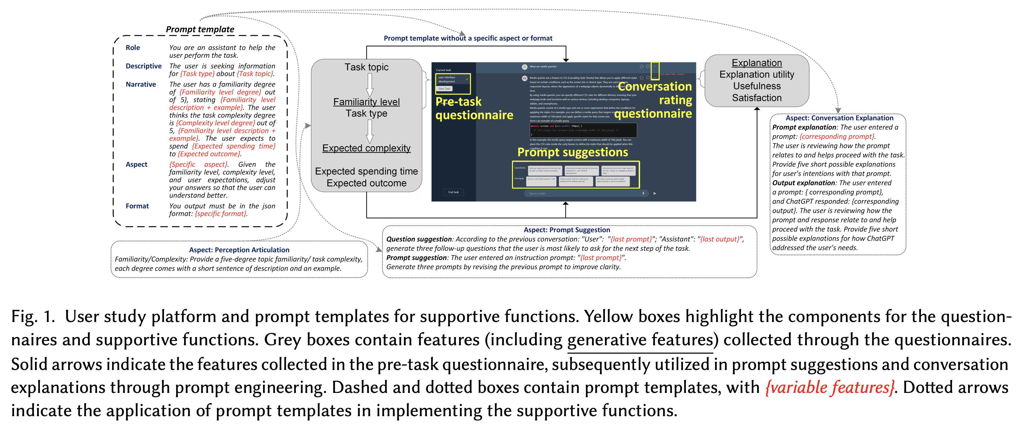

Figure from B. Wang et al. (2024)

## Transitioning to Human-Centered AI: A Systematic Review of Theories, Scenarios, and Hypotheses in Human-AI Interactions.

Wang, D., Zheng, K., Li, C., & Guo, J. (2024). **Transitioning to Human-Centered AI: A Systematic Review of Theories, Scenarios, and Hypotheses in Human-AI Interactions.** Proceedings of the Association for Information Science and Technology, 61(1), 673–678. https://doi.org/10.1002/pra2.1078

Abstract

This study conducted a systematic review of human-AI interaction (HAI)over the past decade for the implemented theories and scenarios, and the tested hypotheses to discover the changes in the current transition to human-centered AI (HCAI). Moving from acceptance theories, Computers are social actors (CASA), anthropomorphism, and the integrative trust model are the most frequent theories. Augmentation scenarios of decision-making, teamwork, and human-AI collaborations are common in the latest HAI studies. Users’ trust, acceptance, and intention to use an AI system are the main research targets in HAI studies. These trends show a clear transition toward HCAI. This paper also discusses opportunities tied to HAI studies based on the interconnections between the various theories, scenarios, and hypotheses.

|  |
| --- |
| Figure 13: Figures from D. Wang et al. (2024) |

## Human Creativity in the Age of LLMs: Randomized Experiments on Divergent and Convergent Thinking

Kumar, H., Vincentius, J., Jordan, E., & Anderson, A. (2024). **Human Creativity in the Age of LLMs: Randomized Experiments on Divergent and Convergent Thinking** (No. arXiv:2410.03703). arXiv. http://arxiv.org/abs/2410.03703

Abstract

Large language models are transforming the creative process by offering unprecedented capabilities to algorithmically generate ideas. While these tools can enhance human creativity when people co-create with them, it’s unclear how this will impact unassisted human creativity. We conducted two large pre-registered parallel experiments involving 1,100 participants attempting tasks targeting the two core components of creativity, divergent and convergent thinking. We compare the effects of two forms of large language model (LLM) assistance – a standard LLM providing direct answers and a coach-like LLM offering guidance – with a control group receiving no AI assistance, and focus particularly on how all groups perform in a final, unassisted stage. Our findings reveal that while LLM assistance can provide short-term boosts in creativity during assisted tasks, it may inadvertently hinder independent creative performance when users work without assistance, raising concerns about the long-term impact on human creativity and cognition.

|  |
| --- |
| Figure 14: Figures from Kumar et al. (2024) |

## To Trust or to Think: Cognitive Forcing Functions Can Reduce Overreliance on AI in AI-assisted Decision-making

Buçinca, Z., Malaya, M. B., & Gajos, K. Z. (2021). **To Trust or to Think: Cognitive Forcing Functions Can Reduce Overreliance on AI in AI-assisted Decision-making.** Proceedings of the ACM on Human-Computer Interaction, 5(CSCW1), 1–21. https://doi.org/10.1145/3449287

Abstract

People supported by AI-powered decision support tools frequently overrely on the AI: they accept an AI’s suggestion even when that suggestion is wrong. Adding explanations to the AI decisions does not appear to reduce the overreliance and some studies suggest that it might even increase it. Informed by the dual-process theory of cognition, we posit that people rarely engage analytically with each individual AI recommendation and explanation, and instead develop general heuristics about whether and when to follow the AI suggestions. Building on prior research on medical decision-making, we designed three cognitive forcing interventions to compel people to engage more thoughtfully with the AI-generated explanations. We conducted an experiment (N=199), in which we compared our three cognitive forcing designs to two simple explainable AI approaches and to a no-AI baseline. The results demonstrate that cognitive forcing significantly reduced overreliance compared to the simple explainable AI approaches. However, there was a trade-off: people assigned the least favorable subjective ratings to the designs that reduced the overreliance the most. To audit our work for intervention-generated inequalities, we investigated whether our interventions benefited equally people with different levels of Need for Cognition (i.e., motivation to engage in effortful mental activities). Our results show that, on average, cognitive forcing interventions benefited participants higher in Need for Cognition more. Our research suggests that human cognitive motivation moderates the effectiveness of explainable AI solutions.



Figure from Buçinca et al. (2021)

## AI can help humans find common ground in democratic deliberation.

Tessler, M. H., Bakker, M. A., Jarrett, D., Sheahan, H., Chadwick, M. J., Koster, R., Evans, G., Campbell-Gillingham, L., Collins, T., Parkes, D. C., Botvinick, M., & Summerfield, C. (2024). **AI can help humans find common ground in democratic deliberation.** Science, 386(6719), eadq2852. https://doi.org/10.1126/science.adq2852

Abstract

Finding agreement through a free exchange of views is often difficult. Collective deliberation can be slow, difficult to scale, and unequally attentive to different voices. In this study, we trained an artificial intelligence (AI) to mediate human deliberation. Using participants’ personal opinions and critiques, the AI mediator iteratively generates and refines statements that express common ground among the group on social or political issues. Participants (N = 5734) preferred AI-generated statements to those written by human mediators, rating them as more informative, clear, and unbiased. Discussants often updated their views after the deliberation, converging on a shared perspective. Text embeddings revealed that successful group statements incorporated dissenting voices while respecting the majority position. These findings were replicated in a virtual citizens’ assembly involving a demographically representative sample of the UK population.

|  |
| --- |
| Figure 15: Figures from Tessler et al. (2024) |

## Evaluating Language Models for Mathematics through Interactions

Collins, K. M., Jiang, A. Q., Frieder, S., Wong, L., Zilka, M., Bhatt, U., Lukasiewicz, T., Wu, Y., Tenenbaum, J. B., Hart, W., Gowers, T., Li, W., Weller, A., & Jamnik, M. (2023). **Evaluating Language Models for Mathematics through Interactions** (No. arXiv:2306.01694). arXiv. http://arxiv.org/abs/2306.01694

Abstract

The standard methodology of evaluating large language models (LLMs) based on static pairs of inputs and outputs is insufficient for developing assistants: this kind of assessments fails to take into account the essential interactive element in their deployment, and therefore limits how we understand language model capabilities. We introduce CheckMate, an adaptable prototype platform for humans to interact with and evaluate LLMs. We conduct a study with CheckMate to evaluate three language models~(InstructGPT, ChatGPT, and GPT-4) as assistants in proving undergraduate-level mathematics, with a mixed cohort of participants from undergraduate students to professors of mathematics. We release the resulting interaction and rating dataset, MathConverse. By analysing MathConverse, we derive a preliminary taxonomy of human behaviours and uncover that despite a generally positive correlation, there are notable instances of divergence between correctness and perceived helpfulness in LLM generations, amongst other findings. Further, we identify useful scenarios and existing issues of GPT-4 in mathematical reasoning through a series of case studies contributed by expert mathematicians. We conclude with actionable takeaways for ML practitioners and mathematicians: models which communicate uncertainty, respond well to user corrections, are more interpretable and concise may constitute better assistants; interactive evaluation is a promising way to continually navigate the capability of these models; humans should be aware of language models’ algebraic fallibility, and for that reason discern where they should be used.

|  |
| --- |
| Figure 16: Figures from Collins et al. (2023) |

## Large Language Models Experimentation Interface

Laban, G., Laban, T., & Gunes, H. (2024). **LEXI: Large Language Models Experimentation Interface** (No. arXiv:2407.01488). arXiv. http://arxiv.org/abs/2407.01488

Abstract

The recent developments in Large Language Models (LLM), mark a significant moment in the research and development of social interactions with artificial agents. These agents are widely deployed in a variety of settings, with potential impact on users. However, the study of social interactions with agents powered by LLM is still emerging, limited by access to the technology and to data, the absence of standardised interfaces, and challenges to establishing controlled experimental setups using the currently available business-oriented platforms. To answer these gaps, we developed LEXI, LLMs Experimentation Interface, an open-source tool enabling the deployment of artificial agents powered by LLM in social interaction behavioural experiments. Using a graphical interface, LEXI allows researchers to build agents, and deploy them in experimental setups along with forms and questionnaires while collecting interaction logs and self-reported data. The outcomes of usability testing indicate LEXI’s broad utility, high usability and minimum mental workload requirement, with distinctive benefits observed across disciplines. A proof-of-concept study exploring the tool’s efficacy in evaluating social HAIs was conducted, resulting in high-quality data. A comparison of empathetic versus neutral agents indicated that people perceive empathetic agents as more social, and write longer and more positive messages towards them.

Laban et al. (2024)

## Human-AI Collaboration in Cooperative Games: A Study of Playing Codenames with an LLM Assistant

Sidji, M., Smith, W., & Rogerson, M. J. (2024). **Human-AI Collaboration in Cooperative Games: A Study of Playing Codenames with an LLM Assistant.** Proc. ACM Hum.-Comput. Interact., 8(CHI PLAY), 316:1-316:25. https://doi.org/10.1145/3677081

Abstract

Playing partial information, restricted communication, cooperative (PIRCC) games with humans have proven challenging for AI, due to our reliance on social dynamics and sophisticated cognitive techniques. Yet, recent advances in generative AI may change this situation through new forms of human-AI collaboration. This paper investigates how teams of players interact with an AI assistant in the PIRCC game Codenames and the impact this has on cognition, social dynamics, and player experience. We observed gameplay and conducted post-game focus groups with 54 participants across ten groups. Each group played three rounds of Codenames, with an AI assistant supporting Cluegivers. We found the AI assistant enhanced players’ convergent and divergent thinking, but interfered with formation of team mental models, highlighting a tension in the use of AI in creative team scenarios. The presence of the AI challenged many players’ understanding of the ‘spirit of the game’. Furthermore, the presence of the AI assistants weakened social connections between human teammates, but strengthened connections across teams. This paper provides an empirical account of an AI assistant’s effect on cognition, social dynamics, and player experience in Codenames. We highlight the opportunities and challenges that arise when designing hybrid digital boardgames that include AI assistants.

Sidji et al. (2024)

## Effects of interacting with a large language model compared with a human coach on the clinical diagnostic process and outcomes among fourth-year medical students: Study protocol for a prospective, randomised experiment using patient vignettes

Kämmer, J. E., Hautz, W. E., Krummrey, G., Sauter, T. C., Penders, D., Birrenbach, T., & Bienefeld, N. (2024). **Effects of interacting with a large language model compared with a human coach on the clinical diagnostic process and outcomes among fourth-year medical students: Study protocol for a prospective, randomised experiment using patient vignettes.** BMJ Open, 14(7), e087469. https://doi.org/10.1136/bmjopen-2024-087469

Abstract

Versatile large language models (LLMs) have the potential to augment diagnostic decision-­making by assisting diagnosticians, thanks to their ability to engage in open-­ended, natural conversations and their comprehensive knowledge access. Yet the novelty of LLMs in diagnostic decision-­making introduces uncertainties regarding their impact. Clinicians unfamiliar with the use of LLMs in their professional context may rely on general attitudes towards LLMs more broadly, potentially hindering thoughtful use and critical evaluation of their input, leading to either over-­reliance and lack of critical thinking or an unwillingness to use LLMs as diagnostic aids. To address these concerns, this study examines the influence on the diagnostic process and outcomes of interacting with an LLM compared with a human coach, and of prior training vs no training for interacting with either of these ‘coaches’. Our findings aim to illuminate the potential benefits and risks of employing artificial intelligence (AI) in diagnostic decision-­making. Methods and analysis  We are conducting a prospective, randomised experiment with N=158 fourth-­year medical students from Charité Medical School, Berlin, Germany. Participants are asked to diagnose patient vignettes after being assigned to either a human coach or ChatGPT and after either training or no training (both between-­subject factors). We are specifically collecting data on the effects of using either of these ‘coaches’ and of additional training on information search, number of hypotheses entertained, diagnostic accuracy and confidence. Statistical methods will include linear mixed effects models. Exploratory analyses of the interaction patterns and attitudes towards AI will also generate more generalisable knowledge about the role of AI in medicine.



Figure from Kämmer et al. (2024)

## Enhancing AI-Assisted Group Decision Making through LLM-Powered Devil’s Advocate.

Chiang, C.-W., Lu, Z., Li, Z., & Yin, M. (2024). **Enhancing AI-Assisted Group Decision Making through LLM-Powered Devil’s Advocate.** Proceedings of the 29th International Conference on Intelligent User Interfaces, 103–119. https://doi.org/10.1145/3640543.3645199

Abstract

Group decision making plays a crucial role in our complex and interconnected world. The rise of AI technologies has the potential to provide data-driven insights to facilitate group decision making, although it is found that groups do not always utilize AI assistance appropriately. In this paper, we aim to examine whether and how the introduction of a devil’s advocate in the AI-assisted group deci- sion making processes could help groups better utilize AI assistance and change the perceptions of group processes during decision making. Inspired by the exceptional conversational capabilities ex- hibited by modern large language models (LLMs), we design four different styles of devil’s advocate powered by LLMs, varying their interactivity (i.e., interactive vs. non-interactive) and their target of objection (i.e., challenge the AI recommendation or the majority opinion within the group). Through a randomized human-subject experiment, we find evidence suggesting that LLM-powered devil’s advocates that argue against the AI model’s decision recommenda- tion have the potential to promote groups’ appropriate reliance on AI. Meanwhile, the introduction of LLM-powered devil’s advocate usually does not lead to substantial increases in people’s perceived workload for completing the group decision making tasks, while interactive LLM-powered devil’s advocates are perceived as more collaborating and of higher quality. We conclude by discussing the practical implications of our findings.

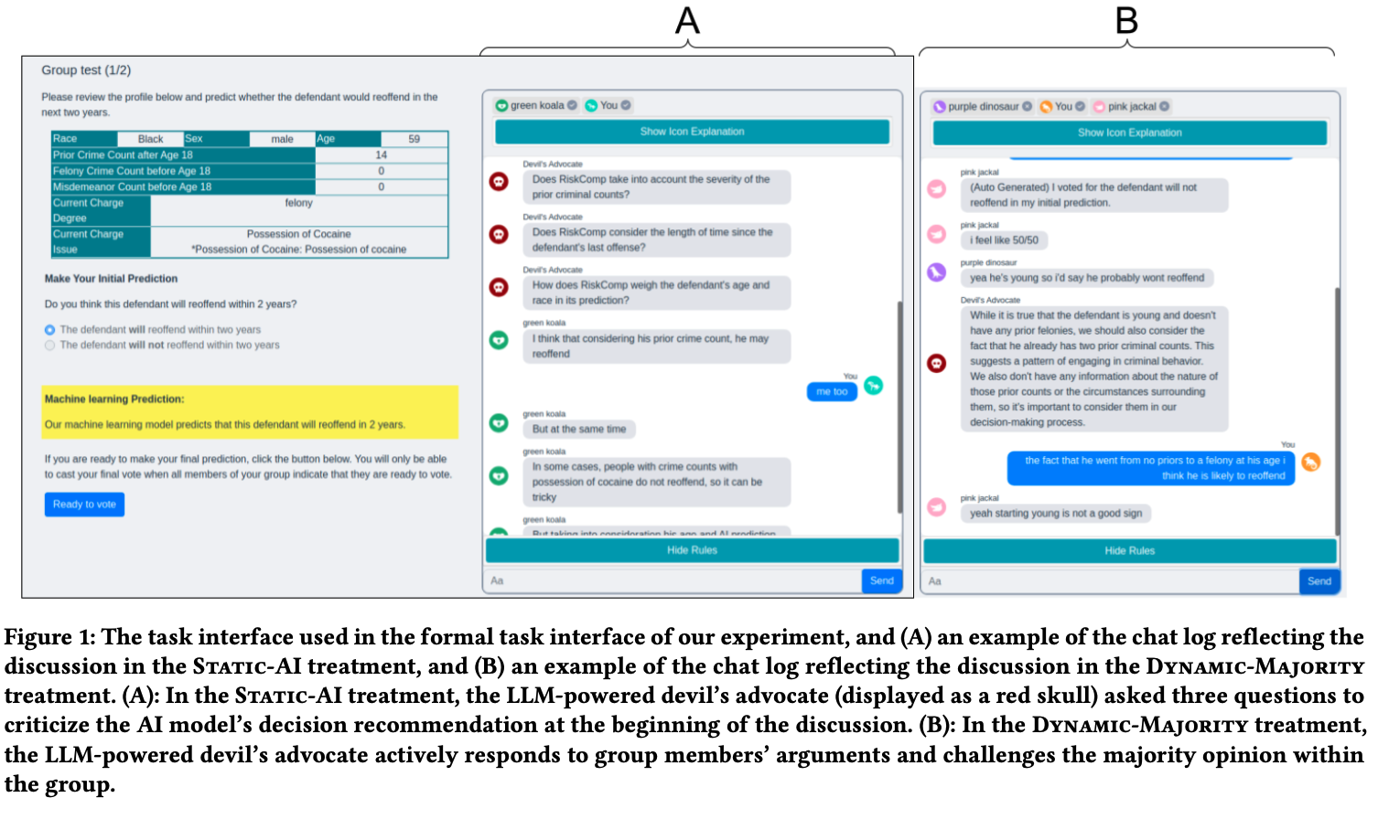

Figure from Chiang et al. (2024)

# References

Abdelnabi, S., Gomaa, A., Sivaprasad, S., Schönherr, L., & Fritz, M. (2023). *LLM-Deliberation: Evaluating LLMs with Interactive Multi-Agent Negotiation Games.* <https://doi.org/10.60882/cispa.25233028.v1>

Almashor, M., & Miyashita, Y. (2024). Can Private LLM Agents Synthesize Household Energy Consumption Data? *Proceedings of the 15th ACM International Conference on Future and Sustainable Energy Systems*, 664–668. <https://doi.org/10.1145/3632775.3661993>

Banerjee, D., Teso, S., Sayin, B., & Passerini, A. (2024). *Learning To Guide Human Decision Makers With Vision-Language Models* (arXiv:2403.16501). arXiv. <https://arxiv.org/abs/2403.16501>

Bhatia, S. (2024). Exploring variability in risk taking with large language models. *Journal of Experimental Psychology: General*, *153*(7), 1838–1860. <https://doi.org/10.1037/xge0001607>

Bienefeld, N., Kolbe, M., Camen, G., Huser, D., & Buehler, P. K. (2023). Human-AI teaming: Leveraging transactive memory and speaking up for enhanced team effectiveness. *Frontiers in Psychology*, *14*. <https://doi.org/10.3389/fpsyg.2023.1208019>

Binz, M., & Schulz, E. (2023). Using cognitive psychology to understand GPT-3. *Proceedings of the National Academy of Sciences*, *120*(6), e2218523120. <https://doi.org/10.1073/pnas.2218523120>

Buçinca, Z., Malaya, M. B., & Gajos, K. Z. (2021). To Trust or to Think: Cognitive Forcing Functions Can Reduce Overreliance on AI in AI-assisted Decision-making. *Proceedings of the ACM on Human-Computer Interaction*, *5*(CSCW1), 1–21. <https://doi.org/10.1145/3449287>

Burton, J. W., Lopez-Lopez, E., Hechtlinger, S., Rahwan, Z., Aeschbach, S., Bakker, M. A., Becker, J. A., Berditchevskaia, A., Berger, J., Brinkmann, L., Flek, L., Herzog, S. M., Huang, S., Kapoor, S., Narayanan, A., Nussberger, A.-M., Yasseri, T., Nickl, P., Almaatouq, A., … Hertwig, R. (2024). How large language models can reshape collective intelligence. *Nature Human Behaviour*, 1–13. <https://doi.org/10.1038/s41562-024-01959-9>

Calò, T., & De Russis, L. (2024). Enhancing smart home interaction through multimodal command disambiguation. *Personal and Ubiquitous Computing*. <https://doi.org/10.1007/s00779-024-01827-3>

Chen, Y., Liu, T. X., Shan, Y., & Zhong, S. (2023). The emergence of economic rationality of GPT. *Proceedings of the National Academy of Sciences*, *120*(51), e2316205120. <https://doi.org/10.1073/pnas.2316205120>

Cheung, V., Maier, M., & Lieder, F. (2024). *Large Language Models Amplify Human Biases in Moral Decision-Making*. <https://doi.org/10.31234/osf.io/aj46b>

Chiang, C.-W., Lu, Z., Li, Z., & Yin, M. (2024). Enhancing AI-Assisted Group Decision Making through LLM-Powered Devil’s Advocate. *Proceedings of the 29th International Conference on Intelligent User Interfaces*, 103–119. <https://doi.org/10.1145/3640543.3645199>

Choi, A. S., Akter, S. S., Singh, J. P., & Anastasopoulos, A. (2024). *The LLM Effect: Are Humans Truly Using LLMs, or Are They Being Influenced By Them Instead?* (arXiv:2410.04699). arXiv. <https://arxiv.org/abs/2410.04699>

Chuang, Y.-S., Harlalka, N., Suresh, S., Goyal, A., Hawkins, R., Yang, S., Shah, D., Hu, J., & Rogers, T. T. (2024). *The Wisdom of Partisan Crowds: Comparing Collective Intelligence in Humans and LLM-based Agents*.

Chuang, Y.-S., Suresh, S., Harlalka, N., Goyal, A., Hawkins, R., Yang, S., Shah, D., Hu, J., & Rogers, T. T. (2023). *Evaluating LLM Agent Group Dynamics against Human Group Dynamics: A Case Study on Wisdom of Partisan Crowds* (arXiv:2311.09665). arXiv. <https://arxiv.org/abs/2311.09665>

Civitarese, G., Fiori, M., Choudhary, P., & Bettini, C. (2024). *Large Language Models are Zero-Shot Recognizers for Activities of Daily Living* (arXiv:2407.01238). arXiv. <https://arxiv.org/abs/2407.01238>

Collins, K. M., Jiang, A. Q., Frieder, S., Wong, L., Zilka, M., Bhatt, U., Lukasiewicz, T., Wu, Y., Tenenbaum, J. B., Hart, W., Gowers, T., Li, W., Weller, A., & Jamnik, M. (2023). *Evaluating Language Models for Mathematics through Interactions* (arXiv:2306.01694). arXiv. <https://arxiv.org/abs/2306.01694>

Collins, K. M., Sucholutsky, I., Bhatt, U., Chandra, K., Wong, L., Lee, M., Zhang, C. E., Zhi-Xuan, T., Ho, M., Mansinghka, V., Weller, A., Tenenbaum, J. B., & Griffiths, T. L. (2024). Building machines that learn and think with people. *Nature Human Behaviour*, *8*(10), 1851–1863. <https://doi.org/10.1038/s41562-024-01991-9>

Du, Y., Rajivan, P., & Gonzalez, C. C. (2024). *Large Language Models for Collective Problem-Solving: Insights into Group Consensus Decision-Making*.

Eigner, E., & Händler, T. (2024). *Determinants of LLM-assisted Decision-Making* (arXiv:2402.17385). arXiv. <https://arxiv.org/abs/2402.17385>

Gallo, S., Paternò, F., & Malizia, A. (2024). A conversational agent for creating automations exploiting large language models. *Personal and Ubiquitous Computing*. <https://doi.org/10.1007/s00779-024-01825-5>

Gao, C., Lan, X., Li, N., Yuan, Y., Ding, J., Zhou, Z., Xu, F., & Li, Y. (2024). Large language models empowered agent-based modeling and simulation: A survey and perspectives. *Humanities and Social Sciences Communications*, *11*(1), 1–24. <https://doi.org/10.1057/s41599-024-03611-3>

Gao, J., Gebreegziabher, S. A., Choo, K. T. W., Li, T. J.-J., Perrault, S. T., & Malone, T. W. (2024). A Taxonomy for Human-LLM Interaction Modes: An Initial Exploration. *Extended Abstracts of the CHI Conference on Human Factors in Computing Systems*, 1–11. <https://doi.org/10.1145/3613905.3650786>

Gao, Y., Lee, D., Burtch, G., & Fazelpour, S. (2024). *Take Caution in Using LLMs as Human Surrogates: Scylla Ex Machina* (arXiv:2410.19599). arXiv. <https://arxiv.org/abs/2410.19599>

Giudici, M., Padalino, L., Paolino, G., Paratici, I., Pascu, A. I., & Garzotto, F. (2024). Designing Home Automation Routines Using an LLM-Based Chatbot. *Designs*, *8*(3), 43. <https://doi.org/10.3390/designs8030043>

Goli, A., & Singh, A. (2024). Can Large Language Models Capture Human Preferences? *Marketing Science*. <https://doi.org/10.1287/mksc.2023.0306>

Guo, X., Huang, K., Liu, J., Fan, W., Vélez, N., Wu, Q., Wang, H., Griffiths, T. L., & Wang, M. (2024). *Embodied LLM Agents Learn to Cooperate in Organized Teams* (arXiv:2403.12482). arXiv. <https://arxiv.org/abs/2403.12482>

Hagendorff, T., Fabi, S., & Kosinski, M. (2023). Human-like intuitive behavior and reasoning biases emerged in large language models but disappeared in ChatGPT. *Nature Computational Science*, *3*(10), 833–838. <https://doi.org/10.1038/s43588-023-00527-x>

Hao, X., Demir, E., & Eyers, D. (2024). Exploring collaborative decision-making: A quasi-experimental study of human and Generative AI interaction. *Technology in Society*, *78*, 102662. <https://doi.org/10.1016/j.techsoc.2024.102662>

Hiremath, S. K., & Plötz, T. (2024). Game of LLMs: Discovering Structural Constructs in Activities using Large Language Models. *Companion of the 2024 on ACM International Joint Conference on Pervasive and Ubiquitous Computing*, 487–492. <https://doi.org/10.1145/3675094.3678444>

Isaza-Giraldo, A., Bala, P., Campos, P. F., & Pereira, L. (2024). Prompt-Gaming: A Pilot Study on LLM-Evaluating Agent in a Meaningful Energy Game. *Extended Abstracts of the 2024 CHI Conference on Human Factors in Computing Systems*, 1–12. <https://doi.org/10.1145/3613905.3650774>

Jin, M., Sel, B., Hardeep, F., & Yin, W. (2023). *A Human-on-the-Loop Optimization Autoformalism Approach for Sustainability* (arXiv:2308.10380). arXiv. <https://arxiv.org/abs/2308.10380>

Joshi, H., Liu, S., Chen, J., Weigle, R., & Lam, M. S. (2024). *LLM-Based Open-Domain Integrated Task and Knowledge Assistants with Programmable Policies* (arXiv:2407.05674). arXiv. <https://arxiv.org/abs/2407.05674>

Kämmer, J. E., Hautz, W. E., Krummrey, G., Sauter, T. C., Penders, D., Birrenbach, T., & Bienefeld, N. (2024). Effects of interacting with a large language model compared with a human coach on the clinical diagnostic process and outcomes among fourth-year medical students: Study protocol for a prospective, randomised experiment using patient vignettes. *BMJ Open*, *14*(7), e087469. <https://doi.org/10.1136/bmjopen-2024-087469>

King, E., Yu, H., Lee, S., & Julien, C. (2024). Sasha: Creative Goal-Oriented Reasoning in Smart Homes with Large Language Models. *Proceedings of the ACM on Interactive, Mobile, Wearable and Ubiquitous Technologies*, *8*(1), 1–38. <https://doi.org/10.1145/3643505>

King, E., Yu, H., Vartak, S., Jacob, J., Lee, S., & Julien, C. (2024). *Thoughtful Things: Building Human-Centric Smart Devices with Small Language Models* (arXiv:2405.03821). arXiv. <https://arxiv.org/abs/2405.03821>

Koehl, D., & Vangsness, L. (2023). Measuring Latent Trust Patterns in Large Language Models in the Context of Human-AI Teaming. *Proceedings of the Human Factors and Ergonomics Society Annual Meeting*, *67*. <https://doi.org/10.1177/21695067231192869>

Kumar, H., Vincentius, J., Jordan, E., & Anderson, A. (2024). *Human Creativity in the Age of LLMs: Randomized Experiments on Divergent and Convergent Thinking* (arXiv:2410.03703). arXiv. <https://arxiv.org/abs/2410.03703>

Laban, G., Laban, T., & Gunes, H. (2024). *LEXI: Large Language Models Experimentation Interface* (arXiv:2407.01488). arXiv. <https://arxiv.org/abs/2407.01488>

Lai, V., Chen, C., Smith-Renner, A., Liao, Q. V., & Tan, C. (2023). Towards a Science of Human-AI Decision Making: An Overview of Design Space in Empirical Human-Subject Studies. *2023 ACM Conference on Fairness, Accountability, and Transparency*, 1369–1385. <https://doi.org/10.1145/3593013.3594087>

Lampinen, A. K., Dasgupta, I., Chan, S. C. Y., Sheahan, H. R., Creswell, A., Kumaran, D., McClelland, J. L., & Hill, F. (2024). Language models, like humans, show content effects on reasoning tasks. *PNAS Nexus*, *3*(7), pgae233. <https://doi.org/10.1093/pnasnexus/pgae233>

Li, H., Kam-Kwai, W., Luo, Y., Chen, J., Liu, C., Zhang, Y., Lau, A. K. H., Qu, H., & Liu, D. (2024). *Save It for the "Hot" Day: An LLM-Empowered Visual Analytics System for Heat Risk Management* (arXiv:2406.03317). arXiv. <https://arxiv.org/abs/2406.03317>

Lu, J., Tian, X., Zhang, C., Zhao, Y., Zhang, J., Zhang, W., Feng, C., He, J., Wang, J., & He, F. (2024). Evaluation of large language models (LLMs) on the mastery of knowledge and skills in the heating, ventilation and air conditioning (HVAC) industry. *Energy and Built Environment*. <https://doi.org/10.1016/j.enbenv.2024.03.010>

Ma, S., Chen, Q., Wang, X., Zheng, C., Peng, Z., Yin, M., & Ma, X. (2024). *Towards Human-AI Deliberation: Design and Evaluation of LLM-Empowered Deliberative AI for AI-Assisted Decision-Making* (arXiv:2403.16812). arXiv. <https://arxiv.org/abs/2403.16812>

Macmillan-Scott, O., & Musolesi, M. (2024). (Ir)rationality and cognitive biases in large language models. *Royal Society Open Science*, *11*(6), 240255. <https://doi.org/10.1098/rsos.240255>

Marjieh, R., Gokhale, A., Bullo, F., & Griffiths, T. L. (2024). *Task Allocation in Teams as a Multi-Armed Bandit*.

Matz, S. C., Teeny, J. D., Vaid, S. S., Peters, H., Harari, G. M., & Cerf, M. (2024). The potential of generative AI for personalized persuasion at scale. *Scientific Reports*, *14*(1), 4692. <https://doi.org/10.1038/s41598-024-53755-0>

Mei, Q., Xie, Y., Yuan, W., & Jackson, M. O. (2024). A Turing test of whether AI chatbots are behaviorally similar to humans. *Proceedings of the National Academy of Sciences*, *121*(9), e2313925121. <https://doi.org/10.1073/pnas.2313925121>

Mongaillard, T., Lasaulce, S., Hicheur, O., Zhang, C., Bariah, L., Varma, V. S., Zou, H., Zhao, Q., & Debbah, M. (2024). *Large Language Models for Power Scheduling: A User-Centric Approach* (arXiv:2407.00476). arXiv. <https://arxiv.org/abs/2407.00476>

Narayanan, S., Yu, G., Ho, C.-J., & Yin, M. (2023). How does Value Similarity affect Human Reliance in AI-Assisted Ethical Decision Making? *Proceedings of the 2023 AAAI/ACM Conference on AI, Ethics, and Society*, 49–57. <https://doi.org/10.1145/3600211.3604709>

Nguyen, J. (2024). Human Bias in AI Models? Anchoring Effects and Mitigation Strategies in Large Language Models. *Journal of Behavioral and Experimental Finance*, 100971. <https://doi.org/10.1016/j.jbef.2024.100971>

Nishida, Y., Shimojo, S., & Hayashi, Y. (2024). Conversational Agent Dynamics with Minority Opinion and Cognitive Conflict in Small-Group Decision-Making. *Japanese Psychological Research*. <https://doi.org/10.1111/jpr.12552>

Nisioti, E., Risi, S., Momennejad, I., Oudeyer, P.-Y., & Moulin-Frier, C. (2024, July). Collective Innovation in Groups of Large Language Models. *ALIFE 2024: Proceedings of the 2024 Artificial Life Conference*. <https://doi.org/10.1162/isal_a_00730>

Nobandegani, A. S., Rish, I., & Shultz, T. R. (2023). Decision-Making Paradoxes in Humans vs Machines: The case of the Allais and Ellsberg Paradoxes. *Proceedings of the Annual Meeting of the Cognitive Science Society*, *46*.

Oprea, S.-V., & Bâra, A. (2024). A Recommendation System for Prosumers Based on Large Language Models. *Sensors*, *24*(11), 3530. <https://doi.org/10.3390/s24113530>

Rastogi, C., Leqi, L., Holstein, K., & Heidari, H. (2023). A Taxonomy of Human and ML Strengths in Decision-Making to Investigate Human-ML Complementarity. *Proceedings of the AAAI Conference on Human Computation and Crowdsourcing*, *11*, 127–139. <https://doi.org/10.1609/hcomp.v11i1.27554>

Rastogi, C., Zhang, Y., Wei, D., Varshney, K. R., Dhurandhar, A., & Tomsett, R. (2022). Deciding Fast and Slow: The Role of Cognitive Biases in AI-assisted Decision-making. *Proceedings of the ACM on Human-Computer Interaction*, *6*(CSCW1), 1–22. <https://doi.org/10.1145/3512930>

Roberts, J., Moore, K., Pham, T., Ewaleifoh, O., & Fisher, D. (2024). *Large Language Model Recall Uncertainty is Modulated by the Fan Effect*.

Saleh, A., Donta, P. K., Morabito, R., Motlagh, N. H., & Lovén, L. (2024). *Follow-Me AI: Energy-Efficient User Interaction with Smart Environments* (arXiv:2404.12486). arXiv. <https://arxiv.org/abs/2404.12486>

Sidji, M., Smith, W., & Rogerson, M. J. (2024). Human-AI Collaboration in Cooperative Games: A Study of Playing Codenames with an LLM Assistant. *Proc. ACM Hum.-Comput. Interact.*, *8*(CHI PLAY), 316:1–316:25. <https://doi.org/10.1145/3677081>

Stadler, M., Bannert, M., & Sailer, M. (2024). Cognitive ease at a cost: LLMs reduce mental effort but compromise depth in student scientific inquiry. *Computers in Human Behavior*, *160*, 108386. <https://doi.org/10.1016/j.chb.2024.108386>

Subramonyam, H., Pea, R., Pondoc, C. L., Agrawala, M., & Seifert, C. (2024). *Bridging the Gulf of Envisioning: Cognitive Design Challenges in LLM Interfaces* (arXiv:2309.14459). arXiv. <https://arxiv.org/abs/2309.14459>

Suri, G., Slater, L. R., Ziaee, A., & Nguyen, M. (2024). Do large language models show decision heuristics similar to humans? A case study using GPT-35. *Journal of Experimental Psychology: General*, *153*(4), 1066–1075. <https://doi.org/10.1037/xge0001547>

Swaroop, S., Buçinca, Z., Gajos, K. Z., & Doshi-Velez, F. (2024). Accuracy-Time Tradeoffs in AI-Assisted Decision Making under Time Pressure. *Proceedings of the 29th International Conference on Intelligent User Interfaces*, 138–154. <https://doi.org/10.1145/3640543.3645206>

Tessler, M. H., Bakker, M. A., Jarrett, D., Sheahan, H., Chadwick, M. J., Koster, R., Evans, G., Campbell-Gillingham, L., Collins, T., Parkes, D. C., Botvinick, M., & Summerfield, C. (2024). AI can help humans find common ground in democratic deliberation. *Science*, *386*(6719), eadq2852. <https://doi.org/10.1126/science.adq2852>

Tjuatja, L., Chen, V., Wu, T., Talwalkwar, A., & Neubig, G. (2024). Do LLMs Exhibit Human-like Response Biases? A Case Study in Survey Design. *Transactions of the Association for Computational Linguistics*, *12*, 1011–1026. <https://doi.org/10.1162/tacl_a_00685>

Vats, V., Nizam, M. B., Liu, M., Wang, Z., Ho, R., Prasad, M. S., Titterton, V., Malreddy, S. V., Aggarwal, R., Xu, Y., Ding, L., Mehta, J., Grinnell, N., Liu, L., Zhong, S., Gandamani, D. N., Tang, X., Ghosalkar, R., Shen, C., … Davis, J. (2024). *A Survey on Human-AI Teaming with Large Pre-Trained Models* (arXiv:2403.04931). arXiv. <https://arxiv.org/abs/2403.04931>

Wang, B., Liu, J., Karimnazarov, J., & Thompson, N. (2024). Task Supportive and Personalized Human-Large Language Model Interaction: A User Study. *Proceedings of the 2024 ACM SIGIR Conference on Human Information Interaction and Retrieval*, 370–375. <https://doi.org/10.1145/3627508.3638344>

Wang, D., Zheng, K., Li, C., & Guo, J. (2024). Transitioning to Human-Centered AI: A Systematic Review of Theories, Scenarios, and Hypotheses in Human-AI Interactions. *Proceedings of the Association for Information Science and Technology*, *61*(1), 673–678. <https://doi.org/10.1002/pra2.1078>

Westphal, M., Vössing, M., Satzger, G., Yom-Tov, G. B., & Rafaeli, A. (2023). Decision control and explanations in human-AI collaboration: Improving user perceptions and compliance. *Computers in Human Behavior*, *144*, 107714. <https://doi.org/10.1016/j.chb.2023.107714>

Yang, H., Siew, M., & Joe-Wong, C. (2024). *An LLM-Based Digital Twin for Optimizing Human-in-the Loop Systems* (arXiv:2403.16809). arXiv. <https://arxiv.org/abs/2403.16809>

Yang, J. C., Dailisan, D., Korecki, M., Hausladen, C. I., & Helbing, D. (2024). *LLM Voting: Human Choices and AI Collective Decision Making* (arXiv:2402.01766). arXiv. <https://arxiv.org/abs/2402.01766>

Yang, Z., Xu, X., Yao, B., Rogers, E., Zhang, S., Intille, S., Shara, N., Gao, G. G., & Wang, D. (2024). Talk2Care: An LLM-based Voice Assistant for Communication between Healthcare Providers and Older Adults. *Proceedings of the ACM on Interactive, Mobile, Wearable and Ubiquitous Technologies*, *8*(2), 1–35. <https://doi.org/10.1145/3659625>

Yax, N., Anlló, H., & Palminteri, S. (2024). Studying and improving reasoning in humans and machines. *Communications Psychology*, *2*(1), 1–16. <https://doi.org/10.1038/s44271-024-00091-8>

Zhang, J., Xu, X., Zhang, N., Liu, R., Hooi, B., & Deng, S. (2024). *Exploring Collaboration Mechanisms for LLM Agents: A Social Psychology View* (arXiv:2310.02124). arXiv. <https://arxiv.org/abs/2310.02124>

Zhang, J., Zhang, C., Lu, J., & Zhao, Y. (2025). Domain-specific large language models for fault diagnosis of heating, ventilation, and air conditioning systems by labeled-data-supervised fine-tuning. *Applied Energy*, *377*, 124378. <https://doi.org/10.1016/j.apenergy.2024.124378>

Zhang, S., Wang, X., Zhang, W., Chen, Y., Gao, L., Wang, D., Zhang, W., Wang, X., & Wen, Y. (2024). *Mutual Theory of Mind in Human-AI Collaboration: An Empirical Study with LLM-driven AI Agents in a Real-time Shared Workspace Task* (arXiv:2409.08811). arXiv. <https://arxiv.org/abs/2409.08811>

Zhao, Y., Huang, Z., Seligman, M., & Peng, K. (2024). Risk and prosocial behavioural cues elicit human-like response patterns from AI chatbots. *Scientific Reports*, *14*(1), 7095. <https://doi.org/10.1038/s41598-024-55949-y>

# Relevant Papers

## AI can help humans find common ground in democratic deliberation.

Tessler, M. H., Bakker, M. A., Jarrett, D., Sheahan, H., Chadwick, M. J., Koster, R., Evans, G., Campbell-Gillingham, L., Collins, T., Parkes, D. C., Botvinick, M., & Summerfield, C. (2024). **AI can help humans find common ground in democratic deliberation.** Science, 386(6719), eadq2852. https://doi.org/10.1126/science.adq2852

Abstract

Finding agreement through a free exchange of views is often difficult. Collective deliberation can be slow, difficult to scale, and unequally attentive to different voices. In this study, we trained an artificial intelligence (AI) to mediate human deliberation. Using participants’ personal opinions and critiques, the AI mediator iteratively generates and refines statements that express common ground among the group on social or political issues. Participants (N = 5734) preferred AI-generated statements to those written by human mediators, rating them as more informative, clear, and unbiased. Discussants often updated their views after the deliberation, converging on a shared perspective. Text embeddings revealed that successful group statements incorporated dissenting voices while respecting the majority position. These findings were replicated in a virtual citizens’ assembly involving a demographically representative sample of the UK population.

|  |
| --- |
| Figure 17: Figures from Tessler et al. (2024) |

## Task Allocation in Teams as a Multi-Armed Bandit.

Marjieh, R., Gokhale, A., Bullo, F., & Griffiths, T. L. (2024). **Task Allocation in Teams as a Multi-Armed Bandit.** https://cocosci.princeton.edu/papers/marjieh2024task.pdf

Abstract

Humans rely on efficient distribution of resources to transcend the abilities of individuals. Successful task allocation, whether in small teams or across large institutions, depends on individuals’ ability to discern their own and others’ strengths and weaknesses, and to optimally act on them. This dependence creates a tension between exploring the capabilities of others and exploiting the knowledge acquired so far, which can be challenging. How do people navigate this tension? To address this question, we propose a novel task allocation paradigm in which a human agent is asked to repeatedly allocate tasks in three distinct classes (categorizing a blurry image, detecting a noisy voice command, and solving an anagram) between themselves and two other (bot) team members to maximize team performance. We show that this problem can be recast as a combinatorial multi-armed bandit which allows us to compare people’s performance against two well-known strategies, Thompson Sampling and Upper Confidence Bound (UCB). We find that humans are able to successfully integrate information about the capabilities of different team members to infer optimal allocations, and in some cases perform on par with these optimal strategies. Our approach opens up new avenues for studying the mechanisms underlying collective cooperation in teams.

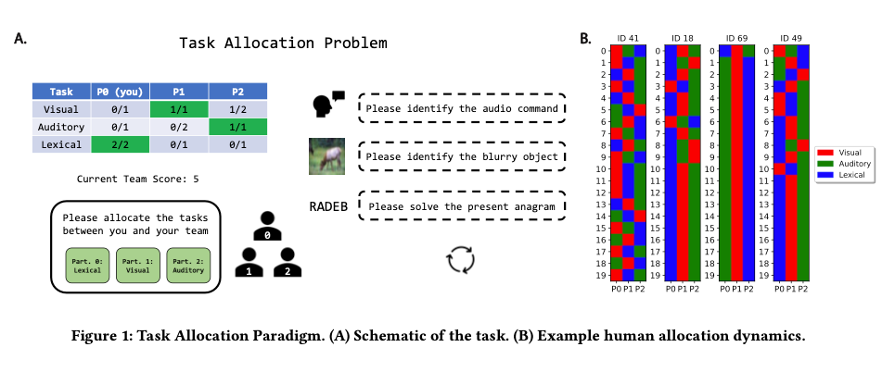

Figure from Marjieh et al. (2024)

## Human-AI teaming: Leveraging transactive memory and speaking up for enhanced team effectiveness.

Bienefeld, N., Kolbe, M., Camen, G., Huser, D., & Buehler, P. K. (2023). **Human-AI teaming: Leveraging transactive memory and speaking up for enhanced team effectiveness.** Frontiers in Psychology, 14. https://doi.org/10.3389/fpsyg.2023.1208019

Abstract

In this prospective observational study, we investigate the role of transactive memory and speaking up in human-AI teams comprising 180 intensive care (ICU) physicians and nurses working with AI in a simulated clinical environment. Our findings indicate that interactions with AI agents differ significantly from human interactions, as accessing information from AI agents is positively linked to a team’s ability to generate novel hypotheses and demonstrate speaking-up behavior, but only in higher-performing teams. Conversely, accessing information from human team members is negatively associated with these aspects, regardless of team performance. This study is a valuable contribution to the expanding field of research on human-AI teams and team science in general, as it emphasizes the necessity of incorporating AI agents as knowledge sources in a team’s transactive memory system, as well as highlighting their role as catalysts for speaking up. Practical implications include suggestions for the design of future AI systems and human-AI team training in healthcare and beyond.

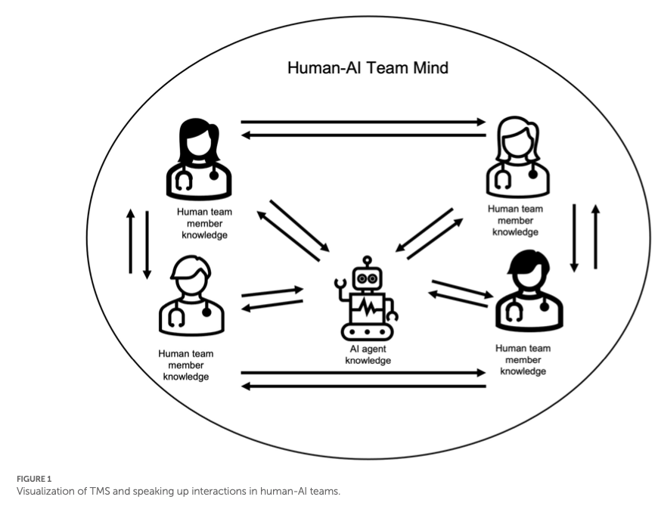

Figure from Bienefeld et al. (2023)

## Large language models empowered agent-based modeling and simulation: A survey and perspectives.

Gao, C., Lan, X., Li, N., Yuan, Y., Ding, J., Zhou, Z., Xu, F., & Li, Y. (2024). **Large language models empowered agent-based modeling and simulation: A survey and perspectives.** Humanities and Social Sciences Communications, 11(1), 1–24. https://doi.org/10.1057/s41599-024-03611-3

Abstract

Agent-based modeling and simulation have evolved as a powerful tool for modeling complex systems, offering insights into emergent behaviors and interactions among diverse agents. Recently, integrating large language models into agent-based modeling and simulation presents a promising avenue for enhancing simulation capabilities. This paper surveys the landscape of utilizing large language models in agent-based modeling and simulation, discussing their challenges and promising future directions. In this survey, since this is an interdisciplinary field, we first introduce the background of agent-based modeling and simulation and large language model-empowered agents. We then discuss the motivation for applying large language models to agent-based simulation and systematically analyze the challenges in environment perception, human alignment, action generation, and evaluation. Most importantly, we provide a comprehensive overview of the recent works of large language model-empowered agent-based modeling and simulation in multiple scenarios, which can be divided into four domains: cyber, physical, social, and hybrid, covering simulation of both real-world and virtual environments, and how these works address the above challenges. Finally, since this area is new and quickly evolving, we discuss the open problems and promising future directions. We summarize the representative papers along with their code repositories in https://github.com/tsinghua-fib-lab/LLM-Agent-Based-Modeling-and-Simulation.

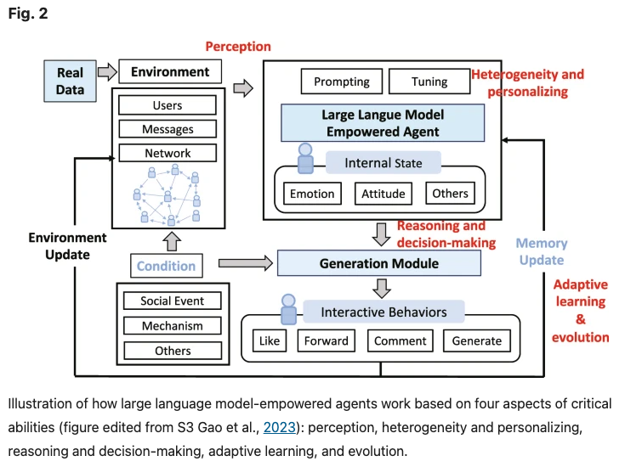

Figure from C. Gao et al. (2024)

## Building Machines that Learn and Think with People

Collins, K. M., Sucholutsky, I., Bhatt, U., Chandra, K., Wong, L., Lee, M., Zhang, C. E., Zhi-Xuan, T., Ho, M., Mansinghka, V., Weller, A., Tenenbaum, J. B., & Griffiths, T. L. (2024). **Building machines that learn and think with people.** Nature Human Behaviour, 8(10), 1851–1863. https://doi.org/10.1038/s41562-024-01991-9

Abstract

What do we want from machine intelligence? We envision machines that are not just tools for thought, but partners in thought: reasonable, insightful, knowledgeable, reliable, and trustworthy systems that think with us. Current artificial intelligence (AI) systems satisfy some of these criteria, some of the time. In this Perspective, we show how the science of collaborative cognition can be put to work to engineer systems that really can be called “thought partners,” systems built to meet our expectations and complement our limitations. We lay out several modes of collaborative thought in which humans and AI thought partners can engage and propose desiderata for human-compatible thought partnerships. Drawing on motifs from computational cognitive science, we motivate an alternative scaling path for the design of thought partners and ecosystems around their use through a Bayesian lens, whereby the partners we construct actively build and reason over models of the human and world.

|  |
| --- |
|  |

|  |
| --- |
|  |

|  |
| --- |
|  |

Figure 18: Figures from Collins et al. (2024)

## Large Language Models for Collective Problem-Solving: Insights into Group Consensus Decision-Making

Du, Y., Rajivan, P., & Gonzalez, C. C. (2024). **Large Language Models for Collective Problem-Solving: Insights into Group Consensus Decision-Making.** https://escholarship.org/uc/item/6s060914

Abstract

Large Language models (LLM) exhibit human-like proficiency in various tasks such as translation, question answering, essay writing, and programming. Emerging research explores the use of LLMs in collective problem-solving endeavors, such as tasks where groups try to uncover clues through discussions. Although prior work has investigated individual problem-solving tasks, leveraging LLM-powered agents for group consensus and decision-making remains largely unexplored. This research addresses this gap by (1) proposing an algorithm to enable free-form conversation in groups of LLM agents, (2) creating metrics to evaluate the human-likeness of the generated dialogue and problem-solving performance, and (3) evaluating LLM agent groups against human groups using an open source dataset. Our results reveal that LLM groups outperform human groups in problem-solving tasks. LLM groups also show a greater improvement in scores after participating in free discussions. In particular, analyses indicate that LLM agent groups exhibit more disagreements, complex statements, and a propensity for positive statements compared to human groups. The results shed light on the potential of LLMs to facilitate collective reasoning and provide insight into the dynamics of group interactions involving synthetic LLM agents.

|  |  |
| --- | --- |
|  |  |

Figure 19: Figure from Du et al. (2024)

## Exploring collaborative decision-making: A quasi-experimental study of human and Generative AI interaction.

Hao, X., Demir, E., & Eyers, D. (2024). **Exploring collaborative decision-making: A quasi-experimental study of human and Generative AI interaction.** Technology in Society, 78, 102662. https://doi.org/10.1016/j.techsoc.2024.102662

Abstract

This paper explores the effects of integrating Generative Artificial Intelligence (GAI) into decision-making processes within organizations, employing a quasi-experimental pretest-posttest design. The study examines the synergistic interaction between Human Intelligence (HI) and GAI across four group decision-making scenarios within three global organizations renowned for their cutting-edge operational techniques. The research progresses through several phases: identifying research problems, collecting baseline data on decision-making, implementing AI interventions, and evaluating the outcomes post-intervention to identify shifts in performance. The results demonstrate that GAI effectively reduces human cognitive burdens and mitigates heuristic biases by offering data-driven support and predictive analytics, grounded in System 2 reasoning. This is particularly valuable in complex situations characterized by unfamiliarity and information overload, where intuitive, System 1 thinking is less effective. However, the study also uncovers challenges related to GAI integration, such as potential over-reliance on technology, intrinsic biases particularly ‘out-of-the-box’ thinking without contextual creativity. To address these issues, this paper proposes an innovative strategic framework for HI-GAI collaboration that emphasizes transparency, accountability, and inclusiveness.

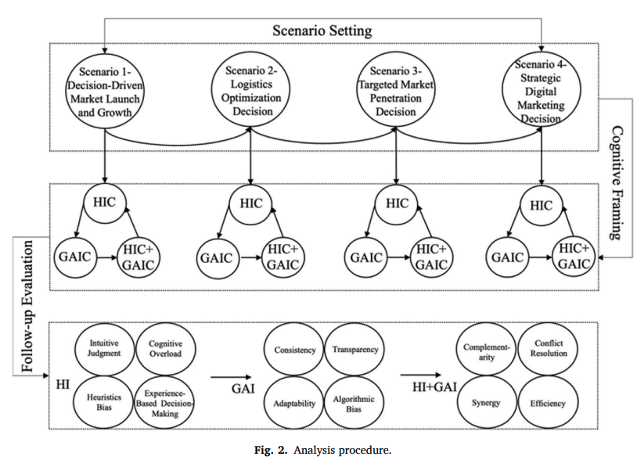

Figure from Hao et al. (2024)

## How large language models can reshape collective intelligence

Burton, J. W., Lopez-Lopez, E., Hechtlinger, S., Rahwan, Z., Aeschbach, S., Bakker, M. A., Becker, J. A., Berditchevskaia, A., Berger, J., Brinkmann, L., Flek, L., Herzog, S. M., Huang, S., Kapoor, S., Narayanan, A., Nussberger, A.-M., Yasseri, T., Nickl, P., Almaatouq, A., … Hertwig, R. (2024). **How large language models can reshape collective intelligence.** Nature Human Behaviour, 1–13. https://doi.org/10.1038/s41562-024-01959-9

Abstract

Collective intelligence underpins the success of groups, organizations, markets and societies. Through distributed cognition and coordination, collectives can achieve outcomes that exceed the capabilities of individuals—even experts—resulting in improved accuracy and novel capabilities. Often, collective intelligence is supported by information technology, such as online prediction markets that elicit the ‘wisdom of crowds’, online forums that structure collective deliberation or digital platforms that crowdsource knowledge from the public. Large language models, however, are transforming how information is aggregated, accessed and transmitted online. Here we focus on the unique opportunities and challenges this transformation poses for collective intelligence. We bring together interdisciplinary perspectives from industry and academia to identify potential benefits, risks, policy-relevant considerations and open research questions, culminating in a call for a closer examination of how large language models affect humans’ ability to collectively tackle complex problems.

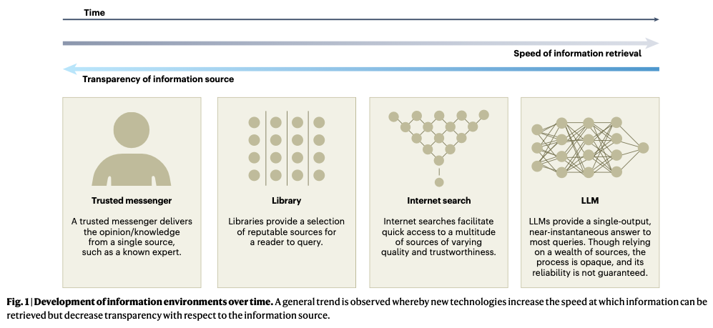

Burton et al. (2024)

## Towards Human-AI Deliberation: Design and Evaluation of LLM-Empowered Deliberative AI for AI-Assisted Decision-Making

Ma, S., Chen, Q., Wang, X., Zheng, C., Peng, Z., Yin, M., & Ma, X. (2024). **Towards Human-AI Deliberation: Design and Evaluation of LLM-Empowered Deliberative AI for AI-Assisted Decision-Making** (arXiv:2403.16812). arXiv. http://arxiv.org/abs/2403.16812

Abstract

In AI-assisted decision-making, humans often passively review AI’s suggestion and decide whether to accept or reject it as a whole. In such a paradigm, humans are found to rarely trigger analytical thinking and face difficulties in communicating the nuances of conflicting opinions to the AI when disagreements occur. To tackle this challenge, we propose Human-AI Deliberation, a novel framework to promote human reflection and discussion on conflicting human-AI opinions in decision-making. Based on theories in human deliberation, this framework engages humans and AI in dimension-level opinion elicitation, deliberative discussion, and decision updates. To empower AI with deliberative capabilities, we designed Deliberative AI, which leverages large language models (LLMs) as a bridge between humans and domain-specific models to enable flexible conversational interactions and faithful information provision. An exploratory evaluation on a graduate admissions task shows that Deliberative AI outperforms conventional explainable AI (XAI) assistants in improving humans’ appropriate reliance and task performance. Based on a mixed-methods analysis of participant behavior, perception, user experience, and open-ended feedback, we draw implications for future AI-assisted decision tool design.

|  |
| --- |
|  |

|  |
| --- |
|  |

|  |
| --- |
|  |

|  |
| --- |
|  |

|  |
| --- |
|  |

|  |
| --- |
|  |

Figure 20: Figure from Ma et al. (2024)

## Enhancing AI-Assisted Group Decision Making through LLM-Powered Devil’s Advocate.

Chiang, C.-W., Lu, Z., Li, Z., & Yin, M. (2024). **Enhancing AI-Assisted Group Decision Making through LLM-Powered Devil’s Advocate.** Proceedings of the 29th International Conference on Intelligent User Interfaces, 103–119. https://doi.org/10.1145/3640543.3645199

Abstract

Group decision making plays a crucial role in our complex and interconnected world. The rise of AI technologies has the potential to provide data-driven insights to facilitate group decision making, although it is found that groups do not always utilize AI assistance appropriately. In this paper, we aim to examine whether and how the introduction of a devil’s advocate in the AI-assisted group deci- sion making processes could help groups better utilize AI assistance and change the perceptions of group processes during decision making. Inspired by the exceptional conversational capabilities ex- hibited by modern large language models (LLMs), we design four different styles of devil’s advocate powered by LLMs, varying their interactivity (i.e., interactive vs. non-interactive) and their target of objection (i.e., challenge the AI recommendation or the majority opinion within the group). Through a randomized human-subject experiment, we find evidence suggesting that LLM-powered devil’s advocates that argue against the AI model’s decision recommenda- tion have the potential to promote groups’ appropriate reliance on AI. Meanwhile, the introduction of LLM-powered devil’s advocate usually does not lead to substantial increases in people’s perceived workload for completing the group decision making tasks, while interactive LLM-powered devil’s advocates are perceived as more collaborating and of higher quality. We conclude by discussing the practical implications of our findings.



Figure from Chiang et al. (2024)

## The Wisdom of Partisan Crowds: Comparing Collective Intelligence in Humans and LLM-based Agents

Chuang, Y.-S., Harlalka, N., Suresh, S., Goyal, A., Hawkins, R., Yang, S., Shah, D., Hu, J., & Rogers, T. T. (2024). **The Wisdom of Partisan Crowds: Comparing Collective Intelligence in Humans and LLM-based Agents.** https://escholarship.org/uc/item/3k67x8s5

Abstract

Human groups are able to converge to more accurate beliefs through deliberation, even in the presence of polarization and partisan bias — a phenomenon known as the “wisdom of partisan crowds.” Large Language Models (LLMs) are increasingly being used to simulate human collective behavior, yet few benchmarks exist for evaluating their dynamics against the behavior of human groups. In this paper, we examine the extent to which the wisdom of partisan crowds emerges in groups of LLM-based agents that are prompted to role-play as partisan personas (e.g., Democrat or Republican). We find that they not only display human-like partisan biases, but also converge to more accurate beliefs through deliberation, as humans do. We then identify several factors that interfere with convergence, including the use of chain-of-thought prompting and lack of details in personas. Conversely, fine-tuning on human data appears to enhance convergence. These findings show the potential and limitations of LLM-based agents as a model of human collective intelligence.

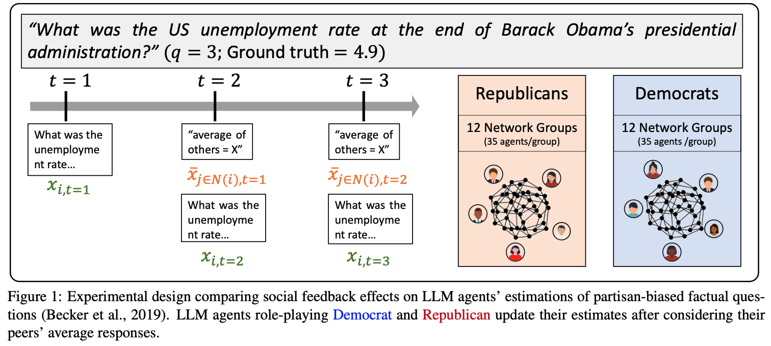

Chuang et al. (2024)

## Collective Innovation in Groups of Large Language Models.

Nisioti, E., Risi, S., Momennejad, I., Oudeyer, P.-Y., & Moulin-Frier, C. (2024, July 7). **Collective Innovation in Groups of Large Language Models.** ALIFE 2024: Proceedings of the 2024 Artificial Life Conference. https://doi.org/10.1162/isal_a_00730

Abstract

Human culture relies on collective innovation: our ability to continuously explore how existing elements in our environment can be combined to create new ones. Language is hypothesized to play a key role in human culture, driving individual cognitive capacities and shaping communication. Yet the majority of models of collective innovation assign no cognitive capacities or language abilities to agents. Here, we contribute a computational study of collective innovation where agents are Large Language Models (LLMs) that play Little Alchemy 2, a creative video game originally developed for humans that, as we argue, captures useful aspects of innovation landscapes not present in previous test-beds. We, first, study an LLM in isolation and discover that it exhibits both useful skills and crucial limitations. We, then, study groups of LLMs that share information related to their behaviour and focus on the effect of social connectivity on collective performance. In agreement with previous human and computational studies, we observe that groups with dynamic connectivity out-compete fully-connected groups. Our work reveals opportunities and challenges for future studies of collective innovation that are becoming increasingly relevant as Generative Artificial Intelligence algorithms and humans innovate alongside each other.

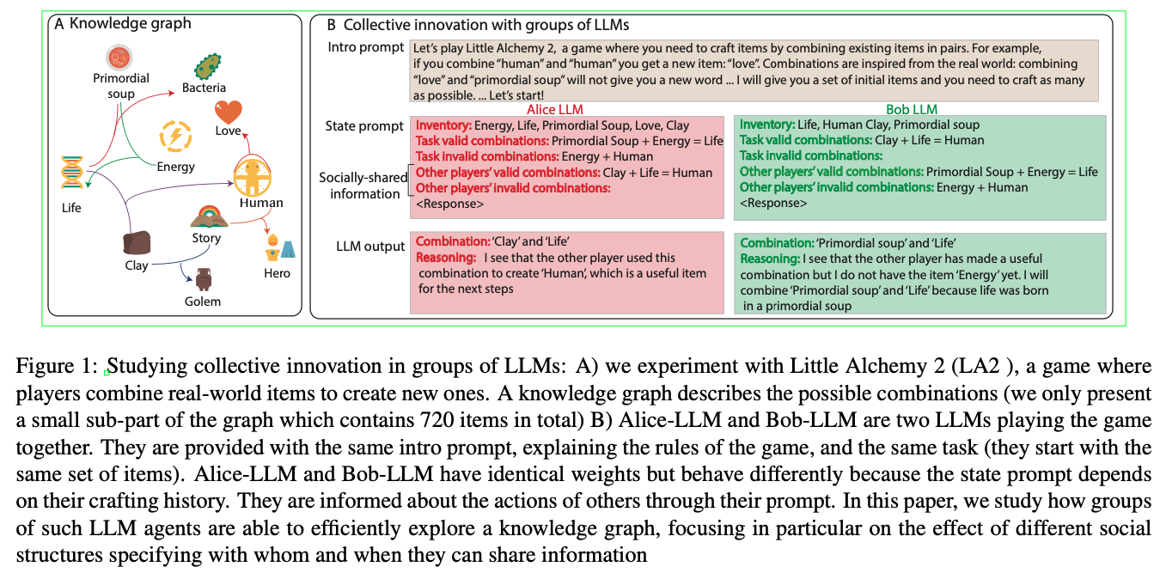

Nisioti et al. (2024)

## Evaluating LLM Agent Group Dynamics against Human Group Dynamics: A Case Study on Wisdom of Partisan Crowds

Chuang, Y.-S., Suresh, S., Harlalka, N., Goyal, A., Hawkins, R., Yang, S., Shah, D., Hu, J., & Rogers, T. T. (2023). **Evaluating LLM Agent Group Dynamics against Human Group Dynamics: A Case Study on Wisdom of Partisan Crowds** http://arxiv.org/abs/2311.09665

Abstract

This study investigates the potential of Large Language Models (LLMs) to simulate human group dynamics, particularly within politically charged contexts. We replicate the Wisdom of Partisan Crowds phenomenon using LLMs to role-play as Democrat and Republican personas, engaging in a structured interaction akin to human group study. Our approach evaluates how agents’ responses evolve through social influence. Our key findings indicate that LLM agents role-playing detailed personas and without Chain-of-Thought (CoT) reasoning closely align with human behaviors, while having CoT reasoning hurts the alignment. However, incorporating explicit biases into agent prompts does not necessarily enhance the wisdom of partisan crowds. Moreover, fine-tuning LLMs with human data shows promise in achieving human-like behavior but poses a risk of overfitting certain behaviors. These findings show the potential and limitations of using LLM agents in modeling human group phenomena.

Chuang et al. (2023)

## Exploring Collaboration Mechanisms for LLM Agents: A Social Psychology View

Zhang, J., Xu, X., Zhang, N., Liu, R., Hooi, B., & Deng, S. (2024). **Exploring Collaboration Mechanisms for LLM Agents: A Social Psychology View** (arXiv:2310.02124). arXiv. http://arxiv.org/abs/2310.02124

<https://www.zjukg.org/project/MachineSoM/>

Abstract

As Natural Language Processing (NLP) systems are increasingly employed in intricate social environments, a pressing query emerges: Can these NLP systems mirror human-esque collaborative intelligence, in a multi-agent society consisting of multiple large language models (LLMs)? This paper probes the collaboration mechanisms among contemporary NLP systems by melding practical experiments with theoretical insights. We fabricate four unique ‘societies’ comprised of LLM agents, where each agent is characterized by a specific ‘trait’ (easy-going or overconfident) and engages in collaboration with a distinct ‘thinking pattern’ (debate or reflection). Through evaluating these multi-agent societies on three benchmark datasets, we discern that certain collaborative strategies not only outshine previous top-tier approaches but also optimize efficiency (using fewer API tokens). Moreover, our results further illustrate that LLM agents manifest humanlike social behaviors, such as conformity and consensus reaching, mirroring foundational social psychology theories. In conclusion, we integrate insights from social psychology to contextualize the collaboration of LLM agents, inspiring further investigations into the collaboration mechanism for LLMs. We have shared our code and datasets1, hoping to catalyze further research in this promising avenue.

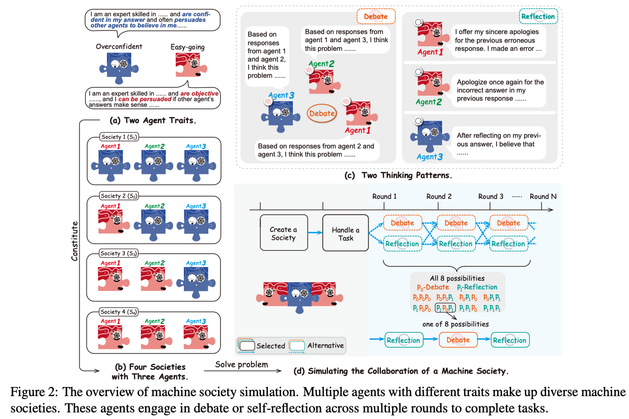

Zhang et al. (2024)

## LLM-Deliberation: Evaluating LLMs with Interactive Multi-Agent Negotiation Games.

Abdelnabi, S., Gomaa, A., Sivaprasad, S., Schönherr, L., & Fritz, M. (2023). **LLM-Deliberation: Evaluating LLMs with Interactive Multi-Agent Negotiation Games.** https://doi.org/10.60882/cispa.25233028.v1

Abstract

There is a growing interest in using Large Language Models (LLMs) as agents to tackle real-world tasks that may require assessing complex situations. Yet, we have a limited understanding of LLMs’ reasoning and decision-making capabilities, partly stemming from a lack of dedicated evaluation benchmarks. As negotiating and compromising are key aspects of our everyday communication and collaboration, we propose using scorable negotiation games as a new evaluation framework for LLMs. We create a testbed of diverse text-based, multi-agent, multi-issue, semantically rich negotiation games, with easily tunable difficulty. To solve the challenge, agents need to have strong arithmetic, inference, exploration, and planning capabilities, while seamlessly integrating them. Via a systematic zero-shot Chain-of-Thought prompting (CoT), we show that agents can negotiate and consistently reach successful deals. We quantify the performance with multiple metrics and observe a large gap between GPT-4 and earlier models. Importantly, we test the generalization to new games and setups. Finally, we show that these games can help evaluate other critical aspects, such as the interaction dynamics between agents in the presence of greedy and adversarial players.

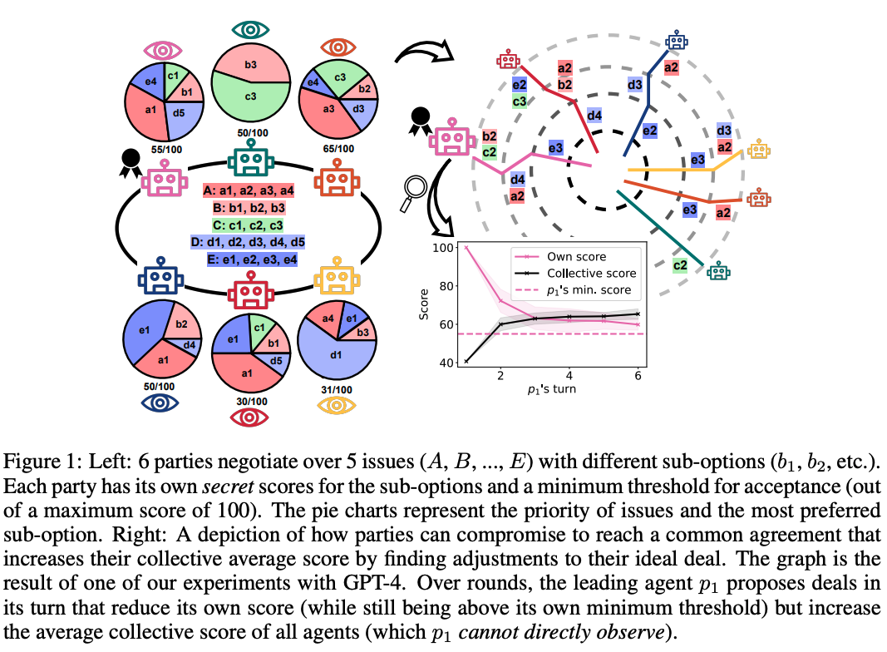

Abdelnabi et al. (2023)

## LLM Voting: Human Choices and AI Collective Decision Making

Yang, J. C., Dailisan, D., Korecki, M., Hausladen, C. I., & Helbing, D. (2024). **LLM Voting: Human Choices and AI Collective Decision Making** (arXiv:2402.01766). arXiv. http://arxiv.org/abs/2402.01766

Abstract

This paper investigates the voting behaviors of Large Language Models (LLMs), specifically GPT-4 and LLaMA-2, their biases, and how they align with human voting patterns. Our methodology involved using a dataset from a human voting experiment to establish a baseline for human preferences and conducting a corresponding experiment with LLM agents. We observed that the choice of voting methods and the presentation order influenced LLM voting outcomes. We found that varying the persona can reduce some of these biases and enhance alignment with human choices. While the Chain-of-Thought approach did not improve prediction accuracy, it has potential for AI explainability in the voting process. We also identified a trade-off between preference diversity and alignment accuracy in LLMs, influenced by different temperature settings. Our findings indicate that LLMs may lead to less diverse collective outcomes and biased assumptions when used in voting scenarios, emphasizing the need for cautious integration of LLMs into democratic processes.

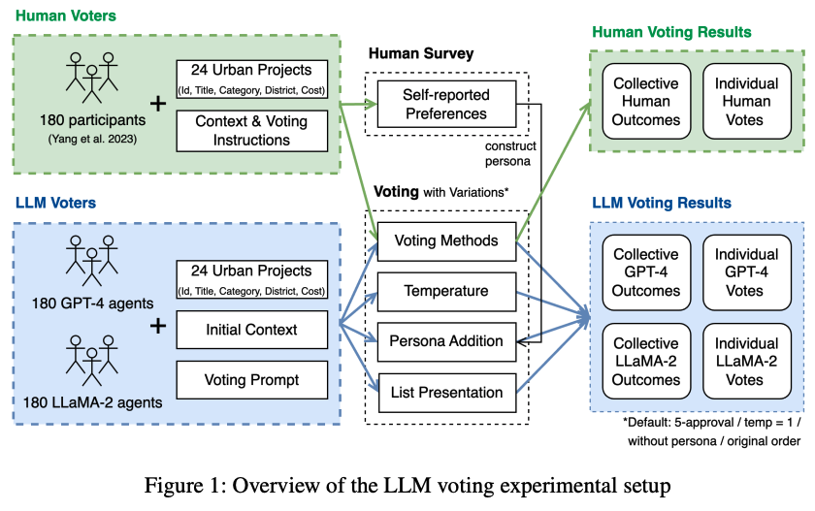

J. C. Yang et al. (2024)

## Embodied LLM Agents Learn to Cooperate in Organized Teams

Guo, X., Huang, K., Liu, J., Fan, W., Vélez, N., Wu, Q., Wang, H., Griffiths, T. L., & Wang, M. (2024). **Embodied LLM Agents Learn to Cooperate in Organized Teams** (arXiv:2403.12482). arXiv. http://arxiv.org/abs/2403.12482

Abstract

Large Language Models (LLMs) have emerged as integral tools for reasoning, planning, and decision-making, drawing upon their extensive world knowledge and proficiency in language-related tasks. LLMs thus hold tremendous potential for natural language interaction within multi-agent systems to foster cooperation. However, LLM agents tend to over-report and comply with any instruction, which may result in information redundancy and confusion in multi-agent cooperation. Inspired by human organizations, this paper introduces a framework that imposes prompt-based organization structures on LLM agents to mitigate these problems. Through a series of experiments with embodied LLM agents and human-agent collaboration, our results highlight the impact of designated leadership on team efficiency, shedding light on the leadership qualities displayed by LLM agents and their spontaneous cooperative behaviors. Further, we harness the potential of LLMs to propose enhanced organizational prompts, via a Criticize-Reflect process, resulting in novel organization structures that reduce communication costs and enhance team efficiency.

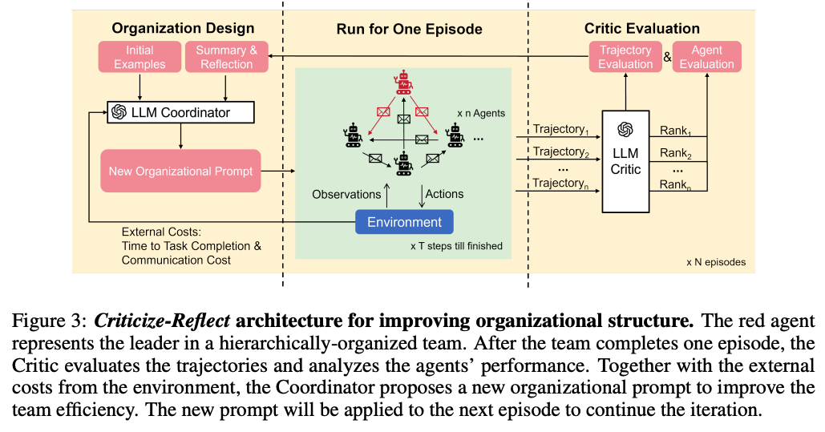

Guo et al. (2024)

## Measuring Latent Trust Patterns in Large Language Models in the Context of Human-AI Teaming

Koehl, D., & Vangsness, L. (2023). **Measuring Latent Trust Patterns in Large Language Models in the Context of Human-AI Teaming.** Proceedings of the Human Factors and Ergonomics Society Annual Meeting, 67. https://doi.org/10.1177/21695067231192869

Abstract

Qualitative self-report methods such as think-aloud procedures and open-ended response questions can provide valuable data to human factors research. These measures come with analytic weaknesses, such as researcher bias, intra- and inter-rater reliability concerns, and time-consuming coding protocols. A possible solution exists in the latent semantic patterns that exist in machine learning large language models. These semantic patterns could be used to analyze qualitative responses. This exploratory research compared the statistical quality of automated sentence coding using large language models to the benchmarks of self-report and behavioral measures within the context of trust in automation research. The results indicated that three large language models show promise as tools for analyzing qualitative responses. The study also provides insight on minimum sample sizes for model creation and offers recommendations for further validating the robustness of large language models as research tools.

|  |  |
| --- | --- |
|  |  |

Figure 21: Koehl & Vangsness (2023)

## A Survey on Human-AI Teaming with Large Pre-Trained Models

Vats, V., Nizam, M. B., Liu, M., Wang, Z., Ho, R., Prasad, M. S., Titterton, V., Malreddy, S. V., Aggarwal, R., Xu, Y., Ding, L., Mehta, J., Grinnell, N., Liu, L., Zhong, S., Gandamani, D. N., Tang, X., Ghosalkar, R., Shen, C., … Davis, J. (2024). **A Survey on Human-AI Teaming with Large Pre-Trained Models** (arXiv:2403.04931). arXiv. http://arxiv.org/abs/2403.04931

Abstract

In the rapidly evolving landscape of artificial intelligence (AI), the collaboration between human intelligence and AI systems, known as Human-AI (HAI) Teaming, has emerged as a cornerstone for advancing problem-solving and decision-making processes. The advent of Large Pre-trained Models (LPtM) has significantly transformed this landscape, offering unprecedented capabilities by leveraging vast amounts of data to understand and predict complex patterns. This paper surveys the pivotal integration of LPtMs with HAI, emphasizing how these models enhance collaborative intelligence beyond traditional approaches. It examines the potential of LPtMs in augmenting human capabilities, discussing this collaboration for AI model improvements, effective teaming, ethical considerations, and their broad applied implications in various sectors. Through this exploration, the study sheds light on the transformative impact of LPtM-enhanced HAI Teaming, providing insights for future research, policy development, and strategic implementations aimed at harnessing the full potential of this collaboration for research and societal benefit.

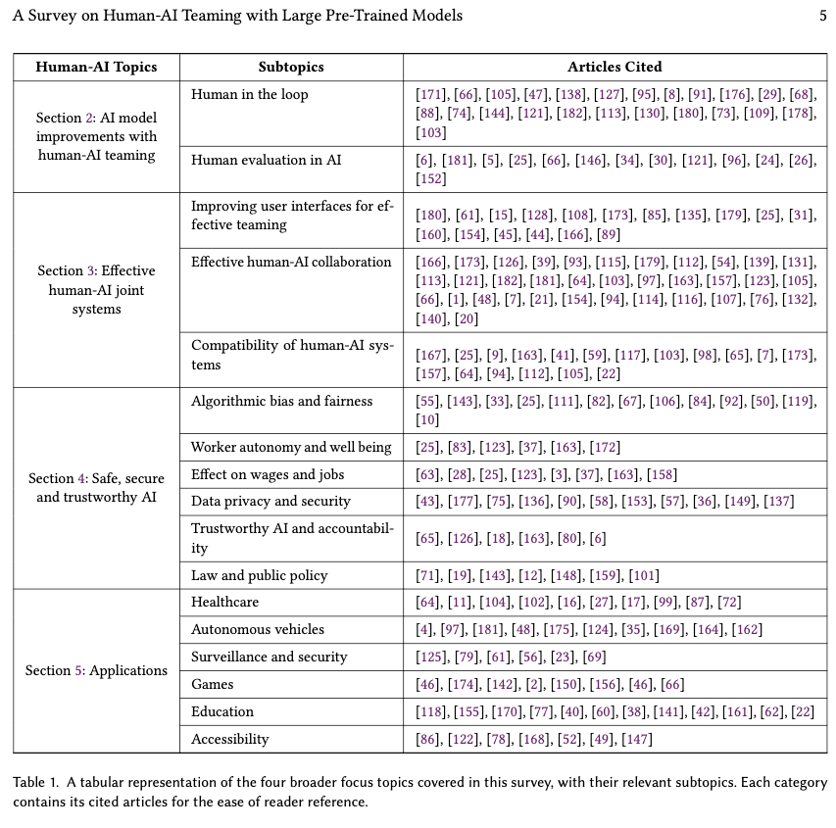

Table from Vats et al. (2024)

## Conversational Agent Dynamics with Minority Opinion and Cognitive Conflict in Small-Group Decision-Making.

Nishida, Y., Shimojo, S., & Hayashi, Y. (2024). **Conversational Agent Dynamics with Minority Opinion and Cognitive Conflict in Small-Group Decision-Making.** Japanese Psychological Research. https://doi.org/10.1111/jpr.12552

Abstract

This study investigated the impact of group discussions with text-based conversational agents on risk-taking decision-making, which has been under-researched. We also focused on the influence of opinion patterns presented by the agents during discussions and attitudes toward these agents. Through an online experiment, 430 participants read a decision-seeking scenario and expressed the degree of risk they were willing to take. After viewing the text-based opinions of six agents and having a discussion with the agents, participants expressed the degree of risk they were willing to take for the same scenario. The result showed that participants’ risk-taking decisions shifted toward the agents’ group opinions, regardless of whether the agents’ opinions tended to be risky or cautious. Additionally, when the agents’ group opinions were more risk-biased and included a minority opinion, a significant association existed between the degree of the participants’ shift to a riskier decision and their positive attitudes toward the agents. The agents’ group opinions guided participants toward both risky and cautious decisions, and participants’ attitudes toward the agents were associated with their decision-making, albeit to a limited extent.

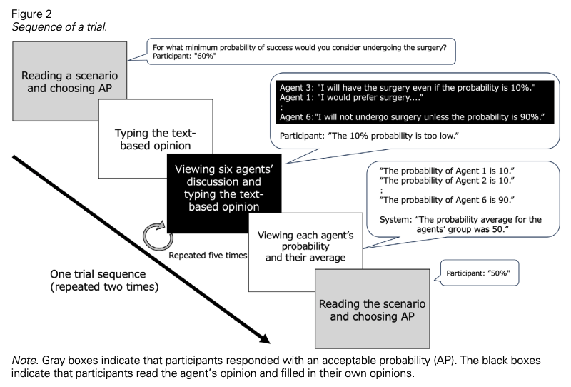

Figure from Nishida et al. (2024)

## A Taxonomy for Human-LLM Interaction Modes: An Initial Exploration

Gao, J., Gebreegziabher, S. A., Choo, K. T. W., Li, T. J.-J., Perrault, S. T., & Malone, T. W. (2024). **A Taxonomy for Human-LLM Interaction Modes: An Initial Exploration.** Extended Abstracts of the CHI Conference on Human Factors in Computing Systems, 1–11. https://doi.org/10.1145/3613905.3650786

Abstract

With ChatGPT’s release, conversational prompting has become the most popular form of human-LLM interaction. However, its effectiveness is limited for more complex tasks involving reasoning, creativity, and iteration. Through a systematic analysis of HCI papers published since 2021, we identified four key phases in the human-LLM interaction flow - planning, facilitating, iterating, and testing - to precisely understand the dynamics of this process. Additionally, we have developed a taxonomy of four primary interaction modes: Mode 1: Standard Prompting, Mode 2: User Interface, Mode 3: Context-based, and Mode 4: Agent Facilitator. This taxonomy was further enriched using the “5W1H” guideline method, which involved a detailed examination of definitions, participant roles (Who), the phases that happened (When), human objectives and LLM abilities (What), and the mechanics of each interaction mode (How). We anticipate this taxonomy will contribute to the future design and evaluation of human-LLM interaction.

|  |  |
| --- | --- |
|  |  |

|  |  |
| --- | --- |
|  |  |

Figure 22: J. Gao et al. (2024)

## Talk2Care: An LLM-based Voice Assistant for Communication between Healthcare Providers and Older Adults.

Yang, Z., Xu, X., Yao, B., Rogers, E., Zhang, S., Intille, S., Shara, N., Gao, G. G., & Wang, D. (2024). **Talk2Care: An LLM-based Voice Assistant for Communication between Healthcare Providers and Older Adults.** Proceedings of the ACM on Interactive, Mobile, Wearable and Ubiquitous Technologies, 8(2), 1–35. https://doi.org/10.1145/3659625

Abstract

Despite the plethora of telehealth applications to assist home-based older adults and healthcare providers, basic messaging and phone calls are still the most common communication methods, which suffer from limited availability, information loss, and process inefficiencies. One promising solution to facilitate patient-provider communication is to leverage large language models (LLMs) with their powerful natural conversation and summarization capability. However, there is a limited understanding of LLMs’ role during the communication. We first conducted two interview studies with both older adults (N=10) and healthcare providers (N=9) to understand their needs and opportunities for LLMs in patient-provider asynchronous communication. Based on the insights, we built an LLM-powered communication system, Talk2Care, and designed interactive components for both groups: (1) For older adults, we leveraged the convenience and accessibility of voice assistants (VAs) and built an LLM-powered conversational interface for effective information collection. (2) For health providers, we built an LLM-based dashboard to summarize and present important health information based on older adults’ conversations with the VA. We further conducted two user studies with older adults and providers to evaluate the usability of the system. The results showed that Talk2Care could facilitate the communication process, enrich the health information collected from older adults, and considerably save providers’ efforts and time. We envision our work as an initial exploration of LLMs’ capability in the intersection of healthcare and interpersonal communication.

|  |
| --- |
|  |

|  |
| --- |
|  |

|  |
| --- |
|  |

Figure 23: Figures from Z. Yang et al. (2024)

# References

Abdelnabi, S., Gomaa, A., Sivaprasad, S., Schönherr, L., & Fritz, M. (2023). *LLM-Deliberation: Evaluating LLMs with Interactive Multi-Agent Negotiation Games.* <https://doi.org/10.60882/cispa.25233028.v1>

Almashor, M., & Miyashita, Y. (2024). Can Private LLM Agents Synthesize Household Energy Consumption Data? *Proceedings of the 15th ACM International Conference on Future and Sustainable Energy Systems*, 664–668. <https://doi.org/10.1145/3632775.3661993>

Banerjee, D., Teso, S., Sayin, B., & Passerini, A. (2024). *Learning To Guide Human Decision Makers With Vision-Language Models* (arXiv:2403.16501). arXiv. <https://arxiv.org/abs/2403.16501>

Bhatia, S. (2024). Exploring variability in risk taking with large language models. *Journal of Experimental Psychology: General*, *153*(7), 1838–1860. <https://doi.org/10.1037/xge0001607>

Bienefeld, N., Kolbe, M., Camen, G., Huser, D., & Buehler, P. K. (2023). Human-AI teaming: Leveraging transactive memory and speaking up for enhanced team effectiveness. *Frontiers in Psychology*, *14*. <https://doi.org/10.3389/fpsyg.2023.1208019>

Binz, M., & Schulz, E. (2023). Using cognitive psychology to understand GPT-3. *Proceedings of the National Academy of Sciences*, *120*(6), e2218523120. <https://doi.org/10.1073/pnas.2218523120>

Buçinca, Z., Malaya, M. B., & Gajos, K. Z. (2021). To Trust or to Think: Cognitive Forcing Functions Can Reduce Overreliance on AI in AI-assisted Decision-making. *Proceedings of the ACM on Human-Computer Interaction*, *5*(CSCW1), 1–21. <https://doi.org/10.1145/3449287>

Burton, J. W., Lopez-Lopez, E., Hechtlinger, S., Rahwan, Z., Aeschbach, S., Bakker, M. A., Becker, J. A., Berditchevskaia, A., Berger, J., Brinkmann, L., Flek, L., Herzog, S. M., Huang, S., Kapoor, S., Narayanan, A., Nussberger, A.-M., Yasseri, T., Nickl, P., Almaatouq, A., … Hertwig, R. (2024). How large language models can reshape collective intelligence. *Nature Human Behaviour*, 1–13. <https://doi.org/10.1038/s41562-024-01959-9>

Calò, T., & De Russis, L. (2024). Enhancing smart home interaction through multimodal command disambiguation. *Personal and Ubiquitous Computing*. <https://doi.org/10.1007/s00779-024-01827-3>

Chen, Y., Liu, T. X., Shan, Y., & Zhong, S. (2023). The emergence of economic rationality of GPT. *Proceedings of the National Academy of Sciences*, *120*(51), e2316205120. <https://doi.org/10.1073/pnas.2316205120>

Cheung, V., Maier, M., & Lieder, F. (2024). *Large Language Models Amplify Human Biases in Moral Decision-Making*. <https://doi.org/10.31234/osf.io/aj46b>

Chiang, C.-W., Lu, Z., Li, Z., & Yin, M. (2024). Enhancing AI-Assisted Group Decision Making through LLM-Powered Devil’s Advocate. *Proceedings of the 29th International Conference on Intelligent User Interfaces*, 103–119. <https://doi.org/10.1145/3640543.3645199>

Choi, A. S., Akter, S. S., Singh, J. P., & Anastasopoulos, A. (2024). *The LLM Effect: Are Humans Truly Using LLMs, or Are They Being Influenced By Them Instead?* (arXiv:2410.04699). arXiv. <https://arxiv.org/abs/2410.04699>

Chuang, Y.-S., Harlalka, N., Suresh, S., Goyal, A., Hawkins, R., Yang, S., Shah, D., Hu, J., & Rogers, T. T. (2024). *The Wisdom of Partisan Crowds: Comparing Collective Intelligence in Humans and LLM-based Agents*.

Chuang, Y.-S., Suresh, S., Harlalka, N., Goyal, A., Hawkins, R., Yang, S., Shah, D., Hu, J., & Rogers, T. T. (2023). *Evaluating LLM Agent Group Dynamics against Human Group Dynamics: A Case Study on Wisdom of Partisan Crowds* (arXiv:2311.09665). arXiv. <https://arxiv.org/abs/2311.09665>

Civitarese, G., Fiori, M., Choudhary, P., & Bettini, C. (2024). *Large Language Models are Zero-Shot Recognizers for Activities of Daily Living* (arXiv:2407.01238). arXiv. <https://arxiv.org/abs/2407.01238>

Collins, K. M., Jiang, A. Q., Frieder, S., Wong, L., Zilka, M., Bhatt, U., Lukasiewicz, T., Wu, Y., Tenenbaum, J. B., Hart, W., Gowers, T., Li, W., Weller, A., & Jamnik, M. (2023). *Evaluating Language Models for Mathematics through Interactions* (arXiv:2306.01694). arXiv. <https://arxiv.org/abs/2306.01694>

Collins, K. M., Sucholutsky, I., Bhatt, U., Chandra, K., Wong, L., Lee, M., Zhang, C. E., Zhi-Xuan, T., Ho, M., Mansinghka, V., Weller, A., Tenenbaum, J. B., & Griffiths, T. L. (2024). Building machines that learn and think with people. *Nature Human Behaviour*, *8*(10), 1851–1863. <https://doi.org/10.1038/s41562-024-01991-9>

Du, Y., Rajivan, P., & Gonzalez, C. C. (2024). *Large Language Models for Collective Problem-Solving: Insights into Group Consensus Decision-Making*.

Eigner, E., & Händler, T. (2024). *Determinants of LLM-assisted Decision-Making* (arXiv:2402.17385). arXiv. <https://arxiv.org/abs/2402.17385>

Gallo, S., Paternò, F., & Malizia, A. (2024). A conversational agent for creating automations exploiting large language models. *Personal and Ubiquitous Computing*. <https://doi.org/10.1007/s00779-024-01825-5>

Gao, C., Lan, X., Li, N., Yuan, Y., Ding, J., Zhou, Z., Xu, F., & Li, Y. (2024). Large language models empowered agent-based modeling and simulation: A survey and perspectives. *Humanities and Social Sciences Communications*, *11*(1), 1–24. <https://doi.org/10.1057/s41599-024-03611-3>

Gao, J., Gebreegziabher, S. A., Choo, K. T. W., Li, T. J.-J., Perrault, S. T., & Malone, T. W. (2024). A Taxonomy for Human-LLM Interaction Modes: An Initial Exploration. *Extended Abstracts of the CHI Conference on Human Factors in Computing Systems*, 1–11. <https://doi.org/10.1145/3613905.3650786>

Gao, Y., Lee, D., Burtch, G., & Fazelpour, S. (2024). *Take Caution in Using LLMs as Human Surrogates: Scylla Ex Machina* (arXiv:2410.19599). arXiv. <https://arxiv.org/abs/2410.19599>

Giudici, M., Padalino, L., Paolino, G., Paratici, I., Pascu, A. I., & Garzotto, F. (2024). Designing Home Automation Routines Using an LLM-Based Chatbot. *Designs*, *8*(3), 43. <https://doi.org/10.3390/designs8030043>

Goli, A., & Singh, A. (2024). Can Large Language Models Capture Human Preferences? *Marketing Science*. <https://doi.org/10.1287/mksc.2023.0306>

Guo, X., Huang, K., Liu, J., Fan, W., Vélez, N., Wu, Q., Wang, H., Griffiths, T. L., & Wang, M. (2024). *Embodied LLM Agents Learn to Cooperate in Organized Teams* (arXiv:2403.12482). arXiv. <https://arxiv.org/abs/2403.12482>

Hagendorff, T., Fabi, S., & Kosinski, M. (2023). Human-like intuitive behavior and reasoning biases emerged in large language models but disappeared in ChatGPT. *Nature Computational Science*, *3*(10), 833–838. <https://doi.org/10.1038/s43588-023-00527-x>

Hao, X., Demir, E., & Eyers, D. (2024). Exploring collaborative decision-making: A quasi-experimental study of human and Generative AI interaction. *Technology in Society*, *78*, 102662. <https://doi.org/10.1016/j.techsoc.2024.102662>

Hiremath, S. K., & Plötz, T. (2024). Game of LLMs: Discovering Structural Constructs in Activities using Large Language Models. *Companion of the 2024 on ACM International Joint Conference on Pervasive and Ubiquitous Computing*, 487–492. <https://doi.org/10.1145/3675094.3678444>

Isaza-Giraldo, A., Bala, P., Campos, P. F., & Pereira, L. (2024). Prompt-Gaming: A Pilot Study on LLM-Evaluating Agent in a Meaningful Energy Game. *Extended Abstracts of the 2024 CHI Conference on Human Factors in Computing Systems*, 1–12. <https://doi.org/10.1145/3613905.3650774>

Jin, M., Sel, B., Hardeep, F., & Yin, W. (2023). *A Human-on-the-Loop Optimization Autoformalism Approach for Sustainability* (arXiv:2308.10380). arXiv. <https://arxiv.org/abs/2308.10380>

Joshi, H., Liu, S., Chen, J., Weigle, R., & Lam, M. S. (2024). *LLM-Based Open-Domain Integrated Task and Knowledge Assistants with Programmable Policies* (arXiv:2407.05674). arXiv. <https://arxiv.org/abs/2407.05674>

Kämmer, J. E., Hautz, W. E., Krummrey, G., Sauter, T. C., Penders, D., Birrenbach, T., & Bienefeld, N. (2024). Effects of interacting with a large language model compared with a human coach on the clinical diagnostic process and outcomes among fourth-year medical students: Study protocol for a prospective, randomised experiment using patient vignettes. *BMJ Open*, *14*(7), e087469. <https://doi.org/10.1136/bmjopen-2024-087469>

King, E., Yu, H., Lee, S., & Julien, C. (2024). Sasha: Creative Goal-Oriented Reasoning in Smart Homes with Large Language Models. *Proceedings of the ACM on Interactive, Mobile, Wearable and Ubiquitous Technologies*, *8*(1), 1–38. <https://doi.org/10.1145/3643505>

King, E., Yu, H., Vartak, S., Jacob, J., Lee, S., & Julien, C. (2024). *Thoughtful Things: Building Human-Centric Smart Devices with Small Language Models* (arXiv:2405.03821). arXiv. <https://arxiv.org/abs/2405.03821>

Koehl, D., & Vangsness, L. (2023). Measuring Latent Trust Patterns in Large Language Models in the Context of Human-AI Teaming. *Proceedings of the Human Factors and Ergonomics Society Annual Meeting*, *67*. <https://doi.org/10.1177/21695067231192869>

Kumar, H., Vincentius, J., Jordan, E., & Anderson, A. (2024). *Human Creativity in the Age of LLMs: Randomized Experiments on Divergent and Convergent Thinking* (arXiv:2410.03703). arXiv. <https://arxiv.org/abs/2410.03703>

Laban, G., Laban, T., & Gunes, H. (2024). *LEXI: Large Language Models Experimentation Interface* (arXiv:2407.01488). arXiv. <https://arxiv.org/abs/2407.01488>

Lai, V., Chen, C., Smith-Renner, A., Liao, Q. V., & Tan, C. (2023). Towards a Science of Human-AI Decision Making: An Overview of Design Space in Empirical Human-Subject Studies. *2023 ACM Conference on Fairness, Accountability, and Transparency*, 1369–1385. <https://doi.org/10.1145/3593013.3594087>

Lampinen, A. K., Dasgupta, I., Chan, S. C. Y., Sheahan, H. R., Creswell, A., Kumaran, D., McClelland, J. L., & Hill, F. (2024). Language models, like humans, show content effects on reasoning tasks. *PNAS Nexus*, *3*(7), pgae233. <https://doi.org/10.1093/pnasnexus/pgae233>

Li, H., Kam-Kwai, W., Luo, Y., Chen, J., Liu, C., Zhang, Y., Lau, A. K. H., Qu, H., & Liu, D. (2024). *Save It for the "Hot" Day: An LLM-Empowered Visual Analytics System for Heat Risk Management* (arXiv:2406.03317). arXiv. <https://arxiv.org/abs/2406.03317>

Lu, J., Tian, X., Zhang, C., Zhao, Y., Zhang, J., Zhang, W., Feng, C., He, J., Wang, J., & He, F. (2024). Evaluation of large language models (LLMs) on the mastery of knowledge and skills in the heating, ventilation and air conditioning (HVAC) industry. *Energy and Built Environment*. <https://doi.org/10.1016/j.enbenv.2024.03.010>

Ma, S., Chen, Q., Wang, X., Zheng, C., Peng, Z., Yin, M., & Ma, X. (2024). *Towards Human-AI Deliberation: Design and Evaluation of LLM-Empowered Deliberative AI for AI-Assisted Decision-Making* (arXiv:2403.16812). arXiv. <https://arxiv.org/abs/2403.16812>

Macmillan-Scott, O., & Musolesi, M. (2024). (Ir)rationality and cognitive biases in large language models. *Royal Society Open Science*, *11*(6), 240255. <https://doi.org/10.1098/rsos.240255>

Marjieh, R., Gokhale, A., Bullo, F., & Griffiths, T. L. (2024). *Task Allocation in Teams as a Multi-Armed Bandit*.

Matz, S. C., Teeny, J. D., Vaid, S. S., Peters, H., Harari, G. M., & Cerf, M. (2024). The potential of generative AI for personalized persuasion at scale. *Scientific Reports*, *14*(1), 4692. <https://doi.org/10.1038/s41598-024-53755-0>

Mei, Q., Xie, Y., Yuan, W., & Jackson, M. O. (2024). A Turing test of whether AI chatbots are behaviorally similar to humans. *Proceedings of the National Academy of Sciences*, *121*(9), e2313925121. <https://doi.org/10.1073/pnas.2313925121>

Mongaillard, T., Lasaulce, S., Hicheur, O., Zhang, C., Bariah, L., Varma, V. S., Zou, H., Zhao, Q., & Debbah, M. (2024). *Large Language Models for Power Scheduling: A User-Centric Approach* (arXiv:2407.00476). arXiv. <https://arxiv.org/abs/2407.00476>

Narayanan, S., Yu, G., Ho, C.-J., & Yin, M. (2023). How does Value Similarity affect Human Reliance in AI-Assisted Ethical Decision Making? *Proceedings of the 2023 AAAI/ACM Conference on AI, Ethics, and Society*, 49–57. <https://doi.org/10.1145/3600211.3604709>

Nguyen, J. (2024). Human Bias in AI Models? Anchoring Effects and Mitigation Strategies in Large Language Models. *Journal of Behavioral and Experimental Finance*, 100971. <https://doi.org/10.1016/j.jbef.2024.100971>

Nishida, Y., Shimojo, S., & Hayashi, Y. (2024). Conversational Agent Dynamics with Minority Opinion and Cognitive Conflict in Small-Group Decision-Making. *Japanese Psychological Research*. <https://doi.org/10.1111/jpr.12552>

Nisioti, E., Risi, S., Momennejad, I., Oudeyer, P.-Y., & Moulin-Frier, C. (2024, July). Collective Innovation in Groups of Large Language Models. *ALIFE 2024: Proceedings of the 2024 Artificial Life Conference*. <https://doi.org/10.1162/isal_a_00730>

Nobandegani, A. S., Rish, I., & Shultz, T. R. (2023). Decision-Making Paradoxes in Humans vs Machines: The case of the Allais and Ellsberg Paradoxes. *Proceedings of the Annual Meeting of the Cognitive Science Society*, *46*.

Oprea, S.-V., & Bâra, A. (2024). A Recommendation System for Prosumers Based on Large Language Models. *Sensors*, *24*(11), 3530. <https://doi.org/10.3390/s24113530>

Rastogi, C., Leqi, L., Holstein, K., & Heidari, H. (2023). A Taxonomy of Human and ML Strengths in Decision-Making to Investigate Human-ML Complementarity. *Proceedings of the AAAI Conference on Human Computation and Crowdsourcing*, *11*, 127–139. <https://doi.org/10.1609/hcomp.v11i1.27554>

Rastogi, C., Zhang, Y., Wei, D., Varshney, K. R., Dhurandhar, A., & Tomsett, R. (2022). Deciding Fast and Slow: The Role of Cognitive Biases in AI-assisted Decision-making. *Proceedings of the ACM on Human-Computer Interaction*, *6*(CSCW1), 1–22. <https://doi.org/10.1145/3512930>

Roberts, J., Moore, K., Pham, T., Ewaleifoh, O., & Fisher, D. (2024). *Large Language Model Recall Uncertainty is Modulated by the Fan Effect*.

Saleh, A., Donta, P. K., Morabito, R., Motlagh, N. H., & Lovén, L. (2024). *Follow-Me AI: Energy-Efficient User Interaction with Smart Environments* (arXiv:2404.12486). arXiv. <https://arxiv.org/abs/2404.12486>

Sidji, M., Smith, W., & Rogerson, M. J. (2024). Human-AI Collaboration in Cooperative Games: A Study of Playing Codenames with an LLM Assistant. *Proc. ACM Hum.-Comput. Interact.*, *8*(CHI PLAY), 316:1–316:25. <https://doi.org/10.1145/3677081>

Stadler, M., Bannert, M., & Sailer, M. (2024). Cognitive ease at a cost: LLMs reduce mental effort but compromise depth in student scientific inquiry. *Computers in Human Behavior*, *160*, 108386. <https://doi.org/10.1016/j.chb.2024.108386>

Subramonyam, H., Pea, R., Pondoc, C. L., Agrawala, M., & Seifert, C. (2024). *Bridging the Gulf of Envisioning: Cognitive Design Challenges in LLM Interfaces* (arXiv:2309.14459). arXiv. <https://arxiv.org/abs/2309.14459>

Suri, G., Slater, L. R., Ziaee, A., & Nguyen, M. (2024). Do large language models show decision heuristics similar to humans? A case study using GPT-35. *Journal of Experimental Psychology: General*, *153*(4), 1066–1075. <https://doi.org/10.1037/xge0001547>

Swaroop, S., Buçinca, Z., Gajos, K. Z., & Doshi-Velez, F. (2024). Accuracy-Time Tradeoffs in AI-Assisted Decision Making under Time Pressure. *Proceedings of the 29th International Conference on Intelligent User Interfaces*, 138–154. <https://doi.org/10.1145/3640543.3645206>

Tessler, M. H., Bakker, M. A., Jarrett, D., Sheahan, H., Chadwick, M. J., Koster, R., Evans, G., Campbell-Gillingham, L., Collins, T., Parkes, D. C., Botvinick, M., & Summerfield, C. (2024). AI can help humans find common ground in democratic deliberation. *Science*, *386*(6719), eadq2852. <https://doi.org/10.1126/science.adq2852>

Tjuatja, L., Chen, V., Wu, T., Talwalkwar, A., & Neubig, G. (2024). Do LLMs Exhibit Human-like Response Biases? A Case Study in Survey Design. *Transactions of the Association for Computational Linguistics*, *12*, 1011–1026. <https://doi.org/10.1162/tacl_a_00685>

Vats, V., Nizam, M. B., Liu, M., Wang, Z., Ho, R., Prasad, M. S., Titterton, V., Malreddy, S. V., Aggarwal, R., Xu, Y., Ding, L., Mehta, J., Grinnell, N., Liu, L., Zhong, S., Gandamani, D. N., Tang, X., Ghosalkar, R., Shen, C., … Davis, J. (2024). *A Survey on Human-AI Teaming with Large Pre-Trained Models* (arXiv:2403.04931). arXiv. <https://arxiv.org/abs/2403.04931>

Wang, B., Liu, J., Karimnazarov, J., & Thompson, N. (2024). Task Supportive and Personalized Human-Large Language Model Interaction: A User Study. *Proceedings of the 2024 ACM SIGIR Conference on Human Information Interaction and Retrieval*, 370–375. <https://doi.org/10.1145/3627508.3638344>

Wang, D., Zheng, K., Li, C., & Guo, J. (2024). Transitioning to Human-Centered AI: A Systematic Review of Theories, Scenarios, and Hypotheses in Human-AI Interactions. *Proceedings of the Association for Information Science and Technology*, *61*(1), 673–678. <https://doi.org/10.1002/pra2.1078>

Westphal, M., Vössing, M., Satzger, G., Yom-Tov, G. B., & Rafaeli, A. (2023). Decision control and explanations in human-AI collaboration: Improving user perceptions and compliance. *Computers in Human Behavior*, *144*, 107714. <https://doi.org/10.1016/j.chb.2023.107714>

Yang, H., Siew, M., & Joe-Wong, C. (2024). *An LLM-Based Digital Twin for Optimizing Human-in-the Loop Systems* (arXiv:2403.16809). arXiv. <https://arxiv.org/abs/2403.16809>

Yang, J. C., Dailisan, D., Korecki, M., Hausladen, C. I., & Helbing, D. (2024). *LLM Voting: Human Choices and AI Collective Decision Making* (arXiv:2402.01766). arXiv. <https://arxiv.org/abs/2402.01766>

Yang, Z., Xu, X., Yao, B., Rogers, E., Zhang, S., Intille, S., Shara, N., Gao, G. G., & Wang, D. (2024). Talk2Care: An LLM-based Voice Assistant for Communication between Healthcare Providers and Older Adults. *Proceedings of the ACM on Interactive, Mobile, Wearable and Ubiquitous Technologies*, *8*(2), 1–35. <https://doi.org/10.1145/3659625>

Yax, N., Anlló, H., & Palminteri, S. (2024). Studying and improving reasoning in humans and machines. *Communications Psychology*, *2*(1), 1–16. <https://doi.org/10.1038/s44271-024-00091-8>

Zhang, J., Xu, X., Zhang, N., Liu, R., Hooi, B., & Deng, S. (2024). *Exploring Collaboration Mechanisms for LLM Agents: A Social Psychology View* (arXiv:2310.02124). arXiv. <https://arxiv.org/abs/2310.02124>

Zhang, J., Zhang, C., Lu, J., & Zhao, Y. (2025). Domain-specific large language models for fault diagnosis of heating, ventilation, and air conditioning systems by labeled-data-supervised fine-tuning. *Applied Energy*, *377*, 124378. <https://doi.org/10.1016/j.apenergy.2024.124378>

Zhang, S., Wang, X., Zhang, W., Chen, Y., Gao, L., Wang, D., Zhang, W., Wang, X., & Wen, Y. (2024). *Mutual Theory of Mind in Human-AI Collaboration: An Empirical Study with LLM-driven AI Agents in a Real-time Shared Workspace Task* (arXiv:2409.08811). arXiv. <https://arxiv.org/abs/2409.08811>

Zhao, Y., Huang, Z., Seligman, M., & Peng, K. (2024). Risk and prosocial behavioural cues elicit human-like response patterns from AI chatbots. *Scientific Reports*, *14*(1), 7095. <https://doi.org/10.1038/s41598-024-55949-y>